 |  | 
United Nations Development Programme

Project title: Strengthening Institutional Capacity for Effective Implementation of Rio Conventions in Uganda
Country: Uganda | Implementing Partner:  National Environment Management Authority (NEMA) |  |  | Management Arrangements :  National Implementation Modality (NIM)
UNDAF/Country Programme Outcome:
UNDAF 2016-2020: Outcome 3.1. Natural Resource Management and Climate Change Resilience: By end 2020, Natural resources management and energy access are gender responsive, effective, and efficient, reducing emissions, negating the impact of climate-induced disasters and environmental degradation on livelihoods and production systems, and strengthening community resilience.
UNDAF 2016-2020: Outcome 1.3. Institutional Development, Transparency, and Accountability: By end 2020, targeted public institutions and Public-Private Partnerships are fully functional at all levels, inclusive, resourced, performance-oriented, innovative and evidence seeking supported by a strategic evaluation function; and with Uganda’s population enforcing a culture of mutual accountability, transparency, and integrity.
UNDP's Country Programme Document (2016-2020): “to strengthen natural resources management and resilience to climate change and disaster risks, while expanding livelihood and employment opportunities for excluded groups”.

UNDP Strategic Plan Output:
Output 1.3: Solutions developed at national and sub-national levels for sustainable management of natural resources, ecosystem services, chemicals, and waste.

UNDP Social and Environmental Screening Category: Low |  |  | UNDP Gender Marker: 2
Atlas Project ID/Award ID number: 00101752 |  |  | Atlas Output ID/Project ID number: 00104050
UNDP-GEF PIMS ID number: 5643 |  |  | GEF ID number: 9335
Planned start date: March 2017 |  |  | Planned end date: March 2021
LPAC date: 13 January 2017
Brief project description: The project goal is to strengthen institutional capacity for Rio Conventions implementation and environmental data and information management in Uganda to improve the reporting process to the Rio Conventions and ensure sustainable development through better design and enforcement of environmental policy. The project’s strategy emphasizes a long-term approach to institutionalizing capacities to meet Rio Conventions obligations through a set of activities that lay the foundation for effective decision-making and policy-making regarding global environmental benefits. Specifically, the project will be implemented through two components, namely, establishing a national institutional framework for environmental management, and development of coordinated information and data management system. Active participation of stakeholder representatives in the project life cycle facilitates the strategic implementation of project activities, mainly at the district level, in line with project objectives. Moreover, the inclusion of multi-stakeholders contributes to the adaptive collaborative management of project implementation and promotes long-term sustainability of project outcomes.

Financing Plan
GEF Trust Fund |  |  | US$ 900,000
- Total Budget administered by UNDP |  |  | US$ 900,000
Co-financing
UNDP |  |  | US$ 200,000
Government |  |  | US$ 275,000 (NEMA)
 |  |  | US$ 200,000 (MWE)
 |  |  | US$ 150,000 (MAAIF)
NGOs |  |  | US$ 40,000 (ACODE)
 |  |  | US$ 30,000 (Nature Uganda)
 |  |  | US$ 30,000 (Environmental Alert)
District (Local Government) |  |  | US$ 25,000 (Buikwe)
 |  |  | US$ 25,000 (Jinja)
 |  |  | US$ 25,000 (Kayunga)
 |  |  | US$ 25,000 (Mukuono)
 |  |  | US$ 25,000 (Wakiso)
- Total co-financing |  |  | US$ 1,050,000
- Grand-Total Project Financing (1) +(2) |  |  | US$ 1,950,000
Signatures
Signature: |  | Agreed by Government |  |  | Date/Month/Year:
Signature: |  | Agreed by Implementing Partner |  |  | Date/Month/Year:
Signature: |  | Agreed by UNDP |  |  | Date/Month/Year:

Table of Contents

LIST OF FIGURES 4
LIST OF TABLES 4
LIST OF ACRONYMS AND ABBREVIATIONS 5

1. Development Challenge 7

2. Strategy 11
2.1 Relevance to Environmental Management 11
2.2 Coordination Effects 12
2.3 Theory of Change 12

3. Results and Partnerships 16
3.1 Expected Results 16
3.2 Partnerships 24
3.3 Stakeholder engagement 26
3.4 Mainstreaming gender 31
3.5 South-South and Triangular Cooperation (SSTrC) 33

4. Feasibility 34
4.1 Cost efficiency and effectiveness 34
4.2 Risk Management 34
4.3 Social and environmental safeguards 35
4.4 Sustainability and Scaling Up 36

5. Project Results Framework 38

6. Monitoring and Evaluation (M&E) Plan 42

7. Governance and Management Arrangements 47

8. Financial Planning and Management 51

9. Total Budget and Work Plan 54

10. Legal Context 63

11. Annexes 64

LIST OF FIGURES

Figure 1. Project's Theory of Change 13
Figure 2. Proposed Project Strategy 14
Figure 3. The causal chain of events expected to lead to the desired outcome 15
Figure 4. Project Organizational Chart 49

LIST OF TABLES

Table 1. Key Stakeholders Involved in the Project 27
Table 2. Project risks and mitigation measures 35
Table 3. Project Results Framework 38
Table 4. Mandatory GEF M&E Requirements and M&E Budget 45
Table 5. Co-financing and Risk Mitigation Measures 51
Table 6. Total Budget and Work Plan 54
Table 7. Multi-year Work Plan 2017-2020 79

LIST OF ANNEXES

ANNEX 1. LIST OF PEOPLE CONSULTED DURING PROJECT DEVELOPMENT 65
Annex 2 DISTRICTS SELECTION CRITERIA 67
ANNEX 3. UNDP SOCIAL AND ENVIRONMENTAL AND SCREENING TEMPLATE (SESP) 70
ANNEX 4. MULTI-YEAR WORK PLAN 79
ANNEX 5. MONITORING PLAN 84
ANNEX 6. EVALUATION PLAN 88
Annex 7. Capacity Development Scorecard 89
ANNEX 8. TERMS OF REFERENCES 101
Annex 9. Letter OF AGREEMENT WITH THE GOVERNMENT 106
ANNEX 10. Results of the capacity assessment of the project implementing partner and HACT micro assessment 110
ANNEX 11. LETTERS OF FINANCIAL COMMITMENTS, GEF OFP LETTER, GEF PIF. 111
Annex 12. UNDP Project Quality Assurance Report 125
LIST OF ACRONYMS AND ABBREVIATIONS

CBOs | Community-Based Organizations
CSOs | Civil Society Organizations
DRR | Disaster Risk Reduction
EU | European Union
FAO | Food and Agriculture Organization of the United Nations
GCCA | Global Climate Change Alliance
GEF | Global Environment Facility
GEF IEO | Global Environment Facility Independent Evaluation Office
GEF OFP | Global Environment Facility Operational Focal Point
GEF SEC | Global Environment Facility Secretariat
ICT | Information and Communication Technology
IDDP | Integrated Drylands Development Programme
M&E | Monitoring and Evaluation
MAAIF | Ministry of Agriculture, Animal Industry, and Fishery
MDGs | Millennium Development Goals
MEAs | Multilateral Environmental Agreements
MWE | Ministry of Water and Environment
NAP | National Action Programme
NAPA | National Adaptation Plan of Action
NBSAP | National Biodiversity Strategy and Action Plan
NCSA | National Capacity Self-Assessment
NDPs | National Development Plans
NEMA | National Environmental Management Plan
NGOs | Non-governmental Organization
PIF | Project Identification Form
POPP | Programme and Operations Policies and Procedures
PPG | Project Preparation Grant
PMU | Project Management Unit
PRSP | Poverty Reduction Strategy Paper
SDGs | Sustainable Development Goals
SESP | Social and Environmental Procedure
SSTrC | South-South and Triangular Cooperation
STAP | GEF Scientific Technical Advisory Panel
TACC | Territorial Approach to Climate Change
TE | Terminal Evaluation
TOC | Theory of Change
TWGs | Technical Working Groups
UNCBD | United Nations Convention on Biological Diversity
UNCCD | United Nations Convention to Combat Desertification
UNFCCC | United Nations Framework Convention on Climate Change
UNDP-CO | UNDP Country Office
UNDP ERC | Evaluation Resource Centre
UNDP-GEF | UNDP Global Environmental Finance Unit
UWA | Uganda Wildlife Authority

Development Challenge

- Uganda is in Eastern Africa continent, at 1.10 27 N latitude and 32.39 68 E longitude. It covers an area of 241,038 km2. It is located to the south of South Sudan and has borders with Kenya in the East, Tanzania and Rwanda in the South, and Democratic Republic of Congo in the West. Many environmental issues in Uganda are international in nature, as it has multiple international borders two major trans-boundary water bodies on its territory: The Nile River, and Lake Victoria. Uganda has just over 34.6 million inhabitants, with more than 28 million of the population living in rural areas. Industry in Uganda is very limited. The most important sectors are the processing of agricultural products (27% of country exports), the manufacture of light consumer goods and textiles, and the production of beverages, electricity, and cement.
- As Uganda is laying around the both sides of the equator, there is limited year around fluctuation in temperature and no real winter or summer. January and February are the hottest months when the average daytime range is 24-33 °C. The south has two wet seasons: from mid- September to November and March to May. The dry season from December to February means only that it rains less. The second dry season- from June and July- is considerably drier. Still, with 1000 to 2000 mm of rain every year, it can rain at almost any time.
- Uganda is exceptionally important in terms of biodiversity, with surveys reporting the occurrence of 18,783 species. The country is relatively small, covers only 241,551 Km², however, it accounts for around 0.18% of the world’s terrestrial and freshwater surface, harbors 4.6% of the dragonflies, 6.8% of the butterflies, 7.5% of the mammals, and 10.2% of the bird species globally recognized. In Bwindi Impenetrable and Kibale National Parks, scientists have recorded 173 species of polypore fungi, which is 16% of the total species known from North America, Tropical Africa, and Europe. The high level of biodiversity in Uganda is a function of Uganda’s location in a zone between the ecological communities that are characteristic of the drier East African savannas and the moister West African rain forests, along with large differences in elevation and extraordinary combinations of terrestrial and aquatic habitats. Uganda has a unique mixture of semi-arid woodlands, savannah, and forest communities, as well as a wealth of Mountains and lake habitats.
- Critical environmental threats to biodiversity, air quality, forests and ecosystems in Uganda were identified in official reports included habitat loss and pollution/contamination, indoor air pollution, land degradation affected by over cultivation and overgrazing, and urbanization. The National Biodiversity Strategy and Action Plan identified climate change as a key threat to biodiversity. Many other threats have links across the conventions: for example, climate variability and climate impacts have also influenced land degradation, while habitat loss and land degradation have reduced carbon sequestration in soils and biomass. Illegal timber harvesting, overgrazing and forest fires also affect multiple convention areas. Uganda's natural ecosystems are experiencing conversion, degradation, and a decline in an unplanned and uncontrolled manner. Examples include uncontrolled expansion of agricultural land; erosion of soils and a decline in soil fertility; falling quality and availability of water; unregulated encroachment and degradation of wetlands; encroachment of forest reserves; deforestation and overgrazing of rangelands; and invasion of weed species and bush encroachment.
- Uganda aspires to transform from a low-income to a high middle-income country by 2040, as indicated by the Uganda’s Vision 2040 and the Government’s series of five-year National Development Plans (NDPs). The National Development Plans aim at increasing overall competitiveness; creating additional employment and wealth while emphasizing inclusive and sustainable growth. The key development opportunities prioritized in the Plan are agriculture, tourism, mineral development, infrastructure, and human development. However, the Government has also identified that addressing the implementation constraints that had affected the implemented of the first NDP is the key challenge.
- At the highest level, Uganda' Poverty Reduction Strategy Paper (PRSP) calls for the pursuit of environmentally friendly development and sustainable development, where the effective management of natural resources, the environmental, and the human environment must be simultaneously integrated with the socio-economic natural resources management, the PRSP's objective areas: 1) Increasing household incomes and promoting equity; 2) Enhancing the availability and quality of gainful employment; 3) Improving stock and quality of economic infrastructure, 4) Increasing access to quality social services, 5) Promoting science, technology, innovation and ICT to enhance competitiveness, 6) Enhancing human capital development, 7) Strengthening good governance, defence and security, and 8) Promoting sustainable population and use of the environment and natural resources. This project responds directly to these PRSP strategies.
- Uganda’s Second National Development Plan 2015/16 to 2019/20 theme aims to strengthen Uganda's competitiveness for sustainable wealth creation, inclusive growth, and employment. Uganda had already met two of the 17 MDG targets by 2012, but there are a few areas where progress has been slow, stagnated, or experienced reveals, these include; loss of valuable environmental resources. Progress has been slow in reducing biodiversity loss.
- Uganda faces a series of environmental challenges including climate change, land degradation, and biodiversity losses. Climate change has considerably added to natural resource degradation and has increased uncertainty and risk. It is not, however, the only challenge facing Uganda’s economy. The complex nature of the environment and the socio-economic situation means it is not possible to clearly separate out the climate change, land degradation, and biodiversity losses challenges from the other challenges.
- Uganda, like many least developed countries, faces a dual challenge in implementing multilateral environmental agreements (MEAs): it must strengthen MEAs in a way that will generate global benefits while also responding effectively to global environmental concerns that threaten its population. At present, the human and institutional capacities of Uganda to achieve its stated environmental objectives are limited. While individual capacity has increased in some areas since the NCSA was completed in 2012, several crosscutting constraints identified in that report are still present. At present, the major challenges have been incurred in the implementation of MEAs in Uganda include: i) low levels of awareness, particularly due to inadequate circulation and complex language of the information materials, ii) weak articulation of the MEAs issues in national development frameworks, particularly the Poverty Eradication Action Plan, iii) weak institutional coordination as demonstrated by weak linkages and lack of synergies among the MEAs, (iv) Lack of Monitoring and Evaluation mechanisms for the MEAs and v) the inconsistencies in policies relevant to implementation of MEAs characterized by weak policy integration.
- There is a clear need in Uganda to establish a coordinated system integrating issues related to the Rio Conventions, especially in respect to improving coordinated reporting to the Conventions. Global environmental benefits can be delivered through providing a comprehensive approach to environmental data analysis, monitoring and reporting; and ensuring the link to policy development.
- The major capacity constraints and barriers in Uganda to implement the Rio Conventions as identified by the NCSA are:
- At the Institutional level:
Weak inter-institutional coordination across government institutions, and the weak institutional framework for addressing Rio Conventions.

- At the organizational level:
Low awareness of Rio Conventions issues, lack of data and information, inadequate technical, capacity for implementation, inadequate monitoring and evaluation mechanisms, inadequate funding, and poor infrastructure.

- At the Individual level:
Low awareness of MEAs issues, and insufficient numbers of trained staff.
- The net result of these barriers and constraints is an environment in which work that is done on the environmental agreements may not get the visibility it deserves or be linked with reducing global environmental threats.
- Another critical issue is the weakness and fragmented environmental monitoring efforts in Uganda. The environmental indicators, observation methodology, procedures, and methods of data collection, analysis, exchange, and dissemination are not fully defined currently in Uganda. To improve the global environmental impact, there is a necessity to: develop a standardized monitoring methodology harmonized with UN requirements focusing on indicators that are crosscutting to the Rio Conventions; develop information flow mechanism; and elaborate an improved framework for monitoring the development of a set of procedures to clarify roles and responsibilities of the institutions responsible for the monitoring of the specific environmental elements.
- The environmental impact of human activity is a function of population, consumption, and technology. Increasing human population and industrial activities have led to problems associated with the pollution of air, water, and soil. As Uganda has finite resources, its ability to sustain the growing population is limited, as well as its ability to provide clean and safe water, reliable energy, and food. Natural resources consumption has increased rapidly and thus, this increasing consumption, emissions, and waste pollute the country and destroy the ecosystems, degrade the lands, and induced climate change.
- In response to these challenges, environmental and natural resources issues, and constraints, the NCSA Uganda recommends increasing and enhancing national coordination capacities for Rio Conventions implementation and monitoring. This project directly addresses this recommendation by supporting the development of institutional mechanisms to better implement Rio Conventions as well as build the capacity of national and sub-national teams in data collection, analysis, and exchange among concerned stakeholders. The project will contribute to meeting the shared obligation under the three Rio Conventions by activities that include the active involvement of line ministries staff (NEMA, MWE, and MAAIF) in the mainstreaming exercises and extensive awareness-raising workshops on the value and contribution of the global environment to socio-economic development. By the end of the project, the benefits at the global level generated indirectly by the capacity-strengthening activities will be indicated by the production of sectoral systems that fully integrate Rio Conventions provisions. This project will help Uganda in meeting the sustainable development goals and protecting its biodiversity, environment, and land by building the needed capacities at the national and district levels.
- This project responds to three main sets of articles under the three Rio Conventions, demonstrating both the global environmental value of the project and its crosscutting capacity development strategy:
- Stakeholder engagement, where the three Rio Conventions call for the building of capacities of relevant individuals and organizations to engage proactively and constructively with one another to manage a global environmental issue (UNFCCC: Articles 4 & 6: UNCBD: Articles 10 & 13; and UNCCD: Articles 5,9,10, &19).
- Develop capacities of individuals and organizations to plan and develop effective environmental policy and legislation set, related strategies, and plans based on informed decision-making for global environmental management (UNFCCC: Article 4 & 6; UNCBD: Articles 8, 9, 16 & 17; and UNCCD: Articles 4, 5, 13, 17, 18, and 19).
- Strengthening environmental governance, to strengthen capacities of individuals and organizations to enact environmental policies or regulatory decisions, as well as plan and execute relevant sustainable global environmental management actions and solutions (UNFCCC: Article 4; UNCBD: Articles 6, 14, 19 & 22; and UNCCD: 4, 5, 8, 9 & 10).
- In addition to article 7 of the UNCBD, article 16 of the UNCCD, and article 5 of the UNFCCC, which specifically call for strengthening monitoring, data and information management and sharing. This project will strengthen the institutional and technical capacities so that institutionalized arrangements to facilitate implementation and monitoring.

Strategy

Relevance to Environmental Management
- Uganda is party to the three Rio Conventions on biodiversity conservation, climate change, and desertification, among other multilateral environmental agreements (MEAs). Several national reports and communications were prepared, with many others are currently underway. Uganda is fully committed to meet its obligations under the MEAs and the proposed project is intended to facilitate an important step towards developing capacities in Uganda for an effective national environmental management framework. More specifically the project, directly and indirectly, addresses the following articles under the Conventions: UNFCCC (Articles 4 and 5); CBD (Articles 12, 14,17, and 26) and UNCCD (9,10, and 16).
- This project is a follow-up to Uganda's NCSA, seeking to implement priority cross-cutting capacity development recommendations that were identified in the NCSA Action Plan. Uganda NCSA final report of which outlines the principles of national capacity building strategy to implement MEAs. Uganda's NCSA Action Plan targets capacity building at both the focal area and cross-sectoral levels. The NCSA action plan was developed based on eight intervention areas identified during the synergies study. The actions identified by the NCSA were to strengthen institutional capacity by establishing and strengthening inter-institutional collaboration framework and strengthening executing institutions. Uganda's second top priority is to strengthen the policy, legislative, and regulative frameworks and their associated institutional structure, including monitoring and evaluation. This project responds to the first and partially to the second top priorities.
- This proposed project also builds on a set of key national strategies and policies and helps Uganda to comply with the international environmental obligations. The project will build on Uganda's National Biodiversity Strategy and Action Plan, which was launched in 2002, and was updated in 2015, the Uganda Second National Communication Report to the UNFCCC, that was submitted to UNFCCC in October 2014, and framework for the national action programme to combat desertification and drought in Uganda. The project will build on key outputs and initiatives under UNCCD, including the National Action Programme (NAP), the Integrated Drylands Development Programme (IDDP), and the Road Map for NAP resource mobilization. Under UNFCCC, the project is in line with the National Adaptation Plan of Action (NAPA). Regarding the International Waters, key regional projects under implementation include the Lake Victoria Environment Management Project (LVEMP), a few initiatives implemented by the Lake Victoria Fisheries Organisation (LVFO), and the Nile Basin Initiative (NBI), among others. Under the CBD, the project is in line with the National Biodiversity Strategy and Action Plan (NBSAP 2015-2025), the Restoration of Lake Victoria / Lake Nakivale Shores, River Nile Banks, and Catchment Areas, and the Clearing House Mechanism Project, among others.
- The project is also aligned with UNDP's global and country-level strategies. At the global level, UNDP’s strategic plan for 2014-2017 calls for solutions at the national and sub-national levels for sustainable management of natural resources, ecosystem services, chemicals and waste, and effective institutional, legislative and policy frameworks in place to enhance the implementation of disaster and climate risk management measures at national and sub-national levels. At the national level, the project is in line with the United Nations Development Assistant Framework, and the UNDP Country Programme Document 2016-2020. The project is aligned with both the medium and long term development plan 2015/20 and is focused on achieving transformative results in areas of Governance, Human Capital Development; and Sustainable and Inclusive Economic Development.

Coordination Effects
- The coordination and harmonization long-term impact of the project is to provide momentum in implementing institutional environmental reforms. By developing inter-ministerial mechanisms within the environmental management system both directly and indirectly in line with the Rio Conventions these stakeholders are reminded of their responsibility to set the tone for respect and observation of the implementation of the Rio Conventions in Uganda. In strengthening the capacity of governments’ officials, the inter-ministerial mechanisms, concerned staffs, and civil society to demand access to information in the country, the project adds impetus to the commitment Uganda has made to ensuring that monitoring and reporting of Rio Conventions become permanent elements of the State’s environmental obligation.
- The goal of the project is to make the best practices and innovative approaches for meeting and sustaining the implementation of the Rio Conventions. The required data in the three focal areas will be made available and accessible for implementation through national development database. The project’s objective is to develop individual capacities and institutional frameworks in the NEMA, MAAIF, and MWE for improved implementation of environmental impacts and trends for the elaboration of collaborative natural resources management.
- Another coordination effect will be in the sphere of an organizational system where new methodologies providing for data collection, analysis, management, and dissemination will capacitate concerned staff and government officials to initiate the process of data collection and management that promote rather than undermine coordination efforts. Through the momentum of the project, the process of “monitoring and reporting of the country’s progress in meeting Rio Conventions obligations” will be significantly enhanced, and the importance of incorporating international standards and environmental reporting expertise into policy-making and decision-making will be reinforced to the benefit of both the inter-ministerial mechanisms and the specialized committees. The project will also strengthen the institutionalization of the three levels of mandatory expertise necessary in relation to natural resources management (institutional, organizational, individual), an obligation that is too often weakly acknowledged.

Theory of Change
- The Theory of Change (ToC) diagram for the project is illustrated in Figure 1. It presents the linkages between the development barriers and the project drivers. It also illustrates the project’s outputs, outcomes, and overarching goal, and how project’s outputs would help in lifting the barriers of the problems related to Rio Conventions implementation.

Figure 1 Project's Theory of Change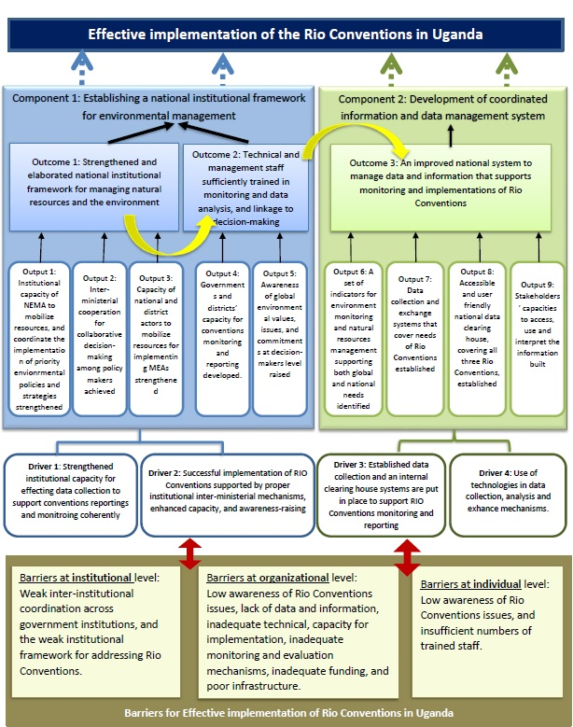
- The proposed capacity development project targets a set of organizational, institutional, and individual capacities to advance Uganda on a path towards environment-friendly and sustainable development. The expected outcome of this project is that Uganda's institutional capacities for sustaining global environmental outcomes, as defined by the Rio Conventions, are strengthened. The objective is to enhance national capacities to deliver and sustain global environmental outcomes within the framework of sustainable development priorities. The project’s activities in strengthening and developing the needed capacities of men and women, at national and sub-national levels, for Rio Conventions and implementation, will take on a particular importance as part of an effort to promote collaboration between national and sub-national teams. This project will develop the capacity of the inter-ministerial cooperation, ensuring that key state institutions are involved in initiating, advancing and implementing critical activities, projects, and programmes in consultation with all stakeholders. Further, it will ensure equal access to environmental data and information. The inter-ministerial mechanisms will be empowered to help the Rio Coordinator and Rio Conventions Focal Points to comply with the requirements of the convention, and make them feel empowered to engage in the implementation process as constructive stakeholders.
- Figure 2 illustrates the proposed project strategy, which is based on creating change at various levels:
Figure 2. Proposed Project Strategy

- There are different drivers- as illustrated in Figure 1- exert pressure in the relevant direction for justifying the project intervention. The key drivers that will have an influence on the project logic are: (1) the successful implementation of Rio Conventions supported by proper institutional inter-ministerial mechanisms, enhanced capacity, and awareness-raising; (2) an established data collection and internal clearing house systems are put in place to support RIO Conventions monitoring and reporting; (3) strengthened district with institutional capacity for affecting data collection to support conventions reportings and monitoring coherently; and (4) use of technologies in data collection, analysis and exchange mechanisms. The GEF-financed project supports an institutional strengthening and data collection, reporting and management systems that are further discussed in Section 3.1. It is expected that the technical assistance, incentives and enabling framework that will be put in place by the project will develop the needed mechanisms and systems for Rio Conventions implementation and mechanisms so that the goal in the ToC is achieved.
- The Theory of Change, however, envisages a set of assumptions, the proven strength or weakness of which will have a critical impact on the achievement of positive outcomes. Thus, the project’s strategy will contribute to the achievement of the project outcome in line with the following assumptions being realized: i) institutions are accountable; ii) technical support received at both, national and district levels; iii) reliable and accurate data is available, collected and analyzed; iv) project-trained teams are retained and operational in Government institutions; and v) government is interested in maintaining the established data collection, clearing-house, and management systems.
- Based on this foundation, the project aims to achieve the following changes that will trigger and accelerate environmental management and conservation efforts:
- Strengthen and elaborate national institutional framework for managing natural resources and the environment;
- Train staff at the technical and managerial levels in monitoring and data analysis, and linkage to decision-making processes;
- Improve national system to manage (i.e. collect, store and access) data and information – that supports monitoring and implementation of Rio Conventions;
- Enable capacities for environmental monitoring and reporting.
- The above changes should lead to the more enhanced cooperation in Rio Conventions implementation, enhanced capacities for monitoring and reporting, and, consequently, enhanced compliance with Rio Conventions obligations as illustrated in Figure 3.

Figure 3 The causal chain of events expected to lead to the desired outcome

- The project needs to coordinate with a wide range of stakeholders in order to strengthen the institutional capacity for Rio Conventions implementation. The project, therefore, has adopted a multi-stakeholder process in order to include all concerned stakeholders contributing to the project outcomes as explained in the project management section and Table 1. The project activities will not be operating in a vacuum but, rather, in a context where there are complementary baseline initiatives with which synergies must be forged to deliver maximum benefits productively (efficiently and effectively) to beneficiaries, as elaborated in section 3.4.
- Knowledge management is critical for the successful implementation of the project. It has not only been retained as a stand-alone component but also considered as a means to an end, is a transversal issue that cuts across the project design. The project’s output 1.2.2 is dedicated to raising the awareness of global environmental values, issues, and commitments at decision-makers level. Similarly, outcome 1.2 will enhance the technical and management staff capacities in monitoring and data analysis, and in making the linkage to decision-making processes.
- Finally, the project will have the effect of reintroducing a multi-level dialogue involving environmental and natural resources management institutions, government, district level government, civil society and academia on the sensitive issue of data collection, analysis, management and reporting as central to the goal of promoting sustainable development in the country in the long term.

Results and Partnerships

Expected Results:
- The proposed capacity development project targets a set of organizational, institutional, and individual capacities to advance Uganda on a path towards environment-friendly and sustainable development. The expected outcome of this project is that Uganda's institutional capacities for sustaining global environmental outcomes, as defined by the Rio Conventions, are strengthened. The objective is to enhance national capacities to deliver and sustain global environmental outcomes within the framework of sustainable development priorities.
- The Project Objective is to strengthen institutional capacity for effective implementation of the Rio Conventions in Uganda. To reach this Objective there are three outcomes:

- Outcome 1: Strengthened and elaborated national institutional framework for managing natural resources and the environment;
- Outcome 2: Technical and management staff sufficiently trained in monitoring and data analysis, and linkage to decision-making processes; and
- Outcome 3: An improved national system to manage (i.e. collect, store, and access) data and information – that supports monitoring and implementations of Rio Conventions.
- As explained in the following paragraphs, the project will improve the institutional capacities for better implementation of the Rio Conventions. This improvement will generate a lot of knowledge and information on the Rio Conventions implementation, and will directly contribute to complying with the multilateral environmental agreements.
- The project consists of two main components, three outcomes, and nine outputs as follows:

Component 1. Establishing a national institutional framework for environmental management
- An in-depth institutional analysis to be conducted to help inform the institutional reforms needed. This component will focus on strengthening inter-ministerial and inter-directorate coordination for improved monitoring and compliance with environmental policies and best practices for delivering and sustaining global environmental outcomes. It will also comprise a set of training and awareness-raising activities. The technical capacities of the staffs in various directorates, services, and units in government ministries/agencies will be strengthened so that they can fulfill their roles and responsibilities. While environmental officers at district levels largely understand the need for sustainable development, they are not necessarily informed about best practices for alternative approaches to environmental and natural resource management. With improved access to information and ability to interpret the information, the capacities of the concerned stakeholders to undertake the needed scientifically derived analysis will be enhanced, considerably.
- This component will also support the government in mobilizing the needed financial resources and explore best practices and innovative approaches to financing activities that produce global environmental outcomes, in particular, the sector development plans that integrate global environmental priorities. The monitoring and tracking of financial resources is a key institutional capacity, which will help ensure the legitimacy, validity, predictability, and relevance of mobilizing financial resources. This component will be achieved through two outcomes:

Outcome 1: Strengthened and elaborated national institutional framework for managing the environment and natural resources
- This outcome focuses on assessing and structuring an improved consultative and decision-making process that effectively integrates global environmental objectives into existing national environmental information management and decision support system. This will be achieved by strengthening the decision-making process to meet global and national environmental reporting systems and development priorities and supporting the NEMA in further developing the proposed data collection, analysis and monitoring system at the data management directorate with optimal linkages to local authorities.
- This outcome will deliver the following outputs:
Output 1.1 Institutional capacity of the National Environment Management Authority to mobilize resources, and coordinate the implementation of priority environmental policies and strategies strengthened.
- This output will deliver specific activities for using environmental data for evidence-based planning and implementation of environmental management projects including donor-funded projects at districts level. The output is closely linked to activities carried out in outputs 2.2 and 2.3, but will be more focused at the national level and pilot exercise for environmental integration and data interpretation for decision-making into a government-funded development activity in relation to the Rio Conventions implementation, resources mobilization, and the coordination of the Rio Conventions implementation at the national level. This output will give a particular attention to the Rio Conventions focal points, the MEAs Coordination Unit, and the concerned staff in NEMA, MWE, and MAAIF.
Activities:
    - Undertake a detailed capacity needs assessment among officers in charge, Rio Convention Coordinator, and convention focal points on the Rio Conventions implementation, reporting, and monitoring in Uganda;
    - Conduct an institutional analysis of the challenges, barriers, and opportunities in relation to coordination and resources mobilization for the Rio Conventions implementation;
    - Develop a capacity development plan based on the assessment and present to relevant authorities for validation through peer review of experts and stakeholders;
    - Design the training modules based on the capacity development plan, with focus on resources mobilization, and coordination among Rio Coordinator, Rio Conventions focal points, and stakeholders; and
    - Implement the designed modules, and document the capacity development progress through the capacity scorecards and events’ evaluation.

Output 1.2 Inter-ministerial cooperation for collaborative decision-making among policy makers achieved.
- Weak inter-institutional coordination, limited access and management of information technology, inadequate training in data management and lack of information on available technologies were identified as weaknesses and constraints in the NCSA of Uganda. In order to address some of the issues related to data collection and management, which have remained, it is necessary to capture more information on the status of current data gathering, analysis, and management in Uganda. For that reason and under component 1 of this project, the investments from GEF financing will make possible a study of the flow of environmental data; structures and processes, and on reporting related specifically to the Rio Conventions in Uganda. Following such a study, activities under this output will also include the development and agreement of a roadmap for improved environmental governance in collaboration with government and other stakeholders partnerships.
- Inter-ministerial cooperation for collaborative decision-making is lacking in Uganda. The NEMA and the MWE have some overlapping responsibilities. The coordination between different units in NEMA and the MWE is limited. For example, there is a National Committee for Biodiversity to oversee the implementation of the NBSAP. The mandate and structure of the committee are clear, yet, the remaining Rio Convention focal points are not fully involved in this committee. Same applies to the other committees. Work under the land degradation and climate change areas do not involve all Rio Convention focal points. Work remain monitored only by the focal point and the responsible departments without a proper in place mechanism at the national level to monitor and follow up on the implementation and decision-making process pertaining to the Rio Convention. This output should strengthen the existed UNCBD committee and further develop and expand the UNFCCC and UNCCD national committees.
- A national mechanism for cooperation can facilitate collaboration between NEMA, MWE, and MAAIF, as well as the ministries of Energy, Finance, Planning and Economic Development, Gender, Labour and Social Development, Lands, Housing and Urban Development and Tourism Wildlife and Antiquities (and any other environmental institutions), and other agencies and bodies working on the issue who may not regularly exchange information and implement activities jointly. Representatives of national civil society organization or non-governmental organization working on environmental projects and services should also participate in the national-level coordination. An inter-ministerial coordination is essential to ensure a clear division of roles and responsibilities and identify areas of collaboration in the implementation of national strategies and plans pertaining to Rio Conventions implementation.
- The inter-ministerial mechanisms will be defined in consultation with the project partners and stakeholders. An example of the needed national mechanism to enhance the inter-ministerial cooperation is the establishment of an inter-ministerial/multi-sectoral committee(s) which meet(s) regularly can contribute to: developing a clear national, regional and local level environmental monitoring process; ensuring that all stakeholders at local and national levels understand the different forms of international environmental commitments; their responsibilities in addressing environmental issues; and how to work with others to achieve the global environmental benefits; identifying clear roles and responsibilities for relevant ministries; coordinating with international actors and partners in a better way; and improving government-civil society collaboration.
- Recommend appropriate inter-ministerial cooperation mechanisms, and define the structure, mandate, and governance structure of the proposed mechanisms to make informed decisions on the global environmental conventions. This could include undertaking an institutional analysis of the effectiveness of the three Rio conventions committees, the role of the MEAs Coordination Unit at the MWE, and recommending the needed update/change to ensure the implementation and the coordination between the three conventions
Activities:
    - Conduct in-depth assessment within concerned stakeholders (NEMA, MWE, and MAAIF) and other relevant institutions on their roles pertaining to the implementation of the Rio Conventions;
    - Conduct an institutional analysis of the challenges and barriers for inter-ministerial/ inter-organization cooperation to manage environmental and relevant data, and monitor Rio Conventions implementation;
    - Design appropriate inter-ministerial cooperation mechanisms, and define the governance structure, and mandate of the proposed mechanisms to make informed decisions on the global environmental conventions;
    - Organize stakeholder consultations to present the proposed mechanisms and to exchange experiences on strengthening available practice for the Rio Conventions implementation; and
    - Implement the selected inter-ministerial cooperation mechanisms in close cooperation with all stakeholders.
Output 1.3 Capacity of national and district actors to mobilize resources for implementing MEAs strengthened
- Resource mobilization capacities are critical to ensuring the mobilization of the needed resources to implement and monitoring the Rio Conventions implementation at the national and district levels. This output consists of two activities including the development of the needed capacity to mobilize resources. Particular attention will be given on how to benefit from and synergize with the ongoing UNDP project on “Inclusive Green Growth for Poverty Reduction” as the project is focusing on building technical, technological, operational and financial capacities to operationalise natural resources management policies in view of establishing strong linkages between natural resources management, livelihood, and job creation. The project will also cover all concerned stakeholders including the local governments, CSOs, and CBOs.
Activities:
    - Assess the capacity of concerned staff, at the national and district levels, working on the implementation of the Rio conventions, in relation to resources mobilization; and
    - Develop and implement capacity development modules and programmes to enhance the capacity, based on the finding of activity 1.3.1.

Outcome 2: Technical and management staff sufficiently trained in monitoring and data analysis, and linkage to decision-making processes.
- The NCSA of Uganda defined three major immediate causes for the problem of an underdeveloped system for data collection and information management as follows; 1) inadequate information and data collection, analysis and dissemination, 2) weak infrastructure for environmental database development and management, and 3) inability of institutions to collect and process information.
- Meetings with stakeholders revealed that various institutions operate their own monitoring systems; but they are tailored to their own specific needs and are not consistent, harmonized, effectively shared with, or integrated into broader systems. Institutions decided themselves without any coordination with other agencies on what information to collect, which is why duplication of activities frequently takes place. This outcome will help the Government of Uganda to address the third immediate cause, while outcome number one will focus on addressing the first and second immediate causes.
- This will be achieved through the following outputs:
- Output 2.1: Governments and districts’ capacity for conventions monitoring and reporting developed.
- Output 2.2: Awareness of global environmental values, issues, and commitments at decision-makers level raised.

Output 2.1 Governments and districts’ capacity for conventions monitoring and reporting developed.
- National reporting is a key commitment for Parties on the Rio Conventions and other multilateral environmental agreements. The aim of national reporting is to inform an improved implementation of the conventions in question. However, governments’ officials feel that the reporting burden has significantly increased for the last few years and get more complicated, as each convention provide guidance on content and format of its national reports. Therefore, developing the capacity of Government officials, Conventions’ focal points and concerned stakeholders on how to monitor and report on Rio Conventions is a key to ensuring proper reporting and the ability to meet the international commitments and obligations.
- The NCSA of Uganda has identified several constraints and capacity gaps to meet the international obligations, among these; i) the limited capacity of the Ugandan Government to meet its obligations, this limited capacity results in uninformed constituency, and ii) the poor knowledge of existing problems and their extent by the decision makers which in turn results in poor planning practices.
- This output focuses on identifying areas where the capacity to monitor and report on Rio Conventions can be further developed at the national and district levels. Under this output, the project will work on strengthening individual and technical capacities through training workshops and the development of a training programme on methodologies and skills to monitor, analyze, and report on global environmental conventions, with a focus on the Rio Conventions.
- The Rio Conventions Focal Points are expected to attend international meetings pertaining to their conventions. Those meetings include a variety of topics and parallel sessions. It is important that the capacities for participation are at the highest level, both technically and professionally are strengthened. The strategic preparation prior to the meetings, identification of topical issues important for Uganda as a part of these conventions, detailed briefings, and debriefings of other issues from other ministries which are related to the topics of concern at the respective COP -these aspects will be analyzed during detailed assessment of capacities and specific training will be developed and systemic reporting procedures will be reviewed and put into place. The output of this particular activity will be strengthened the capacity of relevant staff of the NEMA, MWE and MAAIF in international negotiations and decision-making, which is essential for enforcement of international obligations at the national level.
Activities:
    - Assess the national and districts capacity development needs for Rio Conventions monitoring and reporting; and
    - Prepare and implement a comprehensive capacity development, based on the results of activity 2.1.1, including targeted training modules for district environmental offices.
Output 2.2 Awareness of global environmental values, issues, and commitments at decision-makers level raised.
- This output will deliver enhanced awareness to key government and decision-makers and other stakeholders in relation to key global environmental values, issues, and commitments. The output is designed to engage key decision-makers from concerned stakeholders more closely in the implementation, monitoring, and reporting of the Rio Conventions. This will include analysis of innovative and best practice options that have been learned from other countries, seminars, presentations, debates, and exhibitions.
Activities:
    - Design and undertake awareness-raising activities for decision-makers of global environmental issues, values, and commitments; and
    - Analyze the progress on activity 2.2.1, document, and disseminate lessons learned, utilizing the Government and UNDP networks at national and global levels.

Component 2. Development of coordinated information and data management system
- Global environmental outcomes need to be measured in order to determine the success of activities to achieve sustainable development. An integrated and coordinated environmental management information system is offered as a cost-effective approach to creating and making accessible the data and information needed to create new knowledge that will inform environmentally friendly development actions. This component will focus on improving national system to manage (i.e. collect, store, analyze and access) data and information - that supports monitoring and implementations of Rio Conventions. It will also build the capacities for environmental monitoring by developing a set of training and awareness-raising activities. The technical capacities of the staffs in various concerned ministries and authorities will be strengthened so that they can fulfill their roles and responsibilities.
- The main outcomes of this component are to establish and enhance a coordinated information management and monitoring system, through the review of the existing technical framework that supports environmental monitoring and through an extensive assessment of the current systems. The global environmental impacts via the Rio Conventions will be included in the coordinated system. The agreed approaches will apply international measurement standards and methodologies. A Clean Mechanism House is established in NEMA. A review of this system will be undertaken by the project and investments to be made through the project and other bi-lateral initiatives and the Government. The project seeks to support the process of further developing the existed GIS and Remote Sensing data management system in the NEMA, and ensure that the review and subsequent changes in the NEMA include the strengthening of monitoring and management systems that support the Rio Conventions. Among these will be aspects related to strengthening the country’s capacities to measure and analyze the environmental data. As a result of this review, a coordinated information management system will be developed, a clean house mechanism will be put in place, with agreed approaches and methodologies introduced and capacities strengthened at the NEMA.
Outcome 3: An improved national system to manage (i.e. collect, store, and access) data and information that supports monitoring and implementations of Rio Conventions
- This outcome focuses on assessing and structuring an improved consultative and decision-making process that effectively integrates global environmental objectives into existing national environmental information management and decision support system. This will be achieved by strengthening the decision-making process to meet global and national environmental reporting systems and development priorities, establishing a clear national institutional framework to facilitate monitoring the Rio Convention implementation, and supporting the NEMA in further developing the proposed data collection, analysis and monitoring system with optimal linkages to MWE and MAAIF as well as other national authorities.
- This outcome will deliver the following 4 outputs:
Output 3.1 Data collection and exchange systems that cover needs of Rio Conventions established
Output 3.2 Accessible and user-friendly national data clearinghouse, covering all three Rio Conventions, established
Output 3.3 A set of indicators for environment monitoring and natural resources management supporting both global and national needs identified
Output 3.4 Stakeholders’ capacities to access, use and interpret the information built.

Output 3.1 Data collection and exchange systems that cover needs of Rio Conventions established
- This output will assess the data, information, knowledge generation’s gaps and weaknesses affecting global environmental impacts and trends, and how best to address the associated challenges and barriers. This includes an assessment of the institutional structures and mechanisms to manage data, information and knowledge as well as it will make recommendations on priority capacity development activities at the systemic, institutional, and technical levels. The focus under this output is to carry out activities to ensure that data relevant for environmental management be collected, managed, and shared effectively; and to engage relevant stakeholders to achieve consensus and trust around a mechanism for data and information sharing on the environment.
- A key aspect of the selected mechanism will be its usability and accessibility. The development of the mechanism’s governance structure will clarify the scope, role and uses of the selected mechanism thereby benefitting a greater number of stakeholders, optimizing the data collected and generated, and specifying its applications. The proposed environment information and data in the system will be accessible to any interested parties including other public entities, private agencies, non-governmental organizations, business sector and the general public in easily understandable format of on-line databases.
- The NEMA is mandated to facilitate the exchange of environmental information and data among experts. On the other hand, it will facilitate the coordination of activities between different agencies. However, NEMA needs technical support in strengthening the system. The investment from GEF financing will allow the establishment of a system of information exchange among relevant departments in key ministries. Mechanisms will be further developed which allow for managing information flows from various stakeholders, namely: governments, academic sector, multilateral agents, NGOs, community-level associations, and the private sector. The specific arrangements of the selected mechanisms will be subject to discussions during project implementation.
- Capacity building activities on information-sharing approaches and tools for the target actor group will be undertaken under this output. There is also a need to coordinate these activities with the MEAs Coordination Unit at the MWE.
Activities:
    - Undertake a comprehensive institutional mapping exercise of existing stakeholders involved in the implementation of the Rio Conventions, and analyze their respective roles and responsibilities, including legal mandates as well as institutional overlaps and/or gaps;
    - Develop a harmonization plan for the various mandates and operational plans of the relevant agencies to integrate Rio Convention obligations and determine roles and responsibilities pertaining to information sharing;
    - Identify key databases, pertaining to the Rio Conventions, that need to be linked to the environmental information management system;
    - Prepare detailed data collection and sharing mechanism protocols, in line with the Rio Conventions Reporting, to be adopted by the NEMA for an improved Rio Conventions reporting system;
    - Support sub-national teams to benchmark and continuously collect proportionately disaggregated data and conduct a preliminary analysis of this collected data for submission to Rio Conventions focal points.
    - Develop quality control/validation procedures, and identify responsible scientific and institutional correspondents; and
    - Support NEMA’s team in the strengthening of an environmental information management system and submit for consideration by respective responsible State Committees and Ministries.
Output 3.2 Accessible and user-friendly national data clearinghouse, covering all three Rio Conventions, established
- This output will build a strong unified national data cleaning house and provide a viable financial plan for its sustainability. This could be build by strengthening the existed national data cleaning house for the UNCBD, or by building a new one for the three Rio Conventions. This will include building trust and cooperative agreements among key government agencies (NEMA, MWE, MAAIF and other agencies working in the three fields). Due to the absence of an enabling policy environment, regulatory mechanism and data access protocols there is little trust and cooperation among government agencies currently, especially when it comes to sharing technical and scientific information. The output will review regulatory procedures, recommend changes to the current regulatory framework, review protocols for data sharing in the key custodial agencies and provide the software and framework for a centralized database to support the government’s data sharing infrastructure at NEMA.
Activities:
    - Develop mechanisms for managing information flows from and to identified sources and accessing data online, through a communication and training strategy;
    - Organize national stakeholders’ meetings to discuss and recommend best practices for sharing environmental data, information, and knowledge; and
    - Enhance the capacity of the existed clearing-house mechanism to promote, enable, access, and share of information to support Rio Conventions monitoring and reporting.
Output 3.3 A set of indicators for environment monitoring and natural resources management supporting both global and national needs identified
- Activities to achieve this output will contribute to identifying an agreed set of environmental indicators (for Biodiversity, Climate Change, and Desertification) that support information needs for national sustainable development and the implementation of the Rio conventions recommendations. This output will be delivered through a coordinated work between key stakeholders in the Country. The three RIO Conventions focal points will lead national teams to define the needed data for designing, directing and guiding indicators identification.
Activities:
    - Organize and convene workshops at national and districts levels to identify indicators for key thematic areas that address the implementation of the Rio Conventions in line with the National Plans;
    - Develop new and improved indicators- based on the results of activity 3.3.1- to monitor environmental targets and milestones relevant to the Rio Conventions; and
    - Support activity 3.1.7 for the establishment of databases for spatial, demographic, and economic indicators in the three thematic areas of the Rio Conventions.
Output 3.4 Stakeholders’ capacities to access, use and interpret the information built.
- This output is designed to strengthen the capacities of stakeholder institutions to access and use environmental data and information for integrating Rio Convention obligations into development planning frameworks and processes. The activities under this output will deliver increased knowledge on data availability and access, and improved ability to analyze and interpret this data for development needs at national or local level. Whereas output 2.1 focuses on capacity building at the district level, i.e., district environmental officers, who are in charge of data collection, and transmission to NEMA, MWE, and MAAIF. The activities in this output will target a range of stakeholders working at the national level that includes government ministries and agencies, local governments, non-governmental organizations, and local civil society groups.
Activities:
    - Prepare a detailed capacity development plan for the project stakeholders on how to access, use, and interpret the information;
    - Build the capacities of the project stakeholders (men and women from the government agencies, academia, public, and NGOs) on data access and interpretation for environmental management using modules developed under activity 3.4.1; and
    - Conduct public awareness and dialogues, at the national and district levels, on data and information relevant to the Rio Conventions those are available and readily accessible to support the policy and institutional linkages.

Partnerships
- In line with the national development plan, international and national partners are implementing, or planning to implement, a series of projects and initiatives in the baseline. The most pertinent are described in the following paragraphs.

- “SWITCH Africa Green: Promoting inclusive and sustainable economic development". A 3-year initiative which started in 2015 to support six countries in Africa to transition toward a private sector let inclusive economy, based on sustainable consumption and production patterns. The government agencies are being given the skills and the tools to facilitate sustainable economic development. Furthermore, in this baseline, the government has a clear commitment and policy towards safeguarding environmental assets including global environmental benefits. The GEF project will build on those two key aspects. It intends to support policymakers to be better informed and equipped with relevant scientific information and appropriate tools and instruments such as policies, regulatory frameworks, incentives structures, tax and market, supports the private sector to identify opportunities for green business development and markets for sustainably produced goods and services, and facilitate knowledge development and dissemination.

- "The Green Charcoal Project - Addressing Barriers to Adoption of Improved Charcoal Production Technologies and Sustainable Land Management Practices through an Integrated Approach Project”. UNDP is supporting the Ministry of Energy and the local communities to develop and promote improved charcoal production technologies and sustainable land management practices through an integrated approach. The project started in October 2014 in four districts in Uganda. Its main goal is to develop and promote improved charcoal production technologies and sustainable land management practices through an integrated approach. The project is funded by the GEF (US$ 3.48 Million). The project is co-financed to a tune of $14.6 million by FAO, UNCDF, GIZ, BTC and the Government of Uganda. This proposed project will build on the knowledge and awareness generated from this project, mainly the impacts of charcoal production on climate change and land management.

- "Strengthening Climate Information and Early Warning Systems for Climate Resilient Development and Adaptation to Climate Change in Uganda Project". UNDP, through the GEF funds, is strengthening climate information and early warning systems for climate resilient development and adaptation to climate change in Uganda. The project will cover 28 districts in the country focusing on the disaster-prone areas of Mbale region, Teso region, Northern and Western regions. This project is very much linked to the proposed GEF project; as the later will utilize the information and early warning systems that will be produced by this project to feed into the proposed data gathering systems. The total project budget is 4 Million USD. The project will be implemented by the Uganda National Meteorology Authority and the Department of Water Resources Management in the Ministry of Water and Environment, in partnership with the Ministry of Agriculture, Animal Industry and Fisheries, Office of the Prime Minister, and other relevant partners at the national and district level. UNDP provides quality assurance and oversight to project implementation.

- "Improving policies and strategies for a sustainable environment, natural resources and climate risk management project". UNDP fully funds the project, with a total budget of 1.45 million USD. The project aims to contribute to the strengthening of national capacity for policy implementation through review and/ or development of policies and strategies for environment natural resources and climate risk management policies and strategies. Therefore, introducing and facilitating access to data, through technical and financial support, is a key to ensuring the sustainability of this initiative.

- “Strengthening Capacities for Disaster Risk Management and Resilience Building project". The project aims at strengthening the national Disaster Risk Reduction (DRR) institutions; enhancing sectoral coordination and DRR mainstreamed into national and sector-specific development policies and programmes, generating an evidence base for DRR post-disaster recovery, enhancing community resilience to disasters, and building capacities for comprehensive disaster risk reduction in the country. This is a crucial baseline, as it will generate knowledge, information, and data related to the climate change related disaster. Those data and information should be maintained, analyzed, and communicated with the decision makers and the Rio Conventions Secretariat. The GEF project will build on the ongoing capacity development efforts, and hence the baseline will provide the needed co-financing for capacity development.

- A newly approved project “Building Resilient Communities and Ecosystems living in proximity to critical wetlands and associated catchments in South Western Uganda”, is funded by the Green Climate Funds (GCF) with a total budget of US$ 25.322 million, and will be implemented in the next eight years. It aims at restoring and sustainably managing wetlands and supporting target communities in wetland areas of Uganda to reduce the risks of climate change posed on agricultural-based livelihoods. One of the project’s main components is: Strengthening access to climate and early warning information to farmers and other target communities to support wetland management. This output will focus on strengthening access to reliable climate information and scaling up early warnings for farmers and other target communities in the two wetland target areas and will improve the adaptation capacity of the entire population in and around the wetlands. This will also focus on extending the network that would help in generating and processing climate-related data to the scale and location of local districts, villages, or communities, as well as disseminating of climate-related information/services and early warning to communities. The GCF project will complement this project’s resources to achieve the anticipated outputs. This project will benefit from the assessment and capacity building activities under the GCF. The budget allocated for this component is US$ 3.422 Million.

- UNDP in cooperation with UNEP, supports the Ministry of Water and Environment to implement the "Climate Change Adaptation in the Mbale region of Uganda (TACC) Project: The Territorial Approach to Climate Change (TACC) is part of a partnership between the United Nations and sub-national governments for fostering climate friendly development at the sub-national level. This partnership is a collaborative effort involving UNDP, UNEP and eight associations of regions. The proposed project is going to build on this project by utilizing the information gathered, as well as by building on the existing capacity develop training at the sub-national/district level.

- UNDP with the support from the GEF and the USAID is implementing the Kidepo Critical Landscape Project. The project aims at strengthening management effectiveness of the Kidepo critical landscape Protected Area cluster and to integrate protected area management in the wider landscape. NEMA in collaboration with the UWA, National Forestry Authority and the district governments that surround the National Park, implements the project. The project is funded to a tune of $13 million. The proposed project will build on the findings and the data collected by this project, mainly biodiversity-related data.

- UNDP is supporting the Ministry of Agriculture, Animal Industry and Fisheries and the National Agricultural Research Organization, with the technical support from the Ministry of Water and Environment, Ministry of Trade, Industry and Cooperatives and the Local Government in participating districts, to develop and implement the Enhancing Adaptation to Climate Smart Agriculture Practices in the Framing Systems of Uganda. The overall objective of the project is to increase the productivity of land through the sustainable land management of soil and water resources. The project is funded to a tune of 740,000 USD from a consortium of donors including the European Union, Department of International Development – UK, Government of Norway. The climate change related data collected by this project is an important source of data for the proposed project.

- The Food and Agriculture Organization has developed and currently implements the Global Climate Change Alliance (GCCA) project, with a financial support from the European Union (EU) 11 million Euros and Belgium three million Euros. The GCCA project is intended to contribute to sustainable improvement of livelihoods and food security of the rural population in Uganda. Its primary focus is to strengthen the resilience of rural populations and agricultural production systems covering 18 districts along the cattle corridor. The proposed project is going to build on the climate change data generated by this project. It will also benefit from the capacity building component of this project to build the capacity of the of the environmental officers in the participating districts.
- The concerned national ministries and Institutions (MWE, MAAIF, and NEMA) all have small ongoing national programmes with some activities in relation to MEAs implementation. To summarize, there is the necessary framework at national and regional level including plans, policies, and legislation. Moreover, there is a series of planned and ongoing projects. However, none of these focuses specifically on strengthening institutional capacity for effective implementation of the Rio Conventions.

Stakeholder engagement
- The project will be implemented in line with the established Government and UNDP procedures in Uganda. The National Environment Management Authority will take overall responsibility for implementation of the project, and for the project success. It will establish the necessary planning and management mechanisms to oversee project inputs, activities, and outputs. The UNDP Country Office will support NEMA as requested and as necessary.
- NEMA will take the lead in ensuring coordination with related government, non-government and international organizations and their on-going initiatives. The Rio Convention Coordinator, the Rio Conventions Focal Points, and the GEF focal point will also demonstrate their capacity to ensure the proper coordination with other initiatives. Furthermore, during the NCSA process, broad consultations strengthened the linkages and relationships among many major initiatives. This proposed project will build upon these consultative processes and coordinate with these and other important programmes and projects. Coordination between this project and ongoing baseline projects will be strengthened through the Inter-Ministerial Policy Committee on Environment which oversees implementation of the National Environment Management Policy and Act. In addition, the National GEF Steering Committee will provide technical oversight on the complementarities between the different GEF-financed projects., notably the following:
- NEMA is in charge with the monitoring, restoring, conserving and preserving environmental and natural resources in Uganda. The proposed project will improve the capacity of all concerned departments with the Authority. In addition, the databases will support the monitoring of Uganda environment conservation, development impacts and changes to the natural resources, biodiversity, land management, and climate change. NEMA will be accountable for management the resources to achieve the expected results specified in the project document, in accordance with the UNDP and the GEF rules and regulations; maintaining up-to-date accounting system to ensure accuracy and reliability of financial reporting.
- The project will benefit the concerned staff at the NEMA, the MWE, and the MAAIF, which will include the upper management of the Biodiversity Unit (NEMA), the Climate Change Department (MWE), the Sustainable Land Management Division (MAAIF), and the MEA Coordination Unit (MWE), special attention will be given to female participants to ensure their full participation in the capacity development components. This project will be crucial in providing support to the MEAs Coordination Unit which was created within the MWE. This Unit will be the focus for further reporting to the different secretariats and thus the capacity building of its staff members is of utmost importance. Similarly, the project will provide great support to the three Rio Conventions Units as the national focal points responsible for collecting and analyzing environmental management and monitoring data.

- Stakeholders are not only present at the national level but at the field and district levels. A number of government bodies operating at both the national and regional levels are responsible for protecting the environment and natural resources, and usually are working directly with local communities and the community-based organizations to undertake specific activities. The concerned stakeholders were further elaborated during the project development phase. A comprehensive consultation workshop took place in Kampala, December 2016. The list of participants is included in ANNEX 1.

- Key stakeholders involved in the project are summarized in Table 1 below:

Table 1. Key Stakeholders Involved in the Project

Stakeholder | Relevant Roles
National Environmental Management Authority | It is a semi-autonomous institution, established in May 1995, under the National Environment Act, Cap. 153, and became operational in December 1995, as the principal agency in Uganda, charged with the responsibility of coordinating, monitoring, regulating and supervising environmental management in the country.  In addition, NEMA spearheads the development of environmental policies, laws, regulations, standards, and guidelines; and guides Government on sound environment management in Uganda. NEMA also contributes to the social-economic development and wise use of natural resources, focusing on providing support to Government's main goal of ensuring sustainable development contributing to the National Vision, the National Development Plan (NDP), regional and global commitments including the Sustainable Development Goals (SDGs).  The NEMA will be the project responsible party.
Ministry of Water and Environment (MWE) | It has the responsibility for setting national policies and standards, managing and regulating water resources and determining priorities for water development and management. It also monitors and evaluates sector development programmes to keep track of their performance, efficiency, and effectiveness in service delivery.  MWE hosts the climate change unit, the UNFCCC focal point, and the MEAs Coordination Unit, therefore, its participation in this project is very crucial. It will:  - Provide the needed environmental data in relation to climate change;  - Participate in the technical working groups and the project board (the MEA Coordinator and the UNFCCC Focal Point).
Ministry of Agriculture, Animal Industry, and Fisheries (MAAIF) | The role of Ministry is to create an enabling environment in the Agricultural Sector by performing the following functions: enhancing crop production and productivity, in a sustainable and environmentally safe manner, for improved food and nutrition security, employment, widened export base and improved incomes of the farmers. It has 8 agencies; the National Agricultural Research Organization, the National Agricultural Advisory Services, the National Animal Genetic Resources Center and Data Bank, the Coordinating Office for the Control of Trypanosomiasis in Uganda, the Diary Development Authority, the Uganda Coffee Development Authority, the Cotton Development Organization, and the Plan for modernization of agriculture secretariat.  MAAIF hosts the Sustainable Land Management Unit, and the UNFCCD focal point, therefore, its participation in this project is very crucial. It will:  - Provide the needed environmental data in relation to land degradation;  - Participate in the technical working groups and the project board (the UNCCD Focal Point).
Department of district support coordination and public education/ NEMA | The Department of district support coordination and public education at NEMA is focused on supporting district environmental work. There are about 113 Districts Environmental Officers, of which 43% are women as of 2014. The Department initiates and coordinates activities that support district and communities to address environmental issues, including community training, environmental action planning, support to District Environment Departments and micro projects. The work of the department is expected to: enhance the integration of environmental issues in the formal; and non-formal education; production and dissemination of environmental education and provide information materials and publications, which could promote the improvement of management skills and awareness to stakeholders.  As environmental officers in the field/districts report to this Department, it will be a main partner in the project implementation. It is part of the project’s organization structure as illustrated in Figure 4.  Six district were selected to fully participate in the project. Using a set of criteria Annex 2. The Rio Conventions focal points were involved in developing the set of criteria.
National Forestry Authority | - The Authority reports to the government through the Minister responsible for forestry and is supervised by a Board of Directors. The structure provides for:  - economic and efficient use of resources: forest reserves, money, people, physical and biological assets,  - accountability for areas of work undertaken by divisions, coordination units, ranges, sectors, beats, and individuals,  - coordination of different parts of the organization to ensure they work towards a common goal.  The participation of the NFA is crucial in providing the needed data concerning Biodiversity, the impact of climate change and land degradation on the forest. This info will feed the proposed data management system to be established in NEMA.
Ministry of Finance, Planning, and Economic Development (MFPED) | The Ministry derives its mandate and functions from the 1995 Constitution of the Republic of Uganda and other related subordinate laws, including; the Budget Act (2001), the Public Finance and Accountability Act (2003) and acts establishing agencies and auxiliary organizations. Accordingly, the Ministry plays a pivotal role in the co-ordination of development planning; mobilization of public resources; and ensuring effective accountability for the use of such resources for the benefit of all Ugandans.  The Ministry hosts the GEF operational focal point, therefore, it will be presented to the Project Board.
Ministry of Energy and Mineral Development (MEMD) | The Ministry is mandated to establish, promote the development, strategically manage, and safeguard the rational and sustainable exploitation and utilization of energy and mineral resources for social and economic development. Therefore, the Ministry is responsible for providing a massive database on several sub-sectors in relation to climate change. These data are crucial for the development of the national communication reports to the UNFCCC, and therefore, the participation of the MEMD is critical to ensure the successful implementation of the project.
Ministry of Gender, Labour and Social Development (MGLSD) | The Ministry came into being by a constitutional requirement of the 1995 Constitution, Chapters 4 and 16 which mandates the government to: “empower communities to harness their potential through skills development, Labor productivity, and cultural growth.” The constitution advocates for protection and promotion of fundamental rights of the poor and other vulnerable groups as well as institutions of traditional or cultural leaders.  The MGLSD is responsible for empowering communities in diverse areas. The Ministry promotes cultural growth, skills development, and labor productivity while promoting gender equality, labor administration, social protection, and transformation of communities.  This Ministry has one of its major tasks to ensure that all Ugandans enjoy better standards of living, especially the disadvantaged and vulnerable groups.  The Ministry is the lead agency for this sector and is charged with the development and implementation of the Social Development Investment Plan (SDIP) with the mandate to empower communities to harness their potential through cultural growth, skills development, and Labor productivity for sustainable and gender responsive development.  The MGLSD will take part of the technical working groups to ensure that all data provided are sex-disaggregated, where possible, and ensure that women and men are presented in the different capacity development activities.
Ministry of Tourism Wildlife and Antiquities (MTWA) | The Ministry is mandated to sustain tourism, wildlife, and cultural heritage. This is aimed at contributing to transforming Uganda into a prosperous country.  The Ministry has a mission to develop and promote tourism, wildlife, and cultural heritage resources. The target is to enhance Uganda as a preferred tourist destination, with accelerated sector contribution to the national economy.  The MTWA will take part of the technical working groups as it will provide a very important source of information/data in relation to Biodiversity, climate change, and land degradation.
Ministry of Lands Housing and Urban Development (MLHUD) | The Ministry us responsible for all matters concerning lands, housing, and urban development. It is also tasked to put in place policies and initiate laws responsible for sustainable land management aimed at promoting sustainable housing for all and fostering orderly urban development in the country.  The participation of the MLHUD in the technical working groups of the proposed project is crucial as it provides an important source of information concerning sustainable land management.
Ministry of Education, Science, Technology, and Sports (MoESTS) | The Ministry is mandated to provide quality Education and sports services in the country, which are constitutional obligations for the Ugandan State and Government therefore, its mission is "to provide technical support, guide, coordinate, regulate and promote quality education, training, and sports to all persons in Uganda for national integration, development, and individual advancement."  MLHUD will participate in the technical working groups of the project and benefit from the capacity development activities to ensure the ability of the Ministry’s staff to communicate and share data in relation to Rio Conventions.
Ministry of Local Government (MLG) | The Ministry is responsible for guidance and overall vision of Government in local Governments. It oversees the Government structures and operations at local levels in Uganda such that they are harmonized and supported to bring about the socio-economic transformation of the whole country.  MLG will participate in the technical working groups of the project and benefit from the capacity development activities. It will support the project by providing the local level/district support concerning data collection, transmission, and management.
Uganda Wildlife Authority (UWA) | UWA is a semi-autonomous government agency that conserves and manages Uganda’s wildlife for the people of Uganda and the whole world. This agency was established in 1996 after the merger of the Uganda National Parks and the Game Department, and the enactment of the Uganda Wildlife Statute, which became an Act in 2000. UWA is mandated to ensure sustainable management of wildlife resources and supervise wildlife activities in Uganda both within and outside the protected areas. It is responsible for 10 national parks and 12 wildlife reserves.  UWA will participate in the technical working groups, mainly the Biodiversity one, and will benefit from the capacity development activities. It will also support the project by providing valuable biodiversity-related data/information.
Office of Prime Minister | Through its Departments of Pacification and Development and Disaster Preparedness and Refugees, they both play important roles in managing the response to refugees by assuring their welfare and protection as well as ensure peace, reconciliation, conflict resolution, rehabilitation, and development in different places in Uganda.
National Agricultural Research Organization (NARO) | NARO undertakes, promotes and coordination research and technology transfer in all aspects of crop, livestock, fisheries, and forestry.
Uganda National Council for Science and Technology | It develops and implements strategies for integration of science and technology in national development and advice government on formulation of policies that enhance and foster integration of science and technology in the national economic development. Its involvement in the development and implementing the project will be crucial.
District Local Governments | Responsible for decentralized environment management functions including wetlands, local forests, land use planning, agricultural extension services, and most importantly data gathering.
Civil society and community-based organizations, including women’s associations and youth groups | The participation of these CBOs, NGOs, and CSOs in the project’s technical working groups will support data collection, awareness of the importance of Rio Conventions implementation and enhance the coordination among different stakeholders.
Universities and research center | As they provide quality teaching, research and offer professional services to meet the changing needs of society, their involvement is crucial to the implementation of the proposed project.

Mainstreaming gender:
- Women suffer most from environmental degradation and climate change impacts and benefit most from improved environmental conditions. Women experience numerous negative social outcomes associated with environmental degradation, with much more unaccounted for. Accordingly, gender will be a crosscutting theme in the developed mechanisms of cooperation and strengthening of key capacities at national and sub-national levels. Bringing the need for sound environmental management down from the national level to the local level will ensure that the requirements of the most vulnerable groups in society, such as women, and youth groups can be incorporated into project’s activities. As part of the project development and implementation arrangements, directed attention will be paid to ensuring an appropriate gender balance in the training and capacity development activities. The project will affect both men and women, and it will examine how the project might promote gender equity in its activities, capacity development, and awareness aspects.
- The project will endeavor to ensure a gender balance in the various training. In addition to high level of migration, unemployment, and poverty, the deeply rooted stereotypes that favor men over women are a common problem affecting the status and condition of many women in Uganda. The lack of reliable information, data and statistics are the main obstacles to formulating a gender strategy in Uganda. While there seems to be an improvement in quantitative data collection that provides gender breakdowns, in general, national statistics are still not gender-specific, as a result of which it is difficult to track gender equality in the different sectors.
- However, gender equity and quality are enhancing in Uganda. An assessment of the current situation reveals that the Ninth Parliament of Uganda Government (2016–present) is made of 238 constituency seats, of these 112 (47%) district women representatives. The country has 31 cabinet ministers, of these 11 (36%) are women. There are also 49 ministers of State, of these 13 (27%) are women. The current speaker of parliament is women trained as a lawyer and politician since 19 May 2011. She is the first woman to be elected Speaker in the history of the Parliament of Uganda. She succeeded a male candidate, who had served as Speaker from 2001 to 2011. She is also the current Member of Parliament (MP) for the Kamuli District Women's Constituency, Busoga sub-region, a position she has held since 1989.
- Despite the good progress to include women in high political positions as explained earlier, poverty weighs heavily on rural women in Uganda. They bear a large share of farm work, cultivating crops and tending livestock. Traditionally they contribute to household income as women and girls are usually responsible for processing agricultural and dairy products. Furthermore, the breakdowns in social services and the unreliable nature of public utilities make women’s burden even heavier.
- This project will target the inclusion and participation of women in the following ways:
Output 1.2 Inter-ministerial cooperation for collaborative decision-making among policy makers achieved. As the main activity under this output is to develop a national cooperation mechanism and the needed governance structure, mandate, aim, and objectives of the national mechanisms to enhance the inter-ministerial cooperation, the project will ensure that women are particularly engaged. The project will make sure to include women representatives in the proposed inter-ministerial mechanisms as well as on the national committees to monitor and supervise the implementation of the three Rio Conventions.
Output 2.1 Governments and districts’ capacity for conventions monitoring and reporting developed. As the main activity under this output is to develop and deliver a training programme aimed at government, civil society, and academia on working effectively on the implementation of the Rio Conventions, the project will ensure that women are particularly addressed. As mentioned above, women are disproportionately impacted by degradation of the natural environment and as such, the training will include gender considerations to ensure those women’s views and participation is included. The training will support stakeholders in working effectively with women, taking stock of their gendered issues vis-a-vis the environment.
Output 3.1 Data collection and exchange systems that cover needs of Rio Conventions established. As the data management system is developed, gender information will be incorporated into an important piece of this knowledge system to improve generation, collection, analysis, sharing across sectors, and availability of gender indicators across the country. Project partners will be asked to ensure that a mechanism to input and collect gender data is part of the eventual structure of the database.
Output 3.3 A set of indicators for environment monitoring and natural resources management supporting both global and national needs identified. Gender-disaggregated indicators and data are greatly missing relative to natural resource and environmental management. As the data management system is developed, gender information will be incorporated into an important piece of this knowledge system to improve the generation of the needed national reports and national communications to Rio Conventions, and availability of gender indicators across the country. This Output is being led by NEMA which has the experience of collecting data, and which has noted the shortage of environmental data and can steer cross-sectoral partners in focusing on this area.

South-South and Triangular Cooperation (SSTrC):
- As part of the project activities, section 3, the project’s stakeholders through the project’s activities will learn from other countries around the world (Output 1.2). Data sharing, site visits and documenting lesson learned will enable Ugandans to share experiences and to gather knowledge. The UNDP-GEF Regional Office and the UNDP Country Office will support the project in identifying success stories and experiences in other countries/regions, that the Uganda’s project stakeholders can visit and benefit from.

Feasibility

4.1 Cost efficiency and effectiveness
- Uganda faces a series of environmental challenges including climate change, land degradation, and biodiversity losses. Climate change has considerably added to natural resource degradation and has increased uncertainty and risk. It is not, however, the only challenge facing Uganda’s economy. The complex nature of the environment and the socio-economic situation means it is not possible to clearly separate out the climate change, land degradation, and biodiversity losses challenges from the other challenges.
- There is a clear need in Uganda to establish a coordinated system integrating issues related to the Rio Conventions, especially in respect to improving coordinated reporting to the Conventions. Global environmental benefits can be delivered through providing a holistic approach to environmental data analysis, monitoring and reporting; and ensuring the link to policy development.
- The environmental indicators, observation methodology, procedures, and methods of data collection, analysis, exchange, and dissemination are not fully defined currently in Uganda. Environmental monitoring issues are limited only by general provisions and are dispersed among various environmental laws institutions. To improve the global environmental impact, there is a necessity to: develop a standardized monitoring methodology harmonized with UN requirements focusing on indicators that are crosscutting to the Rio Conventions; develop information flow mechanism; and elaborate an improved legal framework for monitoring the development of the legal acts to clarify roles and responsibilities of the institutions responsible for the monitoring of the specific environmental elements.
- Co-financing will be used to improve the application of analytical tools and methodologies, with the GEF increment used to catalyze the integration of monitoring global environmental impacts and ensuring global benefits through the institutionalization of monitoring and evaluation systems for adaptive collaborative management. The proposed project activities will build upon the on-going parallel government initiatives and other UNDP and donors- funded initiatives, adding to the project’s cost-effectiveness.
- Co-financing will also be used to develop the capacity of Government authorities in the integration of global environmental benefit targets in policy development and implementation. It is essential, that Ministries’ officials and practitioners are trained on the use of data for improved decision-making to meet global environmental objectives. Accordingly, the funds are to contribute to a mosaic of capacity building, knowledge management, and development efforts in Uganda.

4.2 Risk Management
- As per standard UNDP requirements, the Project Manager will monitor risks quarterly and report on the status of risks to the UNDP Country Office. The UNDP Country Office will record progress in the UNDP ATLAS risk log. Risks will be reported as critical when the impact and probability are high (i.e. when the impact is rated as 5, and when the impact is rated as 4 and probability is rated at 3 or higher). Management responses to critical risks will also be reported to the GEF in the annual PIR.
- The risk assessment has identified the risks and tentative management strategies. These are set out in Table 2. This table will be continuously monitored and updated by the project manager. It will be discussed in the project board meeting, and the proper mitigation measures should be proposed/updated by the concerned owner is specified in the table below.
- The identified risks are low to medium risks. No high-level risks were identified to hinder the implementation of the project.

Table 2 Project risks and mitigation measures

Description | Type | Impact &  Probability | Mitigation Measures | Owner | Status
Inadequate Government and other stakeholder commitment to the process | Strategic | P = 3  I = 1  Risk = 3 (low) | The project has a focus on building the needed capacity and raising the awareness, which is designed to promote and generate high-level support. This and the focus on generating good information should ensure that the needed commitment is maintained. | Project Boards, Project manager, UNDP Country Director | No change
Limited institutional capacities to support project implementation and programme continuity, and the lack of horizontal coordination across ministries and agencies | Technical | P = 3  I = 2  Risk = 6 (Medium) | The project interventions are institutionally complex and require effective coordination and collaboration mechanisms. Although Uganda has made great progress on this, there is a danger that it will not be sufficient. The project will adopt integrated approaches and set out to strengthen institutional capacity. | Project Boards, Project manager, UNDP technical team | No change
Inability to maintain adequate co-financing and the finances required for a sustained continuation of project activities and outputs. | Finance | P = 1  I = 1  Risk = 1 (low) | The project will depend on GEF and other co-financing from several sources, and sustained operations after the project, given the budgetary and financial constraints; there is a risk that the needed co-financing may not be forthcoming. The high-level support should facilitate the access to co-financing. In addition, the generation of high-quality data should help demonstrate the need for co-financing. Finally, the project is designed to be efficient and to be able to make impacts even if funds are low | Project Boards, Project manager, UNDP technical team | No change

4.3 Social and environmental safeguards:
- UNDP’s Social and Environmental Screening Procedure (SESP) has been applied to this project. The results are shown in ANNEX 3, which also include an explanation of the different risks that have been identified and what mitigation measures are proposed.
- Important socio-economic benefits are expected to be delivered through this project. In particular, this project is focused heavily on engaging effectively with non-government organizations and academia. The project will foster a strengthened civil society sector, which will in the long-term lead to a sharpening of skills on environmental management of the sector.
- The project would also create employment opportunities at various levels (national and local) for people involved in creation and implementation of the data management systems. The project would also help to create an opportunity for trained nationals to use their recently acquired skills in information technology and natural resource management.

4.4 Sustainability and Scaling Up:
- The Project’s innovative nature stems from the unique and new design in seeking to align country-level environmental priorities with global environmental concerns. The proposed project will represent a first in the CCCD portfolio at the national level; it will encourage policy makers, scientists, and researchers in support of MEAs, as well as encourage linkages between researchers in Uganda and the international research community in fields related to multilateral environmental agreements. The socio-economic situation in Uganda, the loss of biodiversity, and the growing climate challenge combine to create a unique challenge for the GEF and CCCD portfolio.
- The project’s innovativeness lies in introducing locally adopted environmental data management and environmental monitoring systems, utilizing the best international practices, for the integration of data in the local and global environmental management systems, based on the country’s traditional knowledge and experiences. The project will carry out activities that build the needed capacities for harmonizing information management for improved knowledge and monitoring of the global environment in Uganda while producing global environmental benefits; this includes a wide variety of activities such establishing a data collection system, and data morning and reporting system, and building the needed capacity.
- The project’s strategy of establishing information management and synchronized data entry and management systems within the Government responsible authority is an innovative approach that can be applied to another field where other governance systems or decentralization processes create tensions over sovereignty and the rights or needs of information sharing. Many lessons in this regards will be drawn from the project that can be utilized for improved implementation in other fields.
- Nevertheless, UNDP has significant experience it can bring to this Project. Over the past decade – in partnership with government agencies and institutions and civil society organizations–UNDP has implemented a series of national, regional, and global environmental programmes and projects. The following lessons learned or best practices have been documented:
- The importance of capacity development for government institutions; and
- The importance of knowledge management and information systems;
- Sustainability of the project’s impacts will be promoted in a number of ways:
- Environmental Sustainability will be promoted through the multi-level capacity approach whereby not only the system-level but also organizational and individual level capacities will be developed and systematized to see that they continue beyond the project lifetime. Direct involvement of state authorities will facilitate the development of a system, which is economically viable for upkeep, training elements will be integrated into the key institutions to provide the potential for scaling up. All levels of government are responsible for taking on the challenges of the global environment to increase the use of the coordinated mechanism to make more informed decisions. Because of the project, coordination mechanism for collecting data from the relevant sectors and authorities will be established, which will be sustainable and innovative in the context of Uganda.
- Social sustainability will be promoted through maximizing local participation in the development and application of the needed systems, through strengthening the capacities of stakeholders, as well as their empowerment through access to open source and transparent information for UNCBD, UNFCCC, and UNCCD.
- Institutional sustainability will be ensured through strengthening the capacities of existing institutions and Ministries, but also through the multi-stakeholder approach proposed by the project, which will introduce stronger ownership and endorsement of the project’s intervention. The training, communication, and dissemination conducted will utilize modern, cost-effective methodologies and instruments.
- Another feature of the project’s sustainability is the inter-ministerial cooperation mechanisms that will serve as clearinghouses on up-to-date information about Uganda’s national environmental information and monitoring as well as the implementation of the Rio Conventions. These mechanisms will be complemented by a communication strategy targeted to diverse audiences on the most important issues of the conventions
- The project will generate practices for replication and scale up at various levels and through various mechanisms: it is the assumption of the project that the investments made for knowledge generation and management will create stakeholders’ interest for greater consolidated data sets in the long run. In general, the project's components could be replicated to support other focal areas within the environmental sectors or any other developmental areas. The replication and scaling up of project activities are further strengthened by the project implementation arrangements, which will involve numerous stakeholder representatives. This includes working with international, regional, and local NGOs that have a strong presence in the communities and/or are actively supporting related capacity development work.

Project Results Framework

Table 3. Project Results Framework
This project will contribute to the following Sustainable Development Goal (s):
Goal 15: Protect, restore, and promote sustainable use of terrestrial ecosystems, sustainably manage forests, combat desertification, and halt and reverse land degradation and halt biodiversity loss.
Goal 17: Strengthen the means of implementation and revitalize the global partnership for sustainable development.
This project will contribute to the following country outcome included in the UNDAF/Country Programme Document:
UNDAF 2016-2020: Outcome 3.1. Natural Resource Management and Climate Change Resilience: By end 2020, Natural resources management and energy access are gender responsive, effective, and efficient, reducing emissions, negating the impact of climate-induced disasters and environmental degradation on livelihoods and production systems, and strengthening community resilience.
UNDAF 2016-2020: Outcome 1.3. Institutional Development, Transparency, and Accountability: By end 2020, targeted public institutions and Public-Private Partnerships are fully functional at all levels, inclusive, resourced, performance-oriented, innovative and evidence seeking supported by a strategic evaluation function; and with Uganda’s population enforcing a culture of mutual accountability, transparency, and integrity.
UNDP's Country Programme Document (2016-2020): “to strengthen natural resources management and resilience to climate change and disaster risks, while expanding livelihood and employment opportunities for excluded groups”.
This project will be linked to the following output of the UNDP Strategic Plan:
Output 1.3: Solutions developed at national and sub-national levels for sustainable management of natural resources, ecosystem services, chemicals, and waste.

 | Objective and Outcome Indicators | Baseline | Mid-term Target | End of Project Target | Assumptions
Project Objective: to strengthen institutional capacity for effective implementation and monitoring of the Rio Conventions in Uganda | Indicator 1: Number of new partnership mechanisms with funding for sustainable management solutions of natural resources, ecosystem services, chemicals, and waste at national and /or sub-national level, disaggregated by partnership type. | Currently, there are no effective partnership mechanisms in place | 3 partnership mechanisms | 4 partnership mechanisms developed, approved, and implemented. | Proposed partnership mechanisms are approved and politically supported by the State agencies.
 | Indicator 2: Number of institutions and stakeholders trained how to use different tools available to manage information. | Very limited institutional capacities to collect, analyze, share and monitor data at national and district levels. | 75% of the concerned staff at national and district levels | 100% of the targeted institutions and the staffs receive timely and professional training.  At least 30% of the people involved in the training programmes are women | The project will be executed in a transparent, holistic, adaptive, and collaborative manner. Concerned staff to be involved in the capacity development programmes.
Outcome 1  Strengthened and elaborated national institutional framework for managing the environment and natural resources | Indicator 3: Number of established and approved institutional frameworks for environmental management at national level | There are currently fragmented and individualized frameworks for environmental management | Drafts for mechanisms to strengthens institutional frameworks for management the environment and natural resources, in acceptance by government representatives and other stakeholder representatives.  Rio Conventions focal points will document references to MEA Coordination Unit show an improvement in institutional responses to monitoring and implementation of the Rio Conventions | 2 Proposed institutional frameworks are approved and implemented. | The project will be executed in a transparent, holistic, adaptive, and collaborative manner.  The concerned States Departments in Uganda will approve the proposed frameworks.
 | Indicator 4: Enhanced inter-ministerial cooperation on the implementation of Rio Conventions | There is little inter-ministerial/agencies coordination on the implementation of Rio Conventions. | 4 training workshops per year, for technical staff, decision-makers, and key stakeholders.  4 inter-ministerial cooperation protocols developed, | Satisfactory trainees’ evaluation of the implementation of the proposed inter-ministerial cooperation protocols.  4 inter-ministerial cooperation protocols on the implementation of Rio Conventions are in place, tested and adopted by the State agencies. | Institutional reforms and modifications recommended by the project are political, technically, and financially feasible and approved by the States Agencies.
Outcome 2 Technical and management staff sufficiently trained in monitoring and data analysis, and linkage to decision-making processes. | Indicator 5: Strengthened institutional and technical capacities to create knowledge and monitor the implementation of Rio Conventions | Institutional capacities for managing the Rio Conventions are piecemeal and takes place through Rio Convention-specific projects | Annual dialogues involving men and women held by quarters 3, 6, 9,12.  Capacities of at least 4 institutions and 75 females and males are enhanced | Annual dialogues involving men and women held by quarters 4,7,10, 13.  Capacities of at least 4 institutions and 150 females and males are enhanced.  At least 30% of the staff trained are women. | Government staff and non-governmental stakeholder representatives are actively engaged in the project
Outcome 3  An improved national system to manage (i.e. collect, store and access) data and information–that supports monitoring and implementations ofRio Conventions | Indicator 6: Strengthened environmental information management and decisions support system for improved implementation and monitoring of the Rio Conventions. | Most the environmental data are available separately but not accessible to end-users in a comprehensive way.  There are several systems for environmental data collection, analysis, and sharing pertaining, but are not all unified and data are not easily accessible | A unified system for monitoring the implementation of Rio Conventions and reporting on them is proposed and designed. | A unified system for monitoring the implementation of Rio Conventions and reporting on them is established and operational. | The right representation from the various government ministries, departments, and agencies participate in project activities  Cooperation from different agencies to share data with the NEMA.
 | Indicator 7: Existence of an agreed environmental clear house unified system for improved implementation and reporting of the Rio Conventions | There is a clear house mechanism exist in NEMA for the Biodiversity area. There is a need to create a unified system for the three Rio Conventions. | A unified system for data collection, analysis, and sharing established at NEMA. | Sectoral environmental data is accessible to end users in a comprehensive and policy-relevant. | Decision-makers are resistant to adopt new attitudes towards the global environment.  Institutions and individuals’ willingness to cooperate

Monitoring and Evaluation (M&E) Plan
- The project results as outlined in the project results framework will be monitored annually and evaluated periodically during project implementation to ensure the project effectively achieves these results.
- Project-level monitoring and evaluation will be undertaken in compliance with UNDP requirements as outlined in the UNDP POPP and UNDP Evaluation Policy. While these UNDP requirements are not outlined in this project document, the UNDP Country Office will work with the relevant project stakeholders to ensure UNDP M&E requirements are met in a timely fashion and to high-quality standards. Additional mandatory GEF-specific M&E requirements (as outlined below) will be undertaken in accordance with the GEF M&E policy and other relevant GEF policies.
- In addition to these mandatory UNDP and GEF M&E requirements, other M&E activities deemed necessary to support project-level adaptive management will be agreed during the Project Inception Workshop and will be detailed in the Inception Report. This will include the exact role of project target groups and other stakeholders in project M&E activities including the GEF Operational Focal Point and national/regional institutes assigned to undertake project monitoring. The GEF Operational Focal Point will strive to ensure consistency in the approach taken to the GEF-specific M&E requirements (notably the GEF Tracking Tools) across all GEF-financed projects in the country.
  - M&E Oversight and monitoring responsibilities
- Project Manager: The Project Manager is responsible for day-to-day project management and regular monitoring of project results and risks, including social and environmental risks. The Project Manager will ensure that all project staff maintains a high level of transparency, responsibility, and accountability in M&E and reporting of project results. The Project Manager will inform the Project Board, the UNDP Country Office and the UNDP-GEF RTA of any delays or difficulties as they arise during implementation so that appropriate support and corrective measures can be adopted.
- The Project Manager will develop annual work plans based on the multi-year work plan included in ANNEX 4, including annual output targets to support the efficient implementation of the project. The Project Manager will ensure that the standard UNDP and GEF M&E requirements are fulfilled to the highest quality. This includes, but is not limited to, ensuring the results framework indicators are monitored annually in time for evidence-based reporting in the GEF APR, and that the monitoring of risks and the various plans/strategies developed to support project implementation (e.g. gender strategy, KM strategy etc..) occur on a regular basis.
- Project Board: The Project Board will take corrective action as needed to ensure the project achieves the desired results. The Project Board will hold project reviews to assess the performance of the project and appraise the Annual Work Plan for the following year. In the project’s final year, the Project Board will hold an end-of-project review to capture lessons learned and discuss opportunities for scaling up and to highlight project results and lessons learned with relevant audiences. This final review meeting will also discuss the findings outlined in the project terminal evaluation report and the management response.
- Project Implementing Partner: The Implementing Partner is responsible for providing all required information and data necessary for timely, comprehensive, and evidence-based project reporting, including results and financial data, as necessary and appropriate. The Implementing Partner will strive to ensure project-level M&E is undertaken by national institutes and is aligned with national systems so that the data used by and generated by the project supports national systems.
- UNDP Country Office: The UNDP Country Office will support the Project Manager as needed, including through annual supervision missions. The annual supervision missions will take place per the schedule outlined in the annual work plan. Supervision mission reports will be circulated to the project team and Project Board within one month of the mission. The UNDP Country Office will initiate and organize key GEF M&E activities including the annual GEF Report, the independent mid-term review, and the independent terminal evaluation. The UNDP Country Office will also ensure that the standard UNDP and GEF M&E requirements are fulfilled to the highest quality. The Monitoring and Evaluation Plans, ANNEXES 5 and 6, respectively, should be closely followed by the project manager.
- The UNDP Country Office is responsible for complying with all UNDP project-level M&E requirements as outlined in the UNDP POPP. This includes ensuring the UNDP Quality Assurance Assessment during implementation is undertaken annually; that annual targets at the output level are developed, and monitored and reported using UNDP corporate systems; the regular updating of the ATLAS risk log; and, the updating of the UNDP gender marker on an annual basis based on gender mainstreaming progress reported in the GEF PIR and the UNDP ROAR. Any quality concerns flagged during these M&E activities (e.g. annual GEF Report quality assessment ratings) must be addressed by the UNDP Country Office and the Project Manager. The needed M&E budget is explained in Table 4.
- The UNDP Country Office will retain all M&E records for this project for up to seven years after project financial closure to support ex-post evaluations undertaken by the UNDP Independent Evaluation Office (IEO) and/or the GEF Independent Evaluation Office (IEO).
- UNDP-GEF Unit: Additional M&E and implementation quality assurance and troubleshooting support will be provided by the UNDP-GEF Regional Technical Advisor and the UNDP-GEF Directorate as needed.
- Audit: The project will be audited per UNDP Financial Regulations and Rules and applicable audit policies on NIM implemented projects.
  - Additional GEF monitoring and reporting requirements:
- Inception Workshop and Report: A project inception workshop will be held within two months after the project document has been signed by all relevant parties to, amongst others:
- Re-orient project stakeholders to the project strategy and discuss any changes in the overall context that influence project strategy and implementation;
- Discuss the roles and responsibilities of the project team, including reporting and communication lines and conflict resolution mechanisms;
- Review the results framework and finalize the indicators, means of verification and monitoring plan;
- Discuss reporting, monitoring and evaluation roles and responsibilities and finalize the M&E budget; identify national/regional institutes to be involved in project-level M&E; discuss the role of the GEF OFP in M&E;
- Update and review responsibilities for monitoring the various project plans and strategies, including the risk log; Environmental and Social Management Plan and other safeguard requirements; the gender strategy; the knowledge management strategy, and other relevant strategies;
- Review financial reporting procedures and mandatory requirements, and agree to the arrangements for the annual audit; and
- Plan and schedule Project Board meetings and finalize the first-year annual work plan.
- The Project Manager will prepare the inception report no later than one month after the inception workshop. The inception report will be cleared by the UNDP Country Office and the UNDP-GEF Regional Technical Adviser and will be approved by the Project Board.
- Annual Progress Report (APR): The Project Manager and the UNDP Country Office, will prepare an annual progress report (APR). The Project Manager will ensure that the indicators included in the project results framework are monitored annually so that progress can be reported in the APR. The APR prepared by the Project Manager will be shared with the Project Steering Committee, the UNDP Country Office and UNDP/GEF Regional Technical Advisor.
- Any environmental and social risks and related management plans will be monitored regularly, and progress will be reported in the APR. This includes, but is not limited to, reporting on the following:
- Progress made toward project objective and project outcomes - each with indicators, baseline data and end-of-project targets (cumulative)
- Project outputs delivered per project outcome (annual).
- Lesson learned/good practice.
- AWP and other expenditure reports
- Risk and adaptive management
- ATLAS Quarterly Progress Report.
- Lessons learned and knowledge generation: Results from the project will be disseminated within and beyond the project intervention area through existing information sharing networks and forums. The project will identify and participate, as relevant and appropriate, in scientific, policy-based and/or any other networks, which may be of benefit to the project. The project will identify, analyze, and share lessons learned that might be beneficial to the design and implementation of similar projects and disseminate these lessons widely. There will be continuous information exchange between this project and other projects of similar focus in the same country, region and globally.
- GEF Tracking Tool: The Capacity Development Scorecard is the GEF Tracking Tool that will be used to monitor global environmental benefit results. The baseline/CEO Endorsement GEF Focal Area Tracking Tool(s) is the Capacity Development Scorecard (Annex 7) will be undertaken by the independent consultant as part of the Independent Terminal Evaluation and submitted to the GEF Sec as part of the Terminal Evaluation report.
- Terminal Evaluation (TE): An independent terminal evaluation (TE) will take place upon completion of all major project outputs and activities. The terminal evaluation process will begin three months before operational closure of the project allowing the evaluation mission to proceed while the project team is still in place, yet ensuring the project is close enough to completion for the evaluation team to reach conclusions on key aspects such as project sustainability. The Project Manager will remain on a contract until the TE report and management response have been finalized. The terms of reference, the evaluation process and the final TE report will follow the standard templates and guidance prepared by the UNDP IEO for GEF-financed projects available on the UNDP Evaluation Resource Center. The evaluation will be ‘independent, impartial and rigorous’. The consultants that will be hired to undertake the assignment will be independent of organizations that were involved in designing, executing, or advising on the project to be evaluated. The GEF Operational Focal Point and other stakeholders will be involved and consulted during the terminal evaluation process. Additional quality assurance support is available from the UNDP-GEF Directorate. The final TE report will be cleared by the UNDP Country Office and the UNDP-GEF Regional Technical Adviser and will be approved by the Project Board. The TE report will be publicly available in English on the UNDP ERC.
- The UNDP Country Office will include the planned project terminal evaluation in the UNDP Country Office evaluation plan and will upload the final terminal evaluation report in English and the corresponding management response to the UNDP Evaluation Resource Centre (ERC). Once uploaded to the ERC, the UNDP IEO will undertake a quality assessment and validate the findings and ratings in the TE report, and rate the quality of the TE report. The UNDP IEO assessment report will be sent to the GEF IEO along with the project terminal evaluation report.
- Final Report: The project’s terminal report along with the terminal evaluation (TE) report and corresponding management response will serve as the final project report package. The final project report package shall be discussed with the Project Board during an end-of-project review meeting to discuss lesson learned and opportunities for scaling up.

Table 4. Mandatory GEF M&E Requirements and M&E Budget

GEF M&E requirements | Primary responsibility | Indicative costs to be charged to the Project Budget (US$) |  | Timeframe
GEF M&E requirements | Primary responsibility | GEF grant | Co-financing | Timeframe
Inception Workshop | UNDP Country Office (CO) | US$ 5,000 | US$ 14,000 | Within two months of project document signature
Inception Report | Project Manager | None | None | Within two weeks of inception workshop
Standard UNDP monitoring and reporting requirements as outlined in the UNDP POPP | UNDP CO | None | None | Quarterly, annually
Monitoring of indicators in project results in framework | Project Manager | None | Per year:  US$ 1,000  Total US$ 4,000 | Annually
NIM Audit as per UNDP audit policies | UNDP CO | Per year:  US$ 2,000  Total US$ 8,000 | US$ 10,000 | Annually or other frequency as per UNDP Audit policies
Lessons learned and knowledge generation | Project Manager with the support of the UNDP team | To be carried out as part of the development of annual project plan | None | Annually
Monitoring of environmental and social risks, and corresponding management plans as relevant | Project Manager  UNDP CO | None | US$ 5,000 | On-going
Project Board meetings | Project Board  UNDP CO  Project Manager | US$ 2,000 | US$ 4,000 | At minimum annually
Supervision missions | UNDP Country Office | None | US$ 1,000 | Annually
Oversight missions | UNDP-GEF team | None | US$ 3,000 | To be determined.
GEF Secretariat learning missions/site visits | UNDP CO and Project Manager and UNDP-GEF team | None | None | To be determined.
Independent Terminal Evaluation (TE) included in UNDP evaluation plan, and management response | UNDP CO and Project team and UNDP-GEF team | US$ 22,000 | US$ 9,000 | At least three months before operational closure
TOTAL indicative COST  Excluding project team staff time, and UNDP staff and travel expenses |  | US$ 37,000  (4.1% of GEF grant) | US$ 50,000

Governance and Management Arrangements
  - Roles and responsibilities of the project’s governance mechanism
- The project will be implemented following UNDP’s National Implementation Modality (NIM), per the Standard Basic Assistance Agreement (SBAA) between UNDP and the Government of Uganda, and the Country Programme Document (CPD). The Implementing Partner for this project is the National Environmental Management Authority (NEMA). The Implementing Partner is responsible and accountable for managing this project, including the monitoring and evaluation of project interventions, achieving project outcomes, and for the effective use of UNDP resources.
- The project organization structure is illustrated in Figure 4:
Figure 4 Project Organizational Chart
Project Board
Senior Beneficiary:
MWE, MAAIF, District Environment Offices
Executive:
NEMA

Senior Supplier:
UNDP
Project Assurance
UNDP CO, Uganda

Project Assistant

Project Organization Structure
UNCBD Technical Working Group
(Chaired by the UNCCD focal point)

UNCCD Technical Working Group
(Chaired by the UNCCD focal point)
UNFCCC Technical Working Group
(Chaired by the UNFCCC focal point)

Chief Technical Advisor / International
Districts’ Coordinator/
Department of district support coordination and public education / NEMA

Project Manager
(Based at NEMA with close coordination with the MEA Coordination Unit/ MWE)

Environmental Officers at District Level
District 1
District 2

District 5

District 4

District 3

District 6
- The Project Board (PB) is responsible for making by consensus, management decisions when guidance is required by the Project Manager, including recommendations for UNDP/Implementing Partner approval of project plans and revisions. To ensure UNDP’s ultimate accountability, Project Board decisions should be made in accordance with standards that shall ensure management for development results, best value money, fairness, integrity, transparency, and effective international competition. In case a consensus cannot be reached within the Board, final decisions shall rest with the UNDP Programme Manager. The terms of reference for the Project Board are contained ANNEX 8.
- The Project Board is comprised of the following individuals: the Minster of Water and Environment or delegate the Director of the National Environment Management Authority, and include the following organizations as members; the Ministry of Water and Environment, The National Environment Management Authority, the Ministry of Agriculture, Animal Industry and Fishery, the MEAs Coordinator, the Rio Conventions Focal Points, a selected representative from the Environmental Directorates at the sub-national (district levels), and a representative from the Academic sector, in addition to the Project manager. UNDP will participate as the GEF Implementing Agency. Other members can be invited at the decision of the PB on an as-needed basis, but taking due regard that the PB remains sufficiently lean to be operationally effective. The final list of PB members will be completed at the outset of project operations and presented in the Inception Report by taking into account the envisaged role of different parties in the PB. The Project Manager will participate as a non-voting member in the PB meetings and will also be responsible for compiling a summary report of the discussions and conclusions of each meeting.
- The Project Manager will run the project on a day-to-day basis on behalf of the Implementing Partner within the constraints laid down by the Board. The Project Manager function will end when the final project terminal evaluation report and corresponding management response, and other documentation required by the GEF and UNDP, has been completed and submitted to UNDP (including the operational closure of the project).
- The project assurance role will be provided by the UNDP Country Office represented by the Climate Change and Crisis Risk Management Team Leader. The UNDP Regional Technical Advisor will provide additional quality assurance as needed.
- The composition of the PB has been determined so that all target groups are represented in the highest governance structure of the project. Critical organizations are represented in the three technical working groups (TWGs) that will be established for each Rio Convention. The TWGs will be set up to review the operational policies and progress on project outputs, provide project assurance, and provides regular reports to the PB. In this capacity, the TWGs will support the PB in monitoring functions and delivery of project outputs, ensuring that the project is on-track towards achieving the overall outcomes. Additional specific responsibilities of the TWGs will include but are not limited to, ensuring: providing technical support to the project team in relation to their respective Rio Conventions. For example, it is expected that the Biodiversity Technical Working Group review the reports concerning to the type, structure, format, and sources of databases needed for the UNCBD. The UNCBD Focal Point should chair the Biodiversity TWG. Same applies to the other two technical working groups. Furthermore, they will be responsible for ensuring that risks are being controlled; the project remains viable at the technical level; quality management procedures are properly followed; and that the PB decisions are followed and revisions are managed in line with procedures laid down in the project implementation manual.
  - UNDP Direct Project Services as requested by Government
- UNDP will maintain the oversight and management of the overall project budget. It will be responsible for monitoring project implementation, timely reporting of the progress to the UNDP/GEF Regional Technical Advisor in Istanbul and the GEF, as well as organizing mandatory and possible complementary reviews, financial audits, and evaluations on an as-needed basis. It will also support the implementing partner in the procurement of the required expert services and other project inputs and administer the required contracts. Furthermore, it will support the coordination and networking with other related initiatives and institutions in the country.
- UNDP Direct Project Services as requested by Government: will be charged in line with GEF Specific guidance and the Letter of Agreement. These rules are stated in the POPP here and are included as Annex to Delegation of Authority (DOA) letter. Following consultations on the project implementation UNDP and the Government agreed that the UNDP country office will provide support services to the project at the request of the National Implementing Partner. These support services may include assistance with reporting requirements, procurement and direct payments (see Annex 9). In providing such support services, the UNDP country office shall ensure that the capacity of the Government-designated institution is strengthened.
- A Letter of Agreement ANNEX 9 describes all additional services required of UNDP beyond its role in oversight between the NEMA and UNDP. The direct project costs requested of UNDP are also detailed in the Total Budget Work Plan.

  - Agreement on intellectual property rights and use of logo on the project’s deliverables and disclosure of information
- To accord proper acknowledgment to the GEF for providing grant funding, the GEF logo will appear together with the UNDP logo on all promotional materials, other written materials like publications developed by the project, and project hardware. Any citation on publications regarding projects funded by the GEF will also accord proper acknowledgment to the GEF. Information will be disclosed in accordance with relevant policies notably the UNDP Disclosure Policy and the GEF policy on public involvement.

  - Project management
- A Project Management Unit (PMU) under the overall guidance of the National Project Manager operating on behalf of the Project Board will carry out the day-to-day management of the project. The PMU will be established within NEMA and will coordinate its work with the PB. The Project Manager will report to UNDP, the implementing partner, and the PB. An Administrative Assistant will support the PMU. The Terms of Reference of the key project personnel are presented in ANNEX 8. The project personnel will be selected on a competitive basis in accordance with the relevant UNDP rules and procedures and in consultation with the UNDP-GEF Regional Technical Advisor.
- The project manager will be supported by international and national experts in taking the lead in the implementation of specific technical assistance components of the project. Contacts with experts and institutions in other countries that have already gained experience in developing and implementing renewable energy policies and financial support mechanisms are also to be established.
- At the sub-national level, each district will designate a Local Focal Point who will also represent that district on the Project Board, ideally the environmental officer. Depending on the output of the project, activities will be implemented at different levels: for instance, some capacity building activities will take place at the national level while others will be focusing on the district levels.
- To reach the project’s outcomes, it is essential that the progress of different project components be closely monitored, both by the key local stakeholders and authorities as well as by the project’s international experts, starting with the finalization of the detailed, component-specific work plans and implementation arrangements and continuing through the project’s implementation phase. The purpose of this monitoring is to facilitate early identification of possible risks to successful completion of the project together with adaptive management and early corrective action when needed.
- Agreement on intellectual property rights and use of logo on the project’s deliverables and disclosure of information: In order to accord proper acknowledgement to the GEF for providing grant funding, the GEF logo will appear together with the UNDP logo on all promotional materials, other written materials like publications developed by the project, and project hardware. Any citation on publications regarding projects funded by the GEF will also accord proper acknowledgement to the GEF. Information will be disclosed in accordance with relevant policies notably the UNDP Disclosure Policy ^{[1]} and the GEF policy on public involvement ^{[2]}.

Financial Planning and Management

- The total cost of the project is US$ 1,950,000. This is financed by a GEF grant of US$ 900,000, and US$ 1,050,000 in co-financing. UNDP, as the GEF Implementing Agency, is responsible for the execution of the GEF resources and the cash co-financing transferred to UNDP bank account only.
- Co-financing: The actual realization of project co-financing will be monitored during the terminal evaluation process and will be reported to the GEF. The planned co-financing will be used as follows, Table 5.
- Budget Revision and Tolerance: As per UNDP requirements outlined in the UNDP POPP, the project board will agree on a budget tolerance level for each plan under the overall annual work plan allowing the project manager to expend up to the tolerance level beyond the approved project budget amount for the year without requiring a revision from the Project Board. Should the following deviations occur, the Project Manager and UNDP Country Office will seek the approval of the UNDP-GEF team as these are considered major amendments by the GEF: a) Budget re-allocations among components in the project with amounts involving 10% of the total project grant or more; b) Introduction of new budget items/or components that exceed 5% of original GEF allocation.

Table 5. Co-financing and Risk Mitigation Measures

Co-financing source | Co-financing type | Co-financing amount | Planned Activities/Outputs | Risks | Risk Mitigation Measures
Recipient Government- MWE | In kind | 200,000 | - MEA Coordinator technical support to the project.  - Climate Change Department’s resources (human, logistics, equipment and vehicles) to collect data at the district levels and share with the established database in NEMA.  - Teams technical support in reviewing, validating and clearing the Climate Change data. | Low-level risk for co-financing to be realized | The Project Manager will ensure the implementation, as well as the effectiveness, of the communication management strategy for the project and capacity building activities.
Recipient Government - MAAIF | In kind | 150,000 | - Land Degradation Department’s resources (human, logistics, equipment and vehicles) to collect data at the district levels and share with the established database in NEMA.  - Technical support in reviewing, validating and clearing the Land Degradation data and indicators. | Low-level risk for co-financing to be realized | The Project Manager will ensure the implementation, as well as the effectiveness, of the communication management strategy for the project and capacity building activities.
Recipient Government - NEMA | In kind | 275,000  (225,000 Technical support)  (50,000 management support) | - GIS and Remote Sensing Unit’s equipment and facility.  - NEMA technical and logistical support (concerned directorates): Biodiversity, GIS and Remote Sensing, and the Department of district support coordination and public education.  - Use of equipment and vehicles in data collection at the district levels.  - Use of offices spaces at the sub-national levels. | Low-level risk for co-financing to be realized | The project Board ensures, in its quarterly meeting, that all resources are mobilized as agreed.  A follow up at a high level should be done if there is any delay.
Recipient Government – Local Districts | In kind | 125,000 | - Teams technical support at district level in collecting relevant data and indicators.  - Use of equipment and vehicles in data collection at the district levels. | Low-level risk for co-financing to be realized | The capacity development interventions of the project will bridge identified capacity implementation gap at the sub-national level.
Civil Society Organizations at local level | In kind | 100,000 | - Provide technical support to the sub-national teams in data collection, morning, and reporting to NEMA. | Low-level risk for co-financing to be realized | The Project Manager will assess the effectiveness of the stakeholder management strategy and will mobilize civil society in support of the project objectives.
GEF Agency -UNDP | In kind | 200,000 | - Project political and technical supports.  - Provision of technical inputs. | Low-level risk for co-financing to be realized | The Project Board will ensure the technical needed support is provided through UNDP.
Total co-financing | All in kind | US$ 1 million, Technical support  US$ 50,000, management support

- Any over expenditure incurred beyond the available GEF grant amount will be absorbed by non-GEF resources (e.g. UNDP TRAC or cash co-financing).
- Refund to Donor: Should a refund of unspent funds to the GEF be necessary, this will be managed directly by the UNDP-GEF Unit in New York.
- Project Closure: Project closure will be conducted as per UNDP requirements outlined in the UNDP POPP. On an exceptional basis, only, a no-cost extension beyond the initial duration of the project will be sought from in-country UNDP and then the UNDP-GEF Executive Coordinator.
- Operational completion: The project will be operationally completed when the last UNDP-financed inputs have been provided and the related activities have been completed. This includes the final clearance of the Terminal Evaluation Report (that will be available in English) and the corresponding management response, and the end-of-project review Project Board meeting. The Implementing Partner through a Project Board decision will notify the UNDP Country Office when operational closure has been completed. At this time, the relevant parties will have already agreed and confirmed in writing on the arrangements for the disposal of any equipment that is still the property of UNDP.
- Financial completion: The project will be financially closed when the following conditions have been met: a) The project is operationally completed or has been cancelled; b) The Implementing Partner has reported all financial transactions to UNDP; c) UNDP has closed the accounts for the project; d) UNDP and the Implementing Partner have certified a final Combined Delivery Report (which serves as final budget revision).
- The project will be financially completed within 12 months of operational closure or after the date of cancellation. Between operational and financial closure, the implementing partner will identify and settle all financial obligations and prepare a final expenditure report. The UNDP Country Office will send the final signed closure documents including confirmation of final cumulative expenditure and unspent balance to the UNDP-GEF Unit for confirmation before the project will be financially closed in Atlas by the UNDP Country Office.

Total Budget and Work Plan

Table 6. Total Budget and Work Plan
Atlas Proposal or Award ID: | 00101752 | Atlas Primary Output Project ID: | 00104050
Atlas Proposal or Award Title: | Strengthening Institutional Capacity for Effective Implementation of Rio Conventions in Uganda
Atlas Business Unit | UGA10
Atlas Primary Output Project Title | Strengthening Institutional Capacity for Effective Implementation of Rio Conventions in Uganda
UNDP-GEF PIMS No. | 5643
Implementing Partner | National Environmental Management Authority

GEF Component/Atlas Activity | Resp. Party | Fund ID | Donor Name | Atlas Budgetary Account Code | ATLAS Budget Description | Amount Year 1 (USD) | Amount Year 2 (USD) | Amount Year 3 (USD) | Amount Year 4 (USD) | Total (USD) | See Budget Note:
OUTCOME 1: Strengthened and elaborated national institutional framework for managing the environment and natural resources | NEMA | 62000 | GEF | 71200 | International Consultants | 18,100 | 8,150 | 11,275 | 14,400 | 51,925 | 1
 |  |  |  | 71300 | Local Consultants | 12,000 | 32,000 | 10,800 | 5,000 | 59,800 | 2
 |  |  |  | 71400 | Service Contract- Individual | 5,500 | 5,500 | 5,500 | 3,500 | 20,000 | 3
 |  |  |  | 71600 | Travel | 12,500 | 12,500 | 12,500 | 2,500 | 40,000 | 4
 |  |  |  | 72200 | Equipment and Furniture | 2,000 | 2,400 | 0 | 0 | 4,400 | 5
 |  |  |  | 72500 | Supplies | 3,096 | 2,532 | 2,544 | 1,428 | 9,600 | 6
 |  |  |  | 74200 | Printing and Publication Costs | 1,950 | 3,900 | 1,875 | 1,950 | 9,675 | 7
 |  |  |  | 75700 | Workshops and Meetings | 24,200 | 23,000 | 50,000 | 7,400 | 104,600 | 8
 |  |  |  |  | Total Outcome 1 | 79,346 | 89,982 | 94,494 | 36,178 | 300,000
OUTCOME 2: Technical and management staff sufficiently trained in monitoring and data analysis, and linkage to decision-making processes. | NEMA | 62000 | GEF | 71200 | International Consultants | 19,500 | 13,400 | 17,950 | 11,450 | 62,300 | 9
 |  |  |  | 71300 | Local Consultants | 15,000 | 10,800 | 11,160 | 11,250 | 48,210 | 10
 |  |  |  | 71400 | Service Contract- Individual | 3,500 | 3,500 | 3,500 | 3,490 | 13,990 | 11
 |  |  |  | 71600 | Travel | 7,500 | 15,000 | 1,500 | 22,500 | 46,500 | 12
 |  |  |  | 74200 | Printing and Publication Costs | 6,000 | 6,000 | 6,000 | 6,000 | 24,000 | 13
 |  |  |  | 75700 | Workshops and Meetings | 7,000 | 9,000 | 9,000 | 9,000 | 34,000 | 14
 |  |  |  |  | Total Outcome 2 | 58,500 | 57,700 | 49,110 | 63,690 | 229,000
OUTCOME 3: An improved national system to manage (i.e. collect, store and access) data and information- that supports monitoring and implementations of Rio Conventions | NEMA | 62000 | GEF | 71200 | International Consultants | 16,850 | 11,275 | 9,400 | 8,150 | 45,675 | 15
 |  |  |  | 71300 | Local Consultants | 12,600 | 24,000 | 10,200 | 4,500 | 51,300 | 16
 |  |  |  | 71400 | Service Contract- Individual | 6,400 | 5,100 | 5,000 | 3,000 | 19,500 | 17
 |  |  |  | 71600 | Travel | 12,750 | 12,000 | 13,000 | 2,500 | 40,250 | 18
 |  |  |  | 72200 | Equipment and Furniture | 2,000 | 9,420 | 3,500 | 2,000 | 16,920 | 19
 |  |  |  | 72500 | Supplies | 3,100 | 2,700 | 2,640 | 1,765 | 10,205 | 20
 |  |  |  | 74200 | Printing and Publication Costs | 1,950 | 3,900 | 3,000 | 3,000 | 11,850 | 21
 |  |  |  | 75700 | Workshops and Meetings | 20,200 | 20,000 | 48,500 | 2,400 | 91,100 | 22
 |  |  |  | 74500 | Miscellaneous | 800 | 800 | 800 | 800 | 3,200
 |  |  |  |  | Total Outcome 3 | 76,650 | 89,195 | 96,040 | 28,115 | 290,000
Project Management | NEMA | 62000 | GEF | 71400 | Service Contract- Individual | 10,000 | 12,000 | 12,000 | 12,000 | 46,000 | 23
 |  |  |  | 75700 | Workshops and Meetings | 7,000 | 2,000 | 2,000 | 2,000 | 13,000 | 24
 |  |  |  | 71600 | Travel | 500 | 500 | 500 | 500 | 2,000 | 25
 |  |  |  | 72800 | IT Equipment | 4,000 | 0 | 0 | 0 | 4,000 | 26
 |  |  |  | 74100 | Professional Services-Audit | 2,000 | 2,000 | 2,000 | 2,000 | 8,000 | 27
 |  |  |  | 74598 | Direct project costs - GoE | 2,000 | 2,000 | 2,000 | 2,000 | 8,000 | 28
 |  |  |  |  | Total Management | 25,500 | 18,500 | 18,500 | 18,500 | 81,000
 |  |  |  | PROJECT TOTAL |  | 239,996 | 255,377 | 258,144 | 146,483 | 900,000

Summary of Funds:
 |  |  |  |  |  |  |  | Amount  Year 1 | Amount  Year 2 |  | Amount  Year 3 |  | Amount  Year 4 |  | Total
 |  |  |  |  |  | GEF |  | $239,996 | $255,377 |  | $258,144 |  | $146,483 |  | $900,000
 |  |  |  |  |  | UNDP (in-kind) |  | $50,000 | $50,000 |  | $50,000 |  | $50,000 |  | $200,000
 |  |  |  |  |  | Government (Central Level) |  | $175,000 | $150,000 |  | $150,000 |  | $150,000 |  | $625,000
 |  |  |  |  |  | Government (District Level) |  | $30,000 | $35,000 |  | $30,000 |  | $30,000 |  | $125,000
 |  |  |  |  |  | NGOs |  | $25,000 | $25,000 |  | $25,000 |  | $25,000 |  | $100,000
 |  |  |  |  |  | TOTAL |  | $519,996 | $515,377 |  | $513,144 |  | $401,483 |  | $1,950,000
Budget notes:
Component 1
Financial allocations for the achievement of component 1 are distributed as explained below and will primarily aim at strengthening and elaborating a national institutional framework for managing the environment and natural resources. The following budget lines are foreseen with adjustments and fine-tuning to be done on a regular basis:
1 | International consultant: will be recruited by the project over its lifetime to undertake different assignments. The proposed daily rate is 600 USD.
2 | Local consultant: will be recruited by the project over its lifetime to undertake different assignments. The proposed daily rate is 200 USD.
3 | Service Contracts be competitively recruited notably to deliver a comprehensive review of the existed systems, gaps, recommendations to foster the gap, also specialized company/individual will be recruited to assess the implementation the outputs
4 | Travel costs under this component include international travel cost for international experts and the cost of a study tour to locations with similar dynamics. Such study tours will only be undertaken in case local expertise is not available and in the case of a best practice which would significantly benefit the NEMA, and MWE and enables them to leapfrog.
5 | Equipment and Furniture to enable the implementation of the project and the development and deployment of the two systems for data collection, analysis, and sharing, and for monitoring and reporting on the implementation of the Rio Conventions. These software and IT equipment will be purchased; however, costs will be greatly shared by Government of Uganda and the maintenance and running costs provided by Government of Uganda.
6 | Office Supplies to cover the project’s operational costs
7 | Printing and Publication Costs will be used for workshops manuals, to cover the expenses of the meetings, as well as the project publications
8 | Workshop & Meetings for (i) NEMA; (ii) the MWE; (iii) the MAAIF; and (iv) NGOs and academia representatives will be essential to ensure a full understanding and establishment of technical capacity in the country for the deployment and long-term monitoring and reporting system
9 | International consultants will be recruited in year 1,2 and 3 of the project to provide technical support, and to undertake Terminal Evaluation in Year 4.
10 | Local consultants and experts will be recruited and will provide support.
11 | Service Contracts be competitively recruited notably to deliver a comprehensive training progrmeam on monitoring and data analysis, and making the needed linkages to decision-making processes.
12 | Travel costs under this component include international travel cost for international experts and the cost of a study tour to locations with similar dynamics. Such study tours will only be undertaken in case local expertise is not available and in the case of a best practice which would significantly benefit the NEMA, and MWE and enables them to leapfrog.
13 | Printing and Publication Costs will be used for workshops manuals, to cover the expenses of the meetings, as well as the project publications
14 | Workshop & Meetings for (i) NEMA; (ii) the MWE; (iii) the MAAIF; and (iv) NGOs and academia representatives will be essential to ensure coordination between the three Rio Conventions and the MEAs Coordination Unit.
Component 2:
Financial allocations for the achievement of component 2 are distributed as follows and will primarily aim at developing the necessary systems, capacities, and structures to undertake proper monitoring of Rio Conventions implementation. The following budget lines are foreseen with adjustments and fine-tuning to be done on a regular basis.
15 | International expertise will be recruited to help the national team in undertaking the needed comprehensive capacity assessment and implement the capacity development strategy, and to undertake Terminal Evaluation in Year 4. A project Chief Technical Advisor should be recruited to provide the needed technical advice to the project team. The proposed daily rate is 600 USD.
16 | Local expertise will be recruited by the project over its lifetime to undertake different assignments. The proposed daily rate is 200 USD.
17 | Service Contracts be competitively recruited notably to support the project team and the deliver the training programmes.
18 | Travel costs under this component include international travel cost for international experts and the cost of a study tour to locations with similar data management systems as well as the in-country travel of the local environmental officers from different districts.
19 | Equipment and Furniture to enable the implementation of the project and the development and deployment of the two systems for data collection, analysis, and sharing, and for monitoring and reporting on the implementation of the Rio Conventions. These software and IT equipment will be purchased; however, costs will be greatly shared by Government of Uganda and the maintenance and running costs provided by Government of Uganda.
20 | Office Supplies to cover the project’s operational costs
21 | Printing and Publication Costs will be used for workshops manuals, to cover the expenses of the meetings, and the project publications
22 | Workshop & Meetings for all stakeholders, the project technical working groups, and be essential to ensure coordination between the three Rio Conventions and the MEAs Coordination Unit.
23 | Service Contracts the project team will be competitively recruited to ensure the day-to-day management of the project’s activities. This includes the project manager and the assistant.
24 | Workshop & Meetings for the Project Inception Workshop, Project Board meetings.
25 | Travel costs under this component include in-country travel to support the project implementation and attend the inception workshop.
26 | IT Equipment for project management team
27 | Audit annual financial audit exercise shall be undertaken as per the UNDP procedures
28 | Direct Project Services per Letter of Agreement ANNEX 9. DPC are the costs of administrative services (such as those related to human resources, procurement, finance, and other functions) provided by UNDP in relation to the project. Direct project costs will be charged based on the UNDP Universal Price List or the actual corresponding service cost, in line with GEF rules on DPCs. The amounts indicated here are estimations. DPCs will be detailed as part of the annual project operational planning process and included in the yearly budgets. DPC costs can only be used for operational cost per transaction. DPCs are not a flat fee.

Outcome Budget (GEF Contribution and Co-financing)

Activity | Description | Year 1 | Year 2 | Year 3 | Year 4 | GEF | Co-financing | Total
 | Total | 232,996 | 250,377 | 253,144 | 163,483 | 900,000 | 1,050,000 | 1,050,000
Component 1: Establishing a national institutional framework for environmental management |  | 137846 | 147682 | 143604 | 99868 | 529000 | 380,000 | 909,000
Output 1.1 | Strengthened Institutional capacity of the National Environment Management Authority to mobilize resources, and coordinate the implementation of priority environmental policies and strategies strengthened. | 40408 | 57500 | 47576 | 19578 | 165062 | 203590 | 368652
1.1.1 | Undertake a detailed capacity needs assessment among officers in charge, Rio Convention Coordinator, and convention focal points on the Rio Conventions implementation, reporting, and monitoring in Uganda; | 40408 | 57500 | 47576 | 19578 | 165062 | 203590 | 368652
1.1.2 | Conduct an institutional analysis of the challenges, barriers, and opportunities in relation to coordination and resources mobilization for the Rio Conventions implementation; | 13904 | 0 | 0 | 0 | 13904 | 18900 | 32804
1.1.3 | Develop a capacity development plan based on the assessment and present to relevant authorities for validation through peer review of experts and stakeholders; | 11504 | 0 | 0 | 0 | 11504 | 14590 | 26094
1.1.4 | Design the training modules based on the capacity development plan, with focus on resources mobilization, and coordination among Rio Coordinator, Rio Conventions focal points, and stakeholders | 9000 | 0 | 0 | 0 | 9000 | 14300 | 23300
1.1.5 | Implement the designed modules, and document the capacity development progress through the capacity scorecards and events’ evaluation. | 6000 | 0 | 0 | 0 | 6000 | 15800 | 21800
Output 1.2 | Inter-ministerial cooperation for collaborative decision-making among policy makers achieved | 33938 | 23782 | 21918 | 1600 | 81238 | 113010 | 194248
1.2.1 | Conduct in-depth assessment within concerned stakeholders (NEMA, MWE, and MAAIF) and other relevant institutions on their roles pertaining to the implementation of the Rio Conventions; | 10304 | 0 | 0 | 0 | 10304 | 17710 | 28014
1.2.2 | Conduct an institutional analysis of the challenges and barriers for inter-ministerial/ inter-organization cooperation to manage environmental and relevant data, and monitor Rio Conventions implementation; | 7200 | 0 | 0 | 0 | 7200 | 16000 | 23200
1.2.3 | Design appropriate inter-ministerial cooperation mechanisms, and define the governance structure, and mandate of the proposed mechanisms to make informed decisions on the global environmental conventions; | 10907 | 0 | 0 | 0 | 10907 | 18900 | 29807
1.2.4 | Organize stakeholder consultations to present the proposed mechanisms and to exchange experiences on strengthening available practice for the Rio Conventions implementation | 2000 | 10282 | 15710 | 0 | 27992 | 33500 | 61492
1.2.5 | Implement the selected inter-ministerial cooperation mechanisms in close cooperation with all stakeholders. | 3527 | 13500 | 6208 | 1600 | 24835 | 26900 | 51735
Output 1.3 | Capacity of national and district actors to mobilize resources for implementing MEAs strengthened | 5000 | 8700 | 25000 | 15000 | 53700 | 63400 | 117100
1.3.1 | Assess the capacity of concerned staff, at the national and district levels, working on the implementation of the Rio conventions, in relation to resources mobilization; | 5000 | 0 | 0 | 0 | 5000 | 14600 | 19600
1.3.2 | Develop and implement capacity development modules and programmes to enhance the capacity, based on the finding of activity 1.3.1. | 0 | 8700 | 25000 | 15000 | 48700 | 48800 | 97500
Output 2.1 | Governments and districts’ capacity for conventions monitoring and reporting developed | 36008 | 28008 | 32016 | 38520 | 134552 | 239300 | 373852
2.1.1 | Assess the national and districts capacity development needs for Rio Conventions monitoring and reporting | 21808 | 0 | 0 | 0 | 21808 | 33700 | 55508
2.1.2 | Prepare and implement a comprehensive capacity development, based on the results of activity 2.1.1, including targeted training modules for district environmental offices | 14200 | 28008 | 32016 | 38520 | 112744 | 124200 | 236944
Output 2.2 | Awareness of global environmental values, issues, and commitments at decision-makers level raised | 22492 | 29692 | 17094 | 25170 | 94448 | 40700 | 135148
2.2.1 | Design and undertake awareness-raising activities for decision-makers of global environmental issues, values, and commitments. | 14872 | 19860 | 11674 | 18720 | 65126 | 16810 | 81936
2.2.2 | Analyze the progress on activity 2.2.1, document, and disseminate lessons learned, utilizing the Government and UNDP networks at national and global levels | 7620 | 9832 | 5420 | 6450 | 29322 | 23890 | 53212
Component 2: Development of coordinated information and data management system |  | 76650 | 89195 | 96040 | 28115 | 290000 | 340000 | 630000
Output 3.1 | Data collection and exchange systems that cover needs of Rio Conventions established | 41786 | 65155 | 46440 | 0 | 153381 | 177000 | 330381
3.1.1 | Undertake a comprehensive institutional mapping exercise of existing stakeholders involved in the implementation of the Rio Conventions, and analyze their respective roles and responsibilities, including legal mandates as well as institutional overlaps and/or gaps; | 9336 | 16968 | 0 | 0 | 26304 | 28000 | 54304
3.1.2 | Develop a harmonization plan for the various mandates and operational plans of the relevant agencies to integrate Rio Convention obligations and determine roles and responsibilities pertaining to information sharing; | 2336 | 6012 | 0 | 0 | 8348 | 9700 | 18048
3.1.3 | Identify key databases, pertaining to the Rio Conventions, that need to be linked to the environmental information management system; | 2720 | 4080 | 0 | 0 | 6800 | 9250 | 16050
3.1.4 | Prepare detailed data collection and sharing mechanism protocols, in line with the Rio Conventions Reporting, to be adopted by the NEMA for an improved Rio Conventions reporting system; | 10336 | 4336 | 0 | 0 | 14672 | 16650 | 31322
3.1.5 | Support sub-national teams to benchmark and continuously collect proportionately disaggregated data and conduct a preliminary analysis of this collected data for submission to Rio Conventions focal points. | 2874 | 2812 | 0 | 0 | 5686 | 12800 | 18486
3.1.6 | Develop quality control/validation procedures, and identify responsible scientific and institutional correspondents; | 6972 | 2507 | 0 | 0 | 9479 | 14600 | 24079
3.1.7 | Support NEMA’s team in the strengthening of an environmental information management system and submit for consideration by respective responsible State Committees and Ministries | 7212 | 28440 | 46440 | 0 | 82092 | 86000 | 168092
Output 3.2 | Accessible and user-friendly national data clearinghouse, covering all three Rio Conventions, established | 12476 | 16660 | 12980 | 0 | 42116 | 47100 | 89216
3.2.1 | Develop mechanisms for managing information flows from and to identified sources and accessing data online, through a communication and training strategy; | 2832 | 2496 | 0 | 0 | 5328 | 7800 | 13128
3.2.2 | Organize national stakeholders’ meetings to discuss and recommend best practices for sharing environmental data, information, and knowledge | 2672 | 3336 | 0 | 0 | 6008 | 7700 | 13708
3.2.3 | Enhance the capacity of the existed clearing-house mechanism to promote, enable, access, and share of information to support Rio Conventions monitoring and reporting | 6972 | 10828 | 12980 | 0 | 30780 | 31600 | 62380
Output 3.3 | A set of indicators for environment monitoring and natural resources management supporting both global and national needs identified | 13796 | 8096 | 36620 | 28115 | 86627 | 97900 | 184527
3.3.1 | Organize and convene workshops at national and districts levels to identify indicators for key thematic areas that address the implementation of the Rio Conventions in line with the National Plans; | 4672 | 2732 | 10784 | 9880 | 28068 | 32100 | 60168
3.3.2 | Develop new and improved indicators- based on the results of activity 3.3.1- to monitor environmental targets and milestones relevant to the Rio Conventions; and | 2632 | 2692 | 12992 | 12707 | 31023 | 34800 | 65823
3.3.3 | Support activity 3.1.7 for the establishment of databases for spatial, demographic, and economic indicators in the three thematic areas of the Rio Conventions. | 6492 | 2672 | 12844 | 5528 | 27536 | 31000 | 58536
Output 3.4 | Stakeholders’ capacities to access, use and interpret the information built | 8592 | 7380 | 0 | 0 | 15972 | 18000 | 33972
3.4.1 | Prepare a detailed capacity development plan for the project stakeholders on how to access, use, and interpret the information | 2472 | 0 | 0 | 0 | 2472 | 3000 | 5472
3.4.2 | Build the capacities of the project stakeholders (men and women from the government agencies, academia, public, and NGOs) on data access and interpretation for environmental management using modules developed under activity 3.4.1 | 2764 | 4376 | 0 | 0 | 7140 | 8000 | 15140
3.4.3 | Conduct public awareness and dialogues, at the national and district levels, on data and information relevant to the Rio Conventions those are available and readily accessible to support the policy and institutional linkages | 3356 | 3004 | 0 | 0 | 6360 | 7000 | 13360
Project Management |  | 25,500 | 18,500 | 18,500 | 18,500 | 81,000 | 50,000 | 131,000
A | Service Contract- Project team | 10,000 | 12,000 | 12,000 | 12,000 | 46,000 | 0 | 46,000
B | Inception workshop and PB meetings | 7,000 | 2,000 | 2,000 | 2,000 | 13,000 | 14,000 | 27,000
C | Travel | 500 | 500 | 500 | 500 | 2,000 | 17,000 | 19,000
D | IT Equipment | 4,000 | 0 | 0 | 0 | 4,000 | 9,000 | 13,000
E | Audit | 2,000 | 2,000 | 2,000 | 2,000 | 8,000 | 10,000 | 18,000
F | UNDP Direct Project Cost | 2,000 | 2,000 | 2,000 | 2,000 | 8,000 | 0 | 8,000

Legal Context

- Consistent with the Article III of the Standard Basic Assistance Agreement (SBAA), the responsibility for the safety and security of the Implementing Partner and its personnel and property, and of UNDP’s property in the Implementing Partner’s custody, rests with the Implementing Partner. To this end, the Implementing Partner shall:
- put in place an appropriate security plan and maintain the security plan, taking into account the security situation in the country where the project is being carried;
- assume all risks and liabilities related to the implementing partner’s security, and the full implementation of the security plan.
- UNDP reserves the right to verify whether such a plan is in place, and to suggest modifications to the plan when necessary. Failure to maintain and implement an appropriate security plan as required hereunder shall be deemed a breach of the Implementing Partner’s obligations under this Project Document and the Project Cooperation Agreement between UNDP and the Implementing Partner.
- The Implementing Partner agrees to undertake all reasonable efforts to ensure that none of the UNDP funds received pursuant to the Project Document are used to provide support to individuals or entities associated with terrorism and that the recipients of any amounts provided by UNDP hereunder do not appear on the list maintained by the Security Council Committee established pursuant to resolution 1267 (1999). The list can be accessed via http://www.un.org/sc/committees/1267/aq_sanctions_list.shtml. This provision must be included in all sub-contracts or sub-agreements entered into under/further to this Project Document”.
- Any designations on maps or other references employed in this project document do not imply the expression of any opinion whatsoever on the part of UNDP concerning the legal status of any country, territory, city or area or its authorities, or concerning the delimitation of its frontiers or boundaries.

Annexes

Annex 1: List of people consulted during project development.
Annex 2: Districts selection criteria
Annex 3: UNDP Social and Environmental and Social Screening Template (SESP)
Annex 4: Multi-year Workplan
Annex 5: Monitoring Plan
Annex 6: Evaluation Plan
Annex 7: Capacity Development Scorecard
Annex 8: Terms of Reference for Project Board, Project Manager, and Project Assistant.
Annex 9: Letter of Agreement with the Government
Annex 10: Capacity Assessment of NEMA and HACT Micro Assessment (UNDP)
Annex 11: Co-Financing Letters (UNDP)
Annex 12: UNDP Project Quality Assurance Report (UNDP)

ANNEX 1. LIST OF PEOPLE CONSULTED DURING PROJECT DEVELOPMENT

Date | NAME/ Title | Organization
20 December
 | Mr. Onesimus Muhwezi,  Climate Change Team Leader.  Ms. Amal Aldababesh  International Consultant | UNDP Uganda Country Office
 | Mr. David Baguma  National Consultant | UNDP Uganda Country Office
 | Mr. Steven Muwaya  UNCCD Desertification | Ministry of Agriculture (MAAIF)
 | Ms. Fauza Namukuve  Senior Environment Officer/  Rio Conventions Coordinator | Ministry of Water and Environment (MWE)
21 December
 | Mr. Collins Oloya  Representing the Director Environment Affairs | Ministry of Water and Environment
 | Mr. Chebet Maikut  Acting Commissioner / UNFCCC | Climate Change Department MWE
 | Francis Ogwal  CBD-Biodiversity Focal Point | National Environment Management Authority
 | Mr. Daniel Omondo McMondo Programme Analyst | UNDP Kampala
 | Mr. Francis Ogwal  CBD-Biodiversity Focal Point | National Environment Management Authority
 | Ms. Fauza Namukuve  Senior Environment Officer/  Rio Coordinator | Ministry of Water and Environment
22 December
Stakeholders Workshop | Mr. Patrick Rwera  Financial Manager | National Environment Management Authority
Stakeholders Workshop | Mr. John Sendawula  Representing the UNCCD focal person | Ministry of Agriculture (MAAIF)
Stakeholders Workshop | Mr. Moses Maganda  District Education Officer | Jinja District
Stakeholders Workshop | Ms. Fauza Namukuve  Senior Environment Officer/  Rio Coordinator | Ministry of Water and Environment (MWE)
Stakeholders Workshop | Ms. Yoou Kyung SHIN  Gender Programme Analyst | UNDP Kampala
Stakeholders Workshop | Mr. Musoke Solomon  District Natural Resource Officer | Buikwe District
Stakeholders Workshop | Ms. Rebeeca Sasbaganzi  District Education Officer | Kayunga District
Stakeholders Workshop | Mr. Denis Mugagga  Economist | Ministry of Finance (MFPED)
Stakeholders Workshop | Ms. Anna Amupiire  For, ED ACODE | ACODE
Stakeholders Workshop | Mr. Bob Natifu  Principal Climate Change Officer | Climate Change Department  MWE
Stakeholders Workshop | Mr. Chebet Maikut  Acting Commissioner / UNFCCC | Climate Change Department MWE
Stakeholders Workshop | Mr. George Masengere  Senior Environment Officer | Mukono District
Stakeholders Workshop | Mr. Daniel Omondo McMondo  Programme Analyst | UNDP Kampala
Stakeholders Workshop | Mr. Vicent Kalumba  Support Staff | Kayunga District
Stakeholders Workshop | Mr. Brayan Sserunkuma  Support Staff | Wakiso District
Stakeholders Workshop | Mr. Saziri Kirumira  Support Staff | Mukono District
Stakeholders Workshop | Mr. Patrick Musaazi  District Education Officer | Kayunga District
Stakeholders Workshop | Mr. Collins Oloya  For Director Environment Affairs | Ministry of Water and Environment

Annex 2 DISTRICTS SELECTION CRITERIA

Criteria for Selecting Districts for GEF Rio Convention Project
The districts of Kampala, Mukono, Wakiso, Buikwe Kayunga and Jinja were selected due to the following:
- Due to limited resources, only six districts were selected as pilot case for future up scaling i.e., Kampala, Mukono, Buikwe, Kayunga, Jinja, and Wakiso.
- They were involved in National Capacity Self-Assessment (NCSA) i.e., Buikwe, Kayunga, Jinja, and Wakiso
- The districts face high pressures from infrastructural development, such as industries and road development, etc.
- The 5 (five) districts working towards Integrating Rio Convention aspects into their District development plans, and have been part of the review and update of the second National Bio-diversity Strategic Action plan (NBSAPII), which supports implementation of the CBD objectives at National level.
- The districts that experience extreme weather events like drought and are in the cattle corridor, such as Kayunga district.
- The districts that were involved in the review and opportunities of the NSCA, such as Kayunga, Buikwe and Jinja
- All the 6 (six) Districts experience high levels of population growth, encroachment on forests, deforestation, land degradation, and biodiversity loss, i.e., Jinja, Buikwe, Kayunga, Jinja, Kampala and Wakiso
- Rio conventions are policy issues, national representation is necessary, central districts were selected for piloting e.g., Mukono, Wakiso and Kampala
- Districts with a history of pollutions were selected, like Kampala and Jinja
- Strategic in the districts is the presence of the source of River Nile, which is an international water resource and good for international laws or agreement like Rio Conventions serving countries Egypt, Ethiopia, Sudan, and South Sudan.

Criteria for Selecting Districts for GEF Rio Convention Project

Condition | Brief background information or literature review | Selected District
District with pressure for development like industries and road, impacting climate change, and pollution leading. | Unhygienic water, air, and soil impact health causing diseases to millions of people every year, including affecting climatic scenarios, global warming, and environmental degradation. The World Health Organization estimates about 7 million people die - one in eight of total global deaths – because of air pollution exposure. In Uganda, the main cause of air pollution is transport, especially rapid motorization, and industrialization. | Kampala, Jinja, Mukono
Involvement is assessment like the National Capacity Self-Assessment | Districts that were involved in National Capacity Self-Assessment (NCSA) i.e., Buikwe, Kayunga, Jinja, and Wakiso | Buikwe, Kayunga, Jinja, and Wakiso
Encroachment on forests, land degradation, biodiversity loss, choose | District with high pressure for development, like industries and road development, impacting land scape, climate change, and pollution levels. | Jinja, Kampala, Wakiso and Mukono
Integration of Rio Convention issues into district development plans | Districts working to Integrate Bio-diversity into development plans, and have been involved in the review and update of the second National Bio-diversity Strategic Action Plan (NBSAPII), which supports the implementation of CBD objectives at National level. | Kayunga, Mukono, Buikwe, Jinja, Wakiso
Districts involved in the seeking opportunities of the NSCA | The districts that were involved in the review and opportunities of the NSCA, we choose Kayunga, Buikwe and Jinja | Kayunga, Buikwe and Jinja
District with high human pressure | Selected districts with high level of encroachment on forests, deforestation, land degradation, and biodiversity loss, i.e., Jinja, Buikwe, Kayunga, Jinja, Kampala and Wakiso | Jinja, Buikwe, Kayunga, Jinja, Kampala, Wakiso,
Rio conventions are policy issues | Rio conventions are policy issues, national representation and central districts were selected for piloting, Mukono, Wakiso, Kampala, Jinja | Mukono, Wakiso, Kampala, Jinja
Limited resource envelops | With limited resource envelop few district can be handled. In this regard, six districts were chosen for the piloting | Jinja, Buikwe, Kayunga, Mukono, Wakiso, kampala
Districts with a history of waste pollutions | Districts with a history of waste pollutions, which affects bio diversity, climate change and land degradation | Kampala, Mukono, Wakiso, Jinja,
The district that are strategy and can learn from other experienced ones. | Strategic in the districts is the presence of the source of River Nile, which is an international water resource and good for international laws or agreement like Rio Conventions serving Nile Basin Initiative (NBI) countries, such as Egypt, Ethiopia, Rwanda, Kenya, and South Sudan. | Buikwe, Kayunga, Jinja

ANNEX 3. UNDP SOCIAL AND ENVIRONMENTAL AND SCREENING TEMPLATE (SESP)
Project Information

Project Information
- Project Title | Strengthening Institutional Capacity for Effective Implementation of Rio Conventions in Uganda
- Project Number | 00104050
- Location | Uganda
Part A. Integrating Overarching Principles to Strengthen Social and Environmental Sustainability

QUESTION 1: How Does the Project Integrate the Overarching Principles in order to Strengthen Social and Environmental Sustainability?
Briefly describe in the space below how the Project mainstreams the human-rights based approach

The project fully incorporates the human-rights based approach the project will lead towards the provision of a safe and secure living environment. Through the conservation of biodiversity, combating climate change, and sustainable land management, the project will strive to improve the institutional capacities to comply with the Rio Conventions requirements. Participation of districts and civil society, including environmental officers in the districts, will be given priority during project implementation. Multi-stakeholder meetings and sessions will be organized to enhance coordination in the Rio Coordination, implementation, and monitoring sectors. The underlying premise of the project is that districts are accountable to provide the needed data to NEMA. The monitoring, reporting and verification (MRV) system that will be set up by the project will help to strengthen the institutional capacities to implement and monitor the implementation of the Rio Conventions. A participatory and consultative approach has been adopted throughout project preparation.
Briefly describe in the space below how the Project is likely to improve gender equality and women’s empowerment

Women suffer most from environmental degradation and climate change impacts and benefit most from improved environmental conditions. Women experience numerous negative social outcomes associated with environmental degradation, with much more unaccounted for. Accordingly, gender will be a crosscutting theme in the developed mechanisms of cooperation and strengthening of key capacities at national and sub-national levels. Bringing the need for sound environmental management down from the national level to the local level will ensure that the requirements of the most vulnerable groups in society, such as women, and youth groups can be incorporated into project’s activities. As part of the project development and implementation arrangements, directed attention will be paid to ensuring an appropriate gender balance in the training and capacity development activities. The project will affect both men and women, and it will examine how the project might promote gender equity in its activities, capacity development, and awareness aspects. The project implementation arrangements include the structuring of consultative and decision-making mechanisms that will mobilize the unique perspectives of Rio Conventions implementation from the lens of gender priorities and differences. The project will endeavor to ensure a gender balance in the various training. In addition to high level of migration, unemployment, and poverty, the deeply rooted stereotypes that favor men over women are a common problem affecting the status and condition of many women in Uganda. One of the greatest challenges to formulating an effective gender policy in Uganda has been the lack of reliable information, data, and statistics. While there seems to be an improvement in quantitative data collection that provides gender breakdowns, in general, national statistics are still not gender-specific, and gender analyses are either lacking or very weak in policies and plans developed by the different government and non-government players, because of which it is difficult to track gender equality in the different sectors. The State's Department of Statistics has also disclosed that there is virtually no gender-disaggregated environmental data.

Briefly describe in the space below how the Project mainstreams environmental sustainability
There is a clear need in Uganda to establish a coordinated system integrating issues related to the Rio Conventions, especially in respect to improving coordinated reporting to the Conventions. Global environmental benefits can be delivered through providing an integrated approach to environmental data analysis, monitoring and reporting; and ensuring the link to policy development. To improve the global environmental impact, there is a necessity to: develop a standardized monitoring methodology harmonized with UN requirements focusing on indicators that are crosscutting to the Rio Conventions; develop information flow mechanism; and elaborate an improved legal framework for monitoring the development of the legal acts to clarify roles and responsibilities of the institutions responsible for the monitoring of the specific environmental elements. This project will help Uganda in meeting the sustainable development goals and protecting its biodiversity and environment by building the needed capacities at the national levels. This project responds to a set of articles under the three Rio Conventions, demonstrating both the global environmental value of the project and its crosscutting capacity development strategy.

Part B. Identifying and Managing Social and Environmental Risks
QUESTION 2: What are the Potential Social and Environmental Risks?  Note: Describe briefly potential social and environmental risks identified in Attachment 1 – Risk Screening Checklist (based on any “Yes” responses). If no risks have been identified in Attachment 1 then note “No Risks Identified” and skip to Question 4 and Select “Low Risk”. Questions 5 and 6 not required for Low-Risk Projects. | QUESTION 3: What is the level of significance of the potential social and environmental risks?  Note: Respond to Questions 4 and 5 below before proceeding to Question 6 |  |  |  | QUESTION 6: What social and environmental assessment and management measures have been conducted and/or are required to address potential risks (for Risks with Moderate and High Significance)?
Risk Description | Impact and Probability (1-5) | Significance  (Low, Moderate, High) | Comments |  | Description of assessment and management measures as reflected in the Project design. If ESIA or SESA is required note that the assessment should consider all potential impacts and risks.
Risk 1: Inadequate Government and other stakeholder commitment to the process | P = 3  I = 1 | Low
Risk 2: Limited institutional capacities to support project implementation and programme continuity, and the lack of horizontal coordination across ministries and agencies | P = 3  I = 2 | Moderate
Risk 3: Inability to maintain adequate co-financing and the finances required for a sustained continuation of project activities and outputs. | P = 1  I = 1 | Low
 | QUESTION 4: What is the overall Project risk categorization?
 | Select one |  |  |  |  | Comments
 | Low Risk |  |  | x
 | Moderate Risk |  |  | ☐
 | High Risk |  |  | ☐
 | QUESTION 5: Based on the identified risks and risk categorization, what requirements of the SES are relevant?
 | Check all that apply |  |  |  |  | Comments
 | Principle 1: Human Rights |  |  | ☐
 | Principle 2: Gender Equality and Women’s Empowerment |  |  | ☐
 | 1. Biodiversity Conservation and Natural Resource Management |  |  | ☐
 | 2. Climate Change Mitigation and Adaptation |  |  | ☐
 | 3. Community Health, Safety and Working Conditions |  |  | ☐
 | 4. Cultural Heritage |  |  | ☐
 | 5. Displacement and Resettlement |  |  | ☐
 | 6. Indigenous Peoples |  |  | ☐
 | 7. Pollution Prevention and Resource Efficiency |  |  | ☐

Final Sign Off

Signature | Date | Description
QA Assessor |  | UNDP staff member responsible for the Project, typically a UNDP Programme Officer. Final signature confirms they have “checked” to ensure that the SESP is adequately conducted.
QA Approver |  | UNDP senior manager, typically the UNDP Deputy Country Director (DCD), Country Director (CD), Deputy Resident Representative (DRR), or Resident Representative (RR). The QA Approver cannot also be the QA Assessor. Final signature confirms they have “cleared” the SESP prior to submittal to the PAC.
PAC Chair |  | UNDP chair of the PAC. In some cases, PAC Chair may also be the QA Approver. Final signature confirms that the SESP was considered as part of the project appraisal and considered in recommendations of the PAC.

Attachment 1. Social and Environmental Risk Screening Checklist

Checklist Potential Social and Environmental Risks
Principles 1: Human Rights | Answer  (Yes/No)
1. Could the Project lead to adverse impacts on the enjoyment of the human rights (civil, political, economic, social, or cultural) of the affected population and particularly of marginalized groups? | No
2. Is there a likelihood that the Project would have inequitable or discriminatory adverse impacts on affected populations, particularly people living in poverty or marginalized or excluded individuals or groups? | No
3. Could the Project potentially restrict availability, quality of and access to resources or basic services, in particular to marginalized individuals or groups? | No
4. Is there a likelihood that the Project would exclude any potentially affected stakeholders, in particularly marginalized groups, from fully participating in decisions that may affect them? | No
5. Is there a risk that duty-bearers do not have the capacity to meet their obligations in the Project? | No
6. Is there a risk that rights-holders do not have the capacity to claim their rights? | No
7. Have local communities or individuals, given the opportunity, raised human rights concerns regarding the Project during the stakeholder engagement process? | No
8. Is there a risk that the Project would exacerbate conflicts among and/or the risk of violence to project-affected communities and individuals? | No
Principle 2: Gender Equality and Women’s Empowerment
1. Is there a likelihood that the proposed Project would have adverse impacts on gender equality and/or the situation of women and girls? | No
2. Would the Project potentially reproduce discriminations against women based on gender, especially regarding participation in design and implementation or access to opportunities and benefits? | No
3. Have women’s groups/leaders raised gender equality concerns regarding the Project during the stakeholder engagement process and has this been included in the overall Project proposal and in the risk assessment? | No
4. Would the Project potentially limit women’s ability to use, develop and protect natural resources, taking into account different roles and positions of women and men in accessing environmental goods and services?  For example, activities that could lead to natural resources degradation or depletion in communities who depend on these resources for their livelihoods and well-being | No
Principle 3: Environmental Sustainability: Screening questions regarding environmental risks are encompassed by the specific Standard-related questions below
Standard 1: Biodiversity Conservation and Sustainable Natural Resource Management
1.1 Would the Project potentially cause adverse impacts to habitats (e.g. modified, natural, and critical habitats) and/or ecosystems and ecosystem services?  For example, through habitat loss, conversion or degradation, fragmentation, hydrological changes | No
1.2 Are any Project activities proposed within or adjacent to critical habitats and/or environmentally sensitive areas, including legally protected areas (e.g. nature reserve, national park), areas proposed for protection, or recognized as such by authoritative sources and/or indigenous peoples or local communities? | No
1.3 Does the Project involve changes to the use of lands and resources that may have adverse impacts on habitats, ecosystems, and/or livelihoods? (Note: if restrictions and/or limitations of access to lands would apply, refer to Standard 5) | No
1.4 Would Project activities pose risks to endangered species? | No
1.5 Would the Project pose a risk of introducing invasive alien species? | No
1.6 Does the Project involve harvesting of natural forests, plantation development, or reforestation? | No
1.7 Does the Project involve the production and/or harvesting of fish populations or other aquatic species? | No
1.8 Does the Project involve significant extraction, diversion or containment of surface or ground water?  For example, construction of dams, reservoirs, river basin developments, groundwater extraction | No
1.9 Does the Project involve utilization of genetic resources? (e.g. collection and/or harvesting, commercial development) | No
1.10 Would the Project generate potential adverse transboundary or global environmental concerns? | No
1.11 Would the Project result in secondary or consequential development activities which could lead to adverse social and environmental effects, or would it generate cumulative impacts with other known existing or planned activities in the area?  For example, a new road through forested lands will generate direct environmental and social impacts (e.g. felling of trees, earthworks, potential relocation of inhabitants). The new road may also facilitate encroachment on lands by illegal settlers or generate unplanned commercial development along the route, potentially in sensitive areas. These are indirect, secondary, or induced impacts that need to be considered. Also, if similar developments in the same forested area are planned, then cumulative impacts of multiple activities (even if not part of the same Project) need to be considered. | No
Standard 2: Climate Change Mitigation and Adaptation
2.1 Will the proposed Project result in significant greenhouse gas emissions or may exacerbate climate change? | No
2.2 Would the potential outcomes of the Project be sensitive or vulnerable to potential impacts of climate change? | No
2.3 Is the proposed Project likely to directly or indirectly increase social and environmental vulnerability to climate change now or in the future (also known as maladaptive practices)?  For example, changes to land use planning may encourage further development of floodplains, potentially increasing the population’s vulnerability to climate change, specifically flooding | No
Standard 3: Community Health, Safety and Working Conditions
3.1 Would elements of Project construction, operation, or decommissioning pose potential safety risks to local communities? | No
3.2 Would the Project pose potential risks to community health and safety due to the transport, storage, and use and/or disposal of hazardous or dangerous materials (e.g. explosives, fuel, and other chemicals during construction and operation)? | No
3.3 Does the Project involve large-scale infrastructure development (e.g. dams, roads, buildings)? | No
3.4 Would the failure of structural elements of the Project pose risks to communities? (e.g. collapse of buildings or infrastructure) | No
3.5 Would the proposed Project be susceptible to or lead to increased vulnerability to earthquakes, subsidence, landslides, erosion, flooding or extreme climatic conditions? | No
3.6 Would the Project result in potential increased health risks (e.g. from water-borne or other vector-borne diseases or communicable infections such as HIV/AIDS)? | No
3.7 Does the Project pose potential risks and vulnerabilities related to occupational health and safety due to physical, chemical, biological, and radiological hazards during Project construction, operation, or decommissioning? | No
3.8 Does the Project involve support for employment or livelihoods that may fail to comply with national and international labor standards (i.e. principles and standards of ILO fundamental conventions)? | No
3.9 Does the Project engage security personnel that may pose a potential risk to health and safety of communities and/or individuals (e.g. due to a lack of adequate training or accountability)? | No
Standard 4: Cultural Heritage
4.1 Will the proposed Project result in interventions that would potentially adversely impact sites, structures, or objects with historical, cultural, artistic, traditional or religious values or intangible forms of culture (e.g. knowledge, innovations, practices)? (Note: Projects intended to protect and conserve Cultural Heritage may also have inadvertent adverse impacts) | No
4.2 Does the Project propose utilizing tangible and/or intangible forms of cultural heritage for commercial or other purposes? | No
Standard 5: Displacement and Resettlement
5.1 Would the Project potentially involve temporary or permanent and full or partial physical displacement? | No
5.2 Would the Project possibly result in economic displacement (e.g. loss of assets or access to resources due to land acquisition or access restrictions – even in the absence of physical relocation)? | No
5.3 Is there a risk that the Project would lead to forced evictions? | No
5.4 Would the proposed Project possibly affect land tenure arrangements and/or community-based property rights/customary rights to land, territories and/or resources? | No
Standard 6: Indigenous Peoples
6.1 Are indigenous peoples present in the Project area (including Project area of influence)? | Yes
6.2 Is it likely that the Project or portions of the Project will be located on lands and territories claimed by indigenous peoples? | No
6.3 Would the proposed Project potentially affect the human rights, lands, natural resources, territories, and traditional livelihoods of indigenous peoples (regardless of whether indigenous peoples possess the legal titles to such areas, whether the Project is located within or outside of the lands and territories inhabited by the affected peoples, or whether the indigenous peoples are recognized as indigenous peoples by the country in question)?  If the answer to the screening question 6.3 is “yes” the potential risk impacts are considered potentially severe and/or critical and the Project would be categorized as either Moderate or High Risk. | No
6.4 Has there been an absence of culturally appropriate consultations carried out with the objective of achieving FPIC on matters that may affect the rights and interests, lands, resources, territories and traditional livelihoods of the indigenous peoples concerned? | No
6.5 Does the proposed Project involve the utilization and/or commercial development of natural resources on lands and territories claimed by indigenous peoples? | No
6.6 Is there a potential for forced eviction or the whole or partial physical or economic displacement of indigenous peoples, including through access restrictions to lands, territories, and resources? | No
6.7 Would the Project adversely affect the development priorities of indigenous peoples as defined by them? | No
6.8 Would the Project potentially affect the physical and cultural survival of indigenous peoples? | No
6.9 Would the Project potentially affect the Cultural Heritage of indigenous peoples, including through the commercialization, or use of their traditional knowledge and practices? | No
Standard 7: Pollution Prevention and Resource Efficiency
7.1 Would the Project potentially result in the release of pollutants to the environment due to routine or non-routine circumstances with the potential for adverse local, regional, and/or transboundary impacts? | No
7.2 Would the proposed Project potentially result in the generation of waste (both hazardous and non-hazardous)? | No
7.3 Will the proposed Project potentially involve the manufacture, trade, release, and/or use of hazardous chemicals and/or materials? Does the Project propose the use of chemicals or materials subject to international bans or phase-outs?  For example, DDT, PCBs and other chemicals listed in international conventions such as the Stockholm Conventions on Persistent Organic Pollutants or the Montreal Protocol | No
7.4 Will the proposed Project involve the application of pesticides that may have a negative effect on the environment or human health? | No
7.5 Does the Project include activities that require significant consumption of raw materials, energy, and/or water? | No

ANNEX 4. MULTI-YEAR WORK PLAN

Table 7. Multi-year Work Plan 2017-2020
Strengthening Institutional Capacity for Effective Implementation of Rio Conventions in Uganda Project

 | Task | Responsible Party | Year 1 |  |  |  | Year 2 |  |  |  | Year 3 |  |  |  | Year 4
 | Task | Responsible Party | Q1 | Q2 | Q3 | Q4 | Q1 | Q2 | Q3 | Q4 | Q1 | Q2 | Q3 | Q4 | Q1 | Q2 | Q3 | Q4
1 | Strengthened and elaborated national institutional framework for managing the environment and natural resources
1.1 | Institutional capacity of the National Environment Management Authority to mobilize resources, and coordinate the implementation of priority environmental policies and strategies strengthened.
 | Undertake a detailed capacity needs assessment among officers in charge, Rio Convention Coordinator, and convention focal points on the Rio Conventions implementation, reporting, and monitoring in Uganda. | NEMA
 | Conduct an institutional analysis of the challenges, barriers, and opportunities in relation to coordination and resources mobilization for the Rio Conventions implementation | NEMA
 | Develop a capacity development plan based on the assessment and present to relevant authorities for validation through peer review of experts and stakeholders | NEMA
 | Design the training modules based on the capacity development plan, with focus on resources mobilization, and coordination among Rio Coordinator, Rio Conventions focal points, and stakeholders | NEMA
 | Implement the designed modules, and document the capacity development progress through the capacity scorecards and events’ evaluation. | NEMA
1.2 | Inter-ministerial cooperation for collaborative decision-making among policy makers achieved.
 | Conduct in-depth assessment within concerned stakeholders (NEMA, MWE, and MAAIF) and other relevant institutions on their roles pertaining to the implementation of the Rio Conventions. | NEMA
 | Conduct an institutional analysis of the challenges and barriers for inter-ministerial/ inter-organization cooperation to manage environmental and relevant data, and monitor Rio Conventions implementation. | NEMA
 | Design appropriate inter-ministerial cooperation mechanisms and define the governance structure, and mandate of the proposed mechanisms to make informed decisions on the global environmental conventions. | NEMA
 | Organize stakeholder consultations to present the proposed mechanisms and to exchange experiences on strengthening available practice for the Rio Conventions implementation. | NEMA
 | Implement the selected inter-ministerial cooperation mechanisms in close cooperation with all stakeholders. | NEMA
 | Capacity of national and district actors to mobilize resources for implementing MEAs strengthened
1.3.1 | Assess the capacity of concerned staff, at the national and district levels, working on the implementation of the Rio conventions, in relation to resources mobilization. | NEMA
1.3.2 | Develop and implement capacity development modules and programmes to enhance the capacity, based on the finding of activity 1.3.1. | NEMA
2. | Technical and management staff sufficiently trained in monitoring and data analysis, and linkage to decision-making processes.
2.1 | Governments and districts’ capacity for conventions monitoring and reporting developed
2.1.1 | Assess the national and districts capacity development needs for RIO Conventions monitoring and reporting. | NEMA
2.1.2 | Prepare and implement a comprehensive capacity development, based on the results of activity 2.1.1, including targeted training modules for district environmental offices. | NEMA
 | Awareness of global environmental values, issues and commitments at decision-makers level raised
2.2.1 | Design and undertake awareness-raising activities for decision-makers of global environmental issues, values, and commitments. | NEMA
2.2.2 | Analyze the progress on activity 2.2.1, document, and disseminate lessons learned, utilizing the Government and UNDP networks at national and global levels. | NEMA
3. | An improved national system to manage (i.e collect, store, and access) data and information- that supports monitoring and implementation of Rio Conventions.
 | Data collection and exchange systems that cover needs of Rio Conventions established
3.1.1 | Undertake a comprehensive institutional mapping exercise of existing stakeholders involved in the implementation of the Rio Conventions, and analyze their respective roles and responsibilities, including legal mandates as well as institutional overlaps and/or gaps. | NEMA
 | Develop a harmonization plan for the various mandates and operational plans of the relevant agencies to integrate Rio Convention obligations and determine roles and responsibilities pertaining to information sharing. | NEMA
 | Identify key databases, pertaining to the Rio Conventions, that need to be linked to the environmental information management system; | NEMA
 | Prepare detailed data collection and sharing mechanism protocols, in line with the Rio Conventions Reporting, to be adopted by the NEMA for an improved Rio Conventions reporting system. | NEMA
 | Support sub-national teams to benchmark and continuously collect proportionately disaggregated data and conduct a preliminary analysis of this collected data for submission to Rio Conventions focal points. | NEMA
 | Develop quality control/validation procedures, and identify responsible scientific and institutional correspondents. | NEMA
 | Support NEMA’s team in the strengthening of an environmental information management system and submit for consideration by respective responsible State Committees and Ministries. | NEMA
 | Accessible and user-friendly national data clearinghouse, covering all three Rio Conventions, established
3.2.1 | Develop mechanisms for managing information flows from and to identified sources and accessing data online, through a communication and training strategy. | NEMA
3.2.2 | Organize national stakeholders’ meetings to discuss and recommend best practices for sharing environmental data, information and knowledge. | NEMA
3.2.3 | Enhance the capacity of the existed clearing-house mechanism to promote, enable, access, and share of information to support Rio Conventions monitoring and reporting. | NEMA
 | A set of indicators for environment monitoring and natural resources management supporting both global and national needs identified
3.3.1 | Organize and convene workshops at national and districts levels to identify indicators for key thematic areas that address the implementation of the Rio Conventions in line with the National Plans. | NEMA
3.3.2 | Develop new and improved indicators- based on the results of activity 3.3.1- to monitor environmental targets and milestones relevant to the Rio Conventions. | NEMA
3.3.3 | Support activity 3.1.7 for the establishment of databases for spatial, demographic and economic indicators in the three thematic areas of the Rio Conventions. | NEMA
3.4 | Stakeholders’ capacities to access, use and interpret the information built
3.4.1 | Prepare a detailed capacity development plan for the project stakeholders on how to access, use, and interpret the information. | NEMA
3.4.2 | Build the capacities of the project stakeholders (men and women from the government agencies, academia, public, and NGOs) on data access and interpretation for environmental management using modules developed under activity 3.4.1. | NEMA
3.4.3 | Conduct public awareness and dialogues, at the national and district levels, on data and information relevant to the Rio Conventions those are available and readily accessible to support the policy and institutional linkages. | NEMA
Project Management
 | Hire Project’s Staff | NEMA
 | Project Inception Meeting | NEMA
 | PB Meetings | NEMA
 | Project Audits | NEMA
 | Project Terminal Evaluation | NEMA

ANNEX 5. MONITORING PLAN

Monitoring | Indicators | Description | Data source/  Collection Methods | Frequency | Responsible for data collection | Means of verification | Assumptions and Risks
Project objective: to strengthen institutional capacity for effective implementation and monitoring of the Rio Conventions in Uganda | Indicator 1: Number of new partnership mechanisms with funding for sustainable management solutions of natural resources, ecosystem services, chemicals, and waste at national and /or sub-national level, disaggregated by partnership type. | A set of partnership mechanisms needs to be put in place to strengthen institutional capacity for effective implementation of the Rio Conventions. The main purpose is to ensure coordination between concerned partners at the national level. | Institutional frameworks for the newly established environmental data management systems | Annually | UNDP Country Office;  Project Manager | UNDP quarterly progress reports | Assumption: Proposed partnership mechanisms are approved and politically supported by the State agencies.
 | Indicator 2: Number of institutions and stakeholders trained how to use different tools available to manage information. | There are several institutions work on the three Rio Conventions, those will be involved in the capacity development programmes and trained on how to use the newly established systems for data collection, validation, and reporting. | Data from the Project management on the number of institutions and staff involved | Quarterly | Technical Working Groups;  Project Manager | UNDP quarterly progress reports.  Documentation of the training programmes and workshops evaluation reports | Assumption: The project will be executed in a transparent, holistic, adaptive, and collaborative manner. Concerned staff to be involved in the capacity development programmes.
Outcome 1: Strengthened and elaborated national institutional framework for managing the environment and natural resources | Indicator 3: Number of established and approved institutional frameworks for environmental management at national level | The established institutional frameworks will help stakeholders in managing environment at the national level. The States agencies should approve these frameworks. | Institutional frameworks for the newly established environmental data management systems | Annually | UNDP Country Office;  Project Manager | UNDP quarterly progress reports | The project will be executed in a transparent, holistic, adaptive, and collaborative manner.  The concerned States Departments in Uganda will approve the proposed frameworks.
 | Indicator 4: Enhanced inter-ministerial cooperation on the implementation of Rio Convention | As there is little inter-ministerial/agencies coordination on the implementation of Rio Conventions, this indicator helps in measuring the progress in developing the needed inter-ministerial cooperation mechanisms. | Draft and final version of the inter-ministerial mechanisms proposed by the project.  Approval of the State Agencies. | Quarterly | UNDP Country Office;  Project Manager | Documentation of the inter-Ministerial mechanisms established.  The 3 national committees (UNCBD, UNFCCC, UNCBD) decisions and minutes of meetings | Institutional reforms and modifications recommended by the project are political, technically and financially feasible and approved by the States Agencies.
Outcome 2 Technical and management staff sufficiently trained in monitoring and data analysis, and linkage to decision-making processes. | Indicator 5: Strengthened institutional and technical capacities to create knowledge and monitor the implementation of Rio Conventions | Institutional and technical capacities to create knowledge and monitor the implementation of the Rio Conventions are developed to meet the international obligations. | The feedback of the participating staff in different capacity developments programmes. | After each capacity development event | UNDP Country Office;  Project CTA;  Project Manager | GEF Cross-Cutting Capacity Development Scorecard.  There is a minimum of 20% increase in the understanding of the Rio Conventions among government staff | Government staff and non-governmental stakeholder representatives are actively engaged in the project
Outcome 3  An improved national system to manage (i.e. collect, store and access) data and information–that supports monitoring and implementations of Rio Conventions | Indicator 6: Strengthened environmental information management and decisions support system for improved implementation and monitoring of the Rio Conventions. | A GIS/ Remote Sensing environmental information system needs to be developed and a clear house of data collection, sharing and reporting should be put in place.  Concerned Stakeholders have access to environmental data | The new system is designed, established, up and running.  Rio Convention national reports and communications report.  Working Group meetings reports | Quarterly | UNDP Country Office;  Project CTA;  Project Manager | UNDP quarterly progress reports  Signed MOUs between NEMA and different stakeholders | The right representation from the various government ministries, departments, and agencies participate in project activities  Cooperation from different agencies to share data with the NEMA.
 | Indicator 7:  Existence of an agreed environmental clear house unified system for improved implementation and reporting of the Rio Conventions | Clean House Mechanism (CHM) is established and approved by the States Agencies, with signed MOUs between different stakeholders on data collection, review, validation, and transmission mechanisms. | Draft design of the CHM.  The final design of the CHM.  Official approval by the State Agencies and national stakeholders | Mid-term and End of the Project | UNDP Country Office;  Project Manager | UNDP quarterly progress reports.  Signed MOUs between NEMA and different stakeholders | Decision-makers are resistant to adopt new attitudes towards the global environment.  Institutions and individuals’ willingness to cooperate
Environmental and Social risks and management plans, as relevant. | N/A | N/A | Updated SESP and management plans | Annually | Project Manager  UNDP CO | Updated SESP

ANNEX 6. EVALUATION PLAN

Evaluation Title | Planned start date  Month/year | Planned end date  Month/year | Included in the Country Office Evaluation Plan | Budget for consultants | Another budget (i.e. travel, site visits etc…) | Budget for translation
Terminal Evaluation | July 2020 | October 2020 | Mandatory | US$ 22,000 | - | -
Total evaluation budget |  |  |  | US$ 22,000

Annex 7 Capacity Development Scorecard

Project/Programme Name: Strengthening Institutional Capacity for Effective Implementation of Rio Conventions in Uganda
Project/Programme Cycle Phase: | Project development
Date: | January 2017

Capacity Result / Indicator | Staged Indicators | Rating | Score | Comments | Next Steps | Contribution to which Outcome
CR 1: Capacities for engagement
Indicator 1 – Degree of legitimacy/mandate of lead environmental organizations | Institutional responsibilities for environmental management are not clearly defined | 0 |  | Institutional responsibilities for environmental management are clearly defined. Mainly, stakeholders recognize authority and legitimacy of the lead environmental organizations. However, due to some overlap between different organizations/ departments, high level decision-makers from the stakeholder agencies are not always aware of institutional responsibilities for environmental management. To this adds that stakeholders’ meetings and workshops are mostly attended by lower management staff from the stakeholder agencies. | The capacity of lead environmental agencies will be strengthened. By the end of project, Uganda through its Ministry of Water and Environment will have improved capacities and the needed mechanisms to coordinate environmental management in such a way that will create synergies for the national implementation of Rio Conventions. | 1, 2, 3
 | Institutional responsibilities for environmental management are identified | 1 |  |  |  | 1, 2, 3
 | Authority and legitimacy of all lead organizations responsible for environmental management are partially recognized by stakeholders | 2 | 2 |  |  | 1, 2, 3
 | Authority and legitimacy of all lead organizations responsible for environmental management recognized by stakeholders | 3 |  |  |  | 1, 2, 3
Indicator 2 – Existence of operational co-management mechanisms | No co-management mechanisms are in place | 0 |  | There are no well-established formal co-management mechanisms between the responsible state agencies. Intergovernmental Commissions, mostly, have been ineffective and many of them have been abolished. Strategic documents, such as National Development Plan or NBSAP require involvement and collaboration of different responsible stakeholder agencies. However, this collaboration needs strengthening. In addition, MOUs need to be established between the state agencies and scientific-research and other organizations, and further enhancement of such agreements is expected. | Inter-ministerial mechanisms as well as the three national committees dealing with Combating Desertification, Biodiversity, and Climate Change Conventions will be established.  The committees and the established mechanisms will engage representatives of the line ministries to be on the course of the benefits and priority activities committed by the Government on Rio conventions. | 1, 2
 | Some co-management mechanisms are in place and operational | 1 | 1 |  |  | 1, 2
 | Some co-management mechanisms are formally established through agreements, MOUs, etc. | 2 |  |  |  | 1, 2
 | Comprehensive co-management mechanisms are formally established and are operational/functional | 3 |  |  |  | 1, 2
Indicator 3 – Existence of cooperation with stakeholder | Identification of stakeholders and their participation/involvement in decision-making is poor | 0 |  | Stakeholder participation in environmental decision-making is still limited. However, the state agencies involve stakeholders during development of the strategic action plans and programmes as well as legislation. | Stakeholders will first participate in the project inception workshop, and later the project will engage key decision-makers, experts, and other multi-stakeholders to collaborate and discuss an integrated approach to deliver environmental information as well as global environmental benefits through improved interpretation, planning, and decision-making on environmental and sectoral policies, plans, reports and programmes derived from the Rio Conventions perspective. Stakeholders will also participate in training workshops and national dialogues to appropriation of the type, format, and frequency of the environmental information to had better incorporate the best decision-making practices into the inter-ministerial mechanisms. | 2
Indicator 3 – Existence of cooperation with stakeholder | Stakeholders are identified but their participation in decision-making is limited | 1 | 1 |  |  | 2
Indicator 3 – Existence of cooperation with stakeholder | Stakeholders are identified and regular consultations mechanisms are established | 2 |  |  |  | 2
Indicator 3 – Existence of cooperation with stakeholder | Stakeholders are identified and they actively contribute to established participative decision-making processes | 3 |  |  |  | 2
CR 2: Capacities to generate, access and use information and knowledge
Indicator 4 – Degree of environmental awareness of stakeholders | Stakeholders are not aware about global environmental issues and their related possible solutions (MEAs) | 0 |  | Stakeholders are aware about global environmental issues. However, their involvement and participation is limited. Awareness of stakeholders on possible solutions affecting multiple sectors has been also limited. | The project will establish three technical committees to oversee the implementation of the three Rio Conventions; UNFCCC, UNCBD, and UNCCD, while it is going to work intensively with the MEAs Coordination Unit and will help to recommend best environmental information management and monitoring through improved decision-making practices. | 1, 2, 3
 | Stakeholders are aware about global environmental issues but not about the possible solutions (MEAs) | 1 |  |  |  | 1, 2, 3
 | Stakeholders are aware about global environmental issues and the possible solutions but do not know how to participate | 2 | 2 |  |  | 1, 2, 3
 | Stakeholders are aware about global environmental issues and are actively participating in the implementation of related solutions | 3 |  |  |  | 1, 2, 3
Indicator 5 – Access and sharing of environmental information by stakeholders | The environmental information needs are not identified and the information management infrastructure is inadequate | 0 |  | The environmental information needed are identified but there are not enough human, technical, and financial capacities to improve information systems. There are no systems to organize available data and information. Sharing information between stakeholders is limited as well. There are no formalized rules for information sharing and information flow. Normally, information from a stakeholder agency is obtained upon written request. | The project will support the development of two systems for data gathering, analyses and sharing as well as for monitoring the implementation of the Rio Conventions. To run the two systems, the third outcome of the project will focus mainly on building the needed capacity at the targeted State’s agencies in addition to all stakeholders. The training component will assess the existed capacity, define the gaps, and develop and implement a comprehensive capacity development training programs that includes, training workshops, study tours, training courses, etc. | 2,3
 | The environmental information needs are identified but the information management infrastructure is inadequate | 1 | 1 |  |  | 2,3
 | The environmental information is partially available and shared among stakeholders but is not covering all focal areas and/or the information management infrastructure to manage and give information access to the public is limited | 2 |  |  |  | 2,3
 | Comprehensive environmental information is available and shared through an adequate information management infrastructure | 3 |  |  |  | 2,3
Indicator 6 – Existence of environmental education programmes | No environmental education programmes are in place | 0 | 0 | Environmental education programmes are not well integrated into the national education system at the primary and secondary levels. However, delivery and engagement of youth in active environmental practices is weak, and adult learning opportunities are non-existent. Moreover, there is inadequate coverage of civil society programmes for environmental education. | Improved and established environmental information and knowledge systems to fully benefit stakeholders. | 3
 | Environmental education programmes are partially developed and partially delivered | 1 |  |  |  | 3
 | Environmental education programmes are fully developed but partially delivered | 2 |  |  |  | 3
 | Comprehensive environmental education programmes exist and are being delivered | 3 |  |  |  | 3
Indicator 7 – Extent of the linkage between environmental research/science and policy development | No linkage exist between environmental policy development and science/research strategies and programmes | 0 |  | Uganda has many scientific institutions involved in academia. The country’s academic institutions do environmental research, but the information that is generated does not feed the decision-making process or strategy/policy-making procedures. Research needs are identified, but current national environmental research is emerging; this includes data generation for key environmental indicators necessary for the monitoring of MEAs. | Research Centers and other academic institutions will play a key role given their comparative advantage in identifying empirically valid best practice data and information needs, including methodologies | 1, 2
 | Research needs for environmental policy development are identified but are not translated into relevant research strategies and programmes | 1 | 1 |  |  | 1, 2
 | Relevant research strategies and programmes for environmental policy development exist but the research information is not responding fully to the policy research needs | 2 |  |  |  | 1, 2
 | Relevant research results are available for environmental policy development | 3 |  |  |  | 1, 2
Indicator 8 – Extent of inclusion/use of traditional knowledge in environmental decision-making | Traditional knowledge is ignored and not taken into account into relevant participative decision-making processes | 0 |  | There is no mechanism for collecting and use of traditional knowledge. | N/A | 2, 3
 | Traditional knowledge is identified and recognized as important but is not collected and used in relevant participative decision-making processes | 1 | 1 |  | N/A | 2, 3
 | Traditional knowledge is collected but is not used systematically into relevant participative decision-making processes | 2 |  |  | N/A | 2, 3
 | Traditional knowledge is collected, used and shared for effective participative decision-making processes | 3 |  |  | N/A | 2, 3
CR 3: Capacities for strategy, policy, and legislation development
Indicator 9 – Extend of the environmental planning and strategy development process | The environmental planning and strategy development process is not coordinated and does not produce adequate environmental plans and strategies | 0 |  | In some cases, existing environmental strategies and plans lack specific implementation mechanisms, such as integration into the national policies and legislation, which would enable their effective implementation. In addition, strategies and plans often do not envisage sufficient financial resources. Mostly, the international donors fund implementation of the activities. | The development of the needed systems for data collection, analysis and sharing will support all stakeholders in providing and getting the needed data on a timely manner that will help in mainstreaming environmental priorities in the development’s policies and strategies, as well as in developing the needed indicators, projects and programs and seeking the needed funds from international development partners. | 3
 | The environmental planning and strategy development process does produce adequate environmental plans and strategies but there are not implemented/used | 1 |  |  |  | 3
 | Adequate environmental plans and strategies are produced but there are only partially implemented because of funding constraints and/or other problems | 2 | 2 |  |  | 3
 | The environmental planning and strategy development process is well coordinated by the lead environmental organizations and produces the required environmental plans and strategies; which are being implemented | 3 |  |  |  | 3
Indicator 10 – Existence of an adequate environmental policy and regulatory frameworks | The environmental policy and regulatory frameworks are insufficient; they do not provide an enabling environment | 0 |  | Uganda has a high number of environmental policies and legislation, which result in overlapping of mandates and responsibility between institutions (mainly between NEMA and the MWE); contradictions across laws and regulations, especially at the central and district levels; and lack of clarity among law enforcers. | The project will review the organizations mandates and propose a clear framework for the two information and data collection and sharing systems this will improve the information management as well as integrate Rio Conventions provisions. The amendments will be submitted to the Parliament review and approval. | 1
 | Some relevant environmental policies and laws exist but few are implemented and enforced | 1 |  |  |  | 1
 | Adequate environmental policy and legislation frameworks exist but there are problems in implementing and enforcing them | 2 | 2 |  |  | 1
 | Adequate policy and legislation frameworks are implemented and provide an adequate enabling environment; a compliance and enforcement mechanism is established and functions | 3 |  |  |  | 1
Indicator 11 – Adequacy of the environmental information available for decision-making | The availability of environmental information for decision-making is lacking | 0 |  | Availability of sufficient, updated environmental information is a problem almost in all sectors in Uganda. In some cases, vast historical data exists in a paper format, which needs digitalization and update.  There have been attempts to establish and improve data collection systems. However, almost in all cases, these systems are still developing and more time and effort is needed for accumulation of sufficient data and information. | The project will work to improve the generation and management of quality environmental information and support its use at the national and district levels. | 2
 | Some environmental information exists but it is not sufficient to support environmental decision-making processes | 1 | 1 |  |  | 2
 | Relevant environmental information is made available to environmental decision-makers but the process to update this information is not functioning properly | 2 |  |  |  | 2
 | Political and administrative decision-makers obtain and use updated environmental information to make environmental decisions | 3 |  |  |  | 2
CR 4: Capacities for management and implementation
Indicator 12 – Existence and mobilization of resources | The environmental organizations don’t have adequate resources for their programmes and projects and the requirements have not been assessed | 0 |  | Lack of financial resources is one of the major obstacles for implementation of the strategies, plans and programmes in Uganda. Resource requirements are identified and funds are partially mobilized from the state budget, but mostly through the international donor organizations. | The Ministry of Finance is collaborating with NEMA and will be supporting the team in designing and setting up a new system for data collection, analysis and sharing. The project will contribute with comprehensive training modules of concerned staff on best practices and innovations for easing a sharing mechanism for environmental information. Also, an intensive resources mobilization will be provided to support institutions in resource mobilization. | 2
 | The resource requirements are known but are not being addressed | 1 |  |  |  | 2
 | The funding sources for these resource requirements are partially identified and the resource requirements are partially addressed | 2 | 2 |  |  | 2
 | Adequate resources are mobilized and available for the functioning of the lead environmental organizations | 3 |  |  |  | 2
Indicator 13 – Availability of required technical skills and technology transfer | The necessary required skills and technology are not available and the needs are not identified | 0 |  | Needed skills and technologies are mostly identified so as their sources. | The project will support an extensive and extended program of training, information dissemination and advocacy to ensure adherence and involvement of concerned stakeholders in the policy and institutional reforms. | 2
 | The required skills and technologies needs are identified as well as their sources | 1 | 1 |  |  | 2
 | The required skills and technologies are obtained but their access depend on foreign sources | 2 |  |  |  | 2
 | The required skills and technologies are available and there is a national-based mechanism for updating the required skills and for upgrading the technologies | 3 |  |  |  | 2
CR 5: Capacities to monitor and evaluate
Indicator 14 – Adequacy of the project/programme monitoring process | Irregular project monitoring is being done without an adequate monitoring framework detailing what and how to monitor the particular project or programme | 0 | 0 | There is no formal framework for project/program monitoring in the NEMA. | The project will establish three national committees (inter-ministerial mechanisms, UNFCCC, UNCBD, and UNCCD) and support the existed national committee to oversee the implementation of the CBD. These four committee and mechanisms will monitor the development of the data sharing and management systems | 2
 | An adequate resourced monitoring framework is in place but project monitoring is irregularly conducted | 1 |  |  |  | 2
 | Regular participative monitoring of results in being conducted but this information is only partially used by the project/programme implementation team | 2 |  |  |  | 2
 | Monitoring information is produced timely and accurately and is used by the implementation team to learn and possibly to change the course of action | 3 |  |  |  | 2
Indicator 15 – Adequacy of the project/programme monitoring and evaluation process | None or ineffective evaluations are being conducted without an adequate evaluation plan; including the necessary resources | 0 | 0 | There is no evaluation plan to conduct project/programme evaluation. However, qualitative evaluation of the strategic programmes and plans has been done. | Projects progress reports will be prepared on a quarterly basis and shared with Project Board. Annual reports will be prepared by the end of the year and discussed on the annual review meetings. A final evaluation to evaluate the project’s progress towards its original pre-identified outcomes will be conducted. | 2
 | An adequate evaluation plan is in place but evaluation activities are irregularly conducted | 1 |  |  |  | 2
 | Evaluations are being conducted as per an adequate evaluation plan but the evaluation results are only partially used by the project/programme implementation team | 2 |  |  |  | 2
 | Effective evaluations are conducted timely and accurately and are used by the implementation team and the Agencies and GEF Staff to correct the course of action if needed and to learn for further planning activities | 3 |  |  |  | 2

ANNEX 8. TERMS OF REFERENCES FOR PROJECT BOARD, PROJECT MANAGER, AND PROJECT ASSISTANT

PROJECT BOARD
Duties and responsibilities:
The Project Board (PB) is the principal body supervising project implementation in accordance with UNDP rules and regulations, and referring to the specific objectives and the outcomes of the project with their agreed performance indicators. The main functions of the PB are:
- General monitoring of project progress in meeting its objectives and outcomes, and ensuring that they continue to be in line with national development objectives;
- Facilitating co-operation between the different Government entities, whose inputs are required for successful implementation of the project, ensuring access to the required information and resolving eventual conflict situations arising during project implementation when trying to meet its outcomes and stated targets;
- Supporting the elaboration, processing, and adoption of the required institutional, legal and regulatory changes to support the project objectives, and overcoming the related barriers;
- Facilitating and supporting other measures to minimize the identified risks to project success, remove bottlenecks and resolve eventual conflicts;
- Approval of the annual work plans and progress reports, the first plan being prepared at the outset of project implementation;
- Approval of the project management arrangements; and
- Approval of any amendment to be made in the project strategy that may arise from a change in circumstances, after careful analysis and discussion of the ways to solve problems.
PB Structure and Reimbursement of Costs
The PB will be chaired by the Minister of Water and Environment (or delegate thereof) of NEMA. The PB will comprise the Ministry of Water and Environment, NEMA, the Ministry of Agriculture, Animal Industry and Fisheries, and selected representatives from the district, a representative of the private sector (to be determined), and a representative of the local community, as well as the Project Manager. If required, representatives of the project stakeholders or other co-financing partners can be invited to the PB meetings at the discretion of the PB. UNDP will participate as the GEF Implementing Agency. Other members can be invited at the decision of the PB on an as-needed basis, but taking due regard that the PB remains sufficiently lean to be operationally effective. The final list of the PB members will be completed at the outset of project operations and presented in the Inception Report by considering the envisaged role of different parties in the PB. The Project Manager will participate as a non-voting member in the PB meetings and will also be responsible for compiling a summary report of the discussions and conclusions of each meeting.
The costs of the PB’s work, except the work of the Project Manager, shall be considered as the Government’s or other project partners’ voluntary in-kind contribution to the project and shall not be paid separately by the project. Members of the PB are also not eligible to receive any monetary compensation for their work as experts or advisers to the project.
Meetings
It is suggested that the PB will meet at least twice a year. A tentative schedule of the PB meetings will be agreed to as a part of the annual work plans, and all representatives of the PB should be notified again in writing 14 days prior to the agreed date of the meeting. The meeting will be organized provided that the executing agency, UNDP and at least two-thirds of the other members of the PB can confirm their attendance. The Project Manager shall distribute all materials associated with the meeting agenda at least 5 working days prior to the meeting.

PROJECT MANAGER
Description of Responsibilities
The National Project Manager (NPM) has the responsibility for the delivery of the project’s outcomes and activities in accordance with the project document and agreed on the work plan. She/he will serve on a full-time basis and will be committed to the day-to-day management of the project and for its successful implementation in line with the UNDP standards. The specific tasks and responsibilities include the following:

Project management (75%)
- Provide overall management and planning for the implementation of the national project’s outcomes, outputs, and activities per the project document and annual work-plan;
- Participate in conferences, workshops, meetings to provide input in the strategic planning & implementation of the project.
- Establish coordination mechanisms and maintain continuous liaison with UNDP-CO and NEMA.
- Develop and submit a detailed work programme for the national execution of the project and the delivery of outputs.
- Ensure that the project activities are delivered on time per the work-plan and assure quality control.
- Document project activities, processes, and results.
- Provide financial oversight and ensure financial accountability for the Project (monitor and manage the allocation of available budget to project activities, undertake all necessary financial arrangements, processes, requests for authorizations, payments).
- Ensure preparation & timely delivery of narrative & financial reporting (quarterly, progress and annual reports) submitted to UNDP; considering the norms and standards for project monitoring and reporting are properly met.
- Provide management oversight to daily operational and administrative aspects of project (procurement, recruitment, staff supervision); Supervise all staff assignments, consulting agreements and procurements;
- Identify and appoint national experts/consultants, in conjunction with UNDP, to be hired for the implementation of specific project components or training of the project, develop TOR and agreements, and follow-up on performance.
- Initiate, in coordination with the UNDP, the Project Board, and ensure that the Project acts as the Secretariat for the Board (calling for meetings, preparing and consulting on agenda, steering discussions, follow-up on decisions, keep members informed on the progress, etc.).
- Establish and manage office facilities as needed to support project activities.
- Ensure sound programme monitoring and evaluation.
Project Outreach (Education, Awareness, Networking) (25%)
- To prepare & perform awareness campaign & presentations to target audiences (decision makers, universities, etc).
- Attend as appropriate national, regional, and international events to enhance information sharing and dissemination and lessons learned.
- Establish continuous liaison with media providing updates on the project.
- Document and disseminate lessons learned and best practices.
- Participate in, & contribute to, the regional activities and network established by the UNDP and the GEF; a network for influence, exchange, support, capacity development and knowledge management.
- Contribute to, and draw from, relevant knowledge management networks

Relationships
The National Project Manager will:
- Report directly to the UNDP and NEMA regarding project performance, administrative and financial issues.
- Be accountable to the UNDP for the achievement of project objectives, results, and all fundamental aspects of project execution.
- Maintain regular communication with UNDP and the Project Board.

Qualifications and Experience
The National Project Manager will have the following qualifications, or can demonstrate:
Education
- An advanced university degree (MSc) in any appropriate discipline related to the environment, agriculture sciences, engineering, project management or any related field.
- Additional qualifications or experience related to communication will be advantageous

Experience, Skills, and Competencies
- A minimum of ten years’ national experience in project development and management; related to Biodiversity or Climate change or land degradation and /or project management.
- Proven knowledge of the environmental sector in the country; overview knowledge of the region is an added asset.
- Proven ability to work with a variety of people including government officials, international and national NGOs, local stakeholders, experts, and consultants.
- Strong leadership, managerial and team-building skills; committed to enhancing and bringing additional value to the work of the team.
- Proven experience in facilitating and chairing meetings and/or workshops.
- Excellent communication, presentation, and facilitation skills.
- A proven ability to manage budgets.
- Good organizational and planning skills and a proven ability to adhere to deadlines.
- A proven ability to provide financially and progress reports in accordance with reporting schedules.
- Good computer skills;
- Fluency in verbal and written English.

National Project Admin/Finance Assistant

Objectives of the Assignment
The Project Admin/Finance Assistant is responsible for Supporting the Project Manager in operational and administrative aspects of the project.
Key Results Expected and Measurable Outputs
The Assistant is expected to assume the following tasks:
% of Time | Key Results Expected/Major Functional Activities | Measurable Outputs of the Work Assignment
50% | Administrative responsibilities  - Support the Project Manager in operational and administrative aspects of the project.  - Schedule workshops and meetings, and arrange their logistics.  - Draft and type minutes of meetings and correspondence in English.  - Follow-up on correspondence with NEMA, UNDP, etc.  - Assist the Project Manager in maintaining continuous liaison with UNDP and the national partners of the project.  - Maintain up-to-date soft and hard filing systems.  - Support the Project Manager in the project’s role as the Secretariat for the project board (calling for meetings, preparing and consulting on agenda, steering discussions, follow-up on decisions, keep members informed on the progress, etc.).  - Assist Project Manager to develop and submit progress and financial reports to UNDP in accordance with the reporting schedule. | - Project documentations are properly filed.  - Workshops and meetings are properly scheduled and organized.  - Correspondences are properly prepared and followed up.  - Secretarial work is done properly.
30% | Financial responsibilities  - Support the Project Manager in all necessary financial arrangements, processes, requests for authorizations, payments.  - Prepare financial forms and periodic reports per UNDP requirements. | - Financial forms and periodic reports are properly prepared.  - Financial matters are followed-up with the UNDP-Uganda office.
20% | Technical responsibilities  - Assist in some technical aspects of the project such as collection and classification of data and information.  - Assist in drafting inception, progress and final reports, presentations, and any other project related materials.  - Support the Project Manager in documenting and disseminating lessons learned and best practices.  - Assist Project Manager to co-ordinate project implementation.  - Support the Project Manager in preparing awareness campaigns & presentations to target audiences (decision makers, universities, general public…). | - Reports are prepared properly on time.
Minimum Qualifications and Experience

The Project Admin/Finance Assistant will have the following qualifications, or be able to demonstrate:

Minimum Qualifications and Experience
Education | University degree (B.Sc) in any appropriate discipline related to Administration, Finance and Project Management.
Experience | - A minimum of three years’ national experience in project Administration and Financial development and management.  - Previous experience with UN Agencies will be Advantage.  - Proven ability to work with a variety of people including government officials, international and national NGOs, local stakeholders, experts, and consultants.  - Excellent communication, presentation, and facilitation skills.  - A proven ability to manage budgets.  - Good organizational and planning skills and a proven ability to adhere to deadlines.  - A proven ability to provide financially and progress reports in accordance with reporting schedules.
Language requirements | - Fluency in verbal and written English  - Excellent communication (written and oral) skills in English;  - Report writing in English with fluency is necessary
Computer skills | Excellent computer and word processing skills.
Nationality | Ugandan

Annex 9. Letter OF AGREEMENT WITH THE GOVERNMENT

Dear [name of government official],

1. Reference is made to consultations between officials of the Government of Uganda (hereinafter referred to as “the Government”) and officials of UNDP with respect to the provision of support services by the UNDP country office for nationally managed programmes and projects. UNDP and the Government hereby agree that the UNDP country office may provide such support services at the request of the Government through its institution designated in the relevant programme support document or project document, as described below.

2. The UNDP country office may provide support services for assistance with reporting requirements and direct payment. In providing such support services, the UNDP country office shall ensure that the capacity of the Government-designated institution is strengthened to enable it to carry out such activities directly. The costs incurred by the UNDP country office in providing such support services shall be recovered from the administrative budget of the office.

3. The UNDP country office may provide, at the request of the designated institution, the following support services for the activities of the programme/project:
(a) Identification and/or recruitment of project and programme personnel;
(b) Identification and facilitation of training activities;
(c) Procurement of goods and services;

4. The procurement of goods and services and the recruitment of project and programme personnel by the UNDP country office shall be in accordance with the UNDP regulations, rules, policies, and procedures. Support services described in paragraph 3 above shall be detailed in an annex to the programme support document or project document, in the form provided in the Attachment hereto. If the requirements for support services by the country office change during the life of a programme or project, the annex to the programme support document or project document is revised with the mutual agreement of the UNDP resident representative and the designated institution.

5. The relevant provisions of the [Insert title and date of the UNDP standard basic assistance agreement with the Government] (the “SBAA”), including the provisions on liability and privileges and immunities, shall apply to the provision of such support services. The Government shall retain overall responsibility for the nationally managed programme or project through its designated institution. The responsibility of the UNDP country office for the provision of the support services described herein shall be limited to the provision of such support services detailed in the annex to the programme support document or project document.

6. Any claim or dispute arising under or in connection with the provision of support services by the UNDP country office in accordance with this letter shall be handled pursuant to the relevant provisions of the SBAA.

7. The manner and method of cost-recovery by the UNDP country office in providing the support services described in paragraph 3 above shall be specified in the annex to the programme support document or project document.
8. The UNDP country office shall submit progress reports on the support services provided and shall report on the costs reimbursed in providing such services, as may be required.

9. Any modification of the present arrangements shall be effected by mutual written agreement of the parties hereto.

10. If you are in agreement with the provisions set forth above, please sign and return to this office two signed copies of this letter. Upon your signature, this letter shall constitute an agreement between your Government and UNDP on the terms and conditions for the provision of support services by the UNDP country office for nationally managed programmes and projects.

Yours sincerely,

________________________
Signed on behalf of UNDP
Almaz Gebru
Country Director

_____________________
For the Government
Dr. Tom O. Okurut/Executive Director National Environment Management Authority
[Date]

Attachment

DESCRIPTION OF UNDP COUNTRY OFFICE SUPPORT SERVICES

1. Reference is made to consultations between NEMA, the institution designated by the Government of Uganda and officials of UNDP with respect to the provision of support services by the UNDP country office for the nationally managed strengthening institutional capacity for effective implementation of Rio Conventions in Uganda project (Atlas Project ID/Award ID number: 0010175; Atlas Output ID/Project ID number: 00104050; PIMS: 5643)

2. In accordance with the provisions of the letter of agreement signed on [insert date of agreement] and the project document, the UNDP country office shall provide support services for the strengthening institutional capacity for effective implementation of Rio Conventions in Uganda project as described below.

3. Support services to be provided:
Support services  (insert description) | Schedule for the provision of the support services | Cost to UNDP of providing such support services (where appropriate) | Amount and method of reimbursement of UNDP (where appropriate)
1. Identification and/or recruitment of project personnel  * Project Manager  * Project Assistant | Ongoing throughout implementation when applicable | As per the UPL | UNDP will directly charge the project upon receipt of request of services from the Implementing Partner
2. Procurement of goods:  * Data show  * PCs  * Printers | Ongoing throughout implementation when applicable | As above | As above
3. Procurement of Services  Contractual services for companies | Ongoing throughout implementation when applicable | As above | As above
4. Payment Process | Ongoing throughout implementation when applicable | As above | As above
5. Ticket request (booking, purchase) | Ongoing throughout implementation when applicable | As above | As above
6. F10 settlement | Ongoing throughout implementation when applicable | As above | As above
 |  | Total: up to USD 8,000 from GEF grant

4. Description of functions and responsibilities of the parties involved:

- The Implementing Partner will send a timetable for services requested annually/ updated quarterly
- The Implementing Partner will send the request to UNDP for the services enclosing the specifications or Terms of Reference required
- For the hiring staff process: the IP representatives will be on the interview panel,

ANNEX 10. Results of the capacity assessment of the project implementing partner and HACT micro assessment
ANNEX 11. LETTERS OF FINANCIAL COMMITMENTS, GEF OFP LETTER, GEF PIF.

- Endorsement Letters: GEF Operational Focal Point

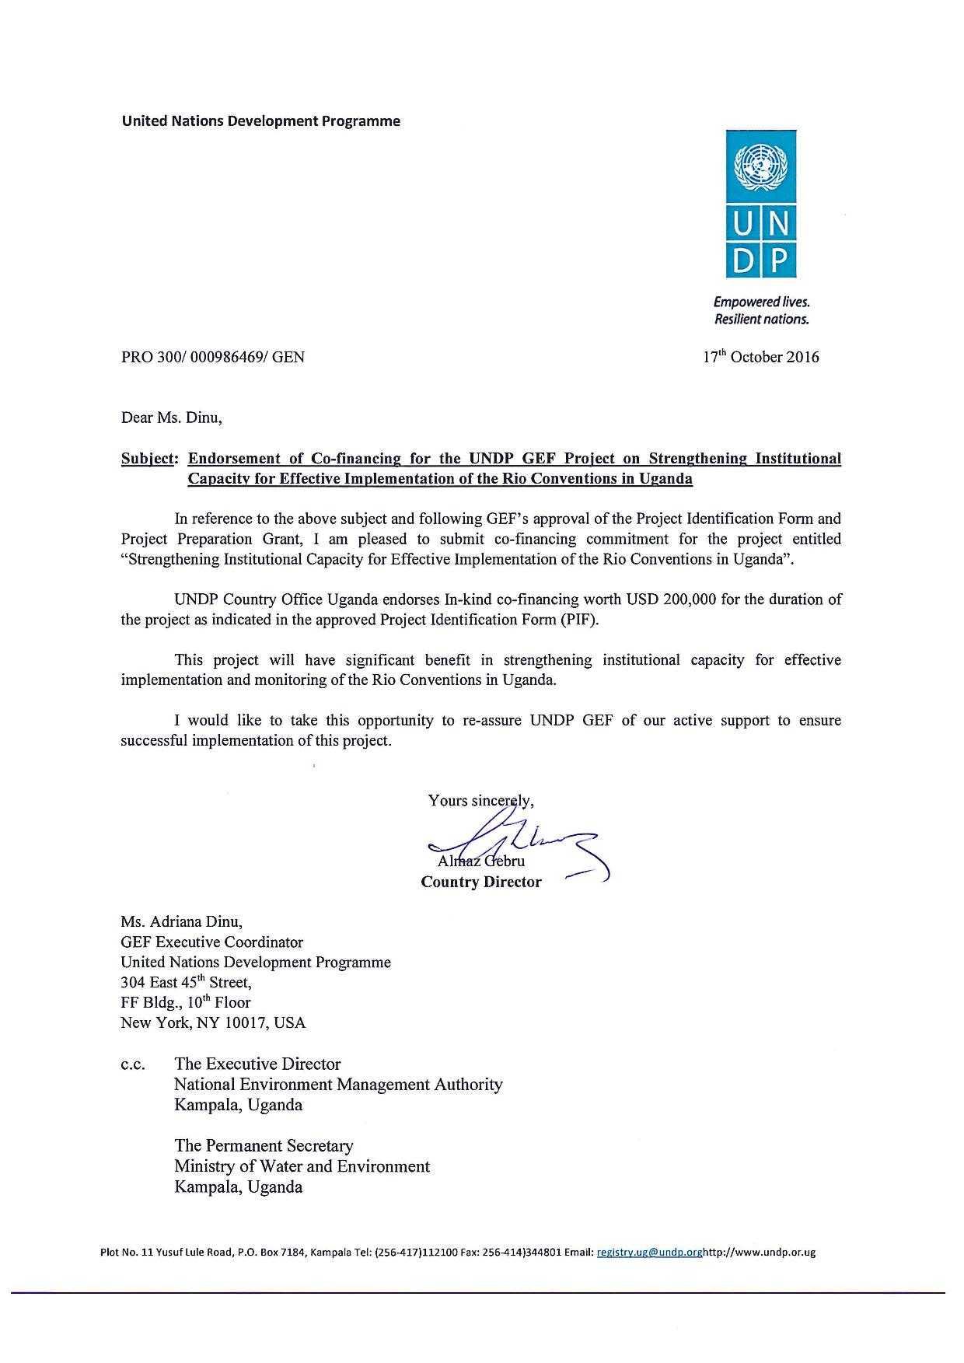

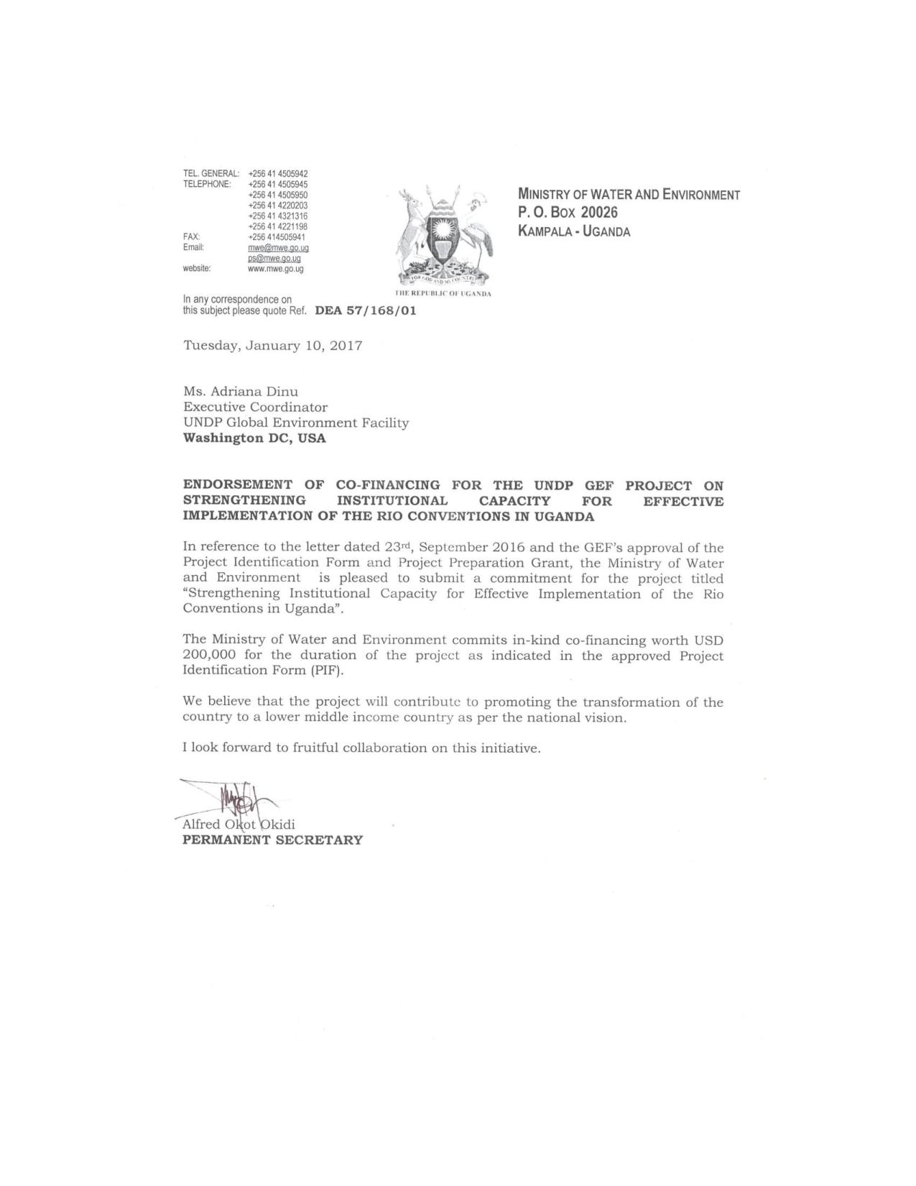

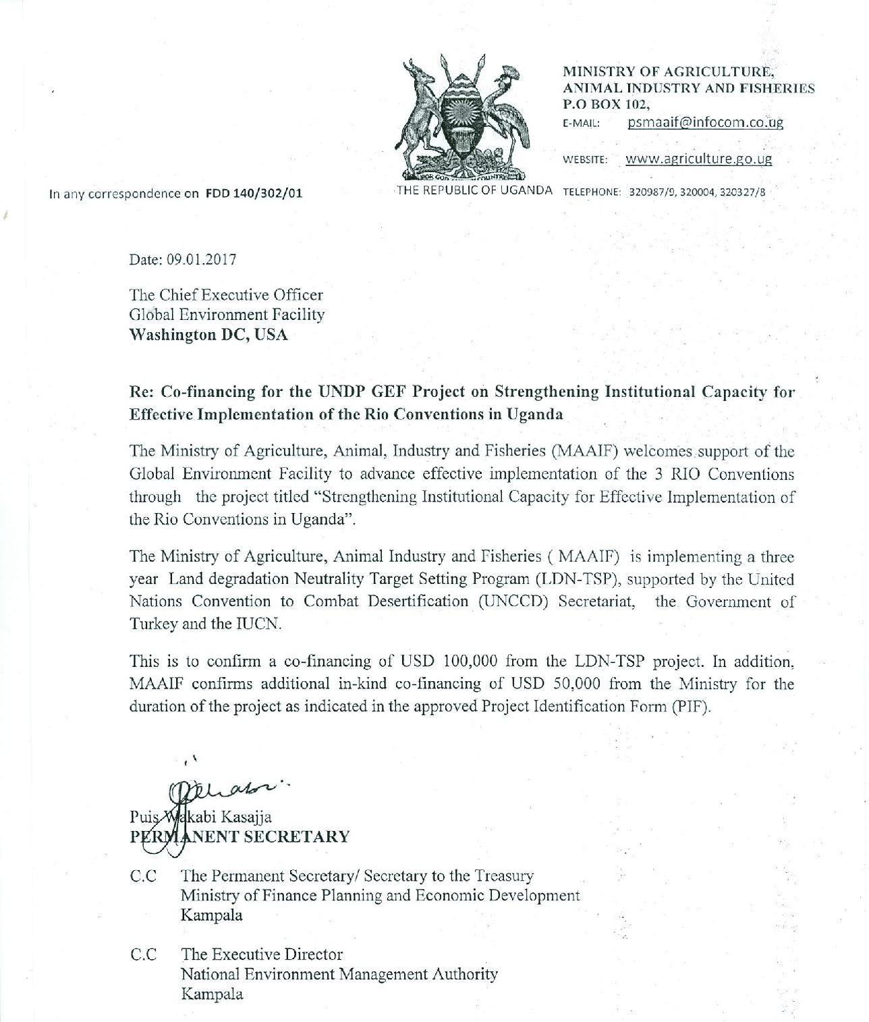
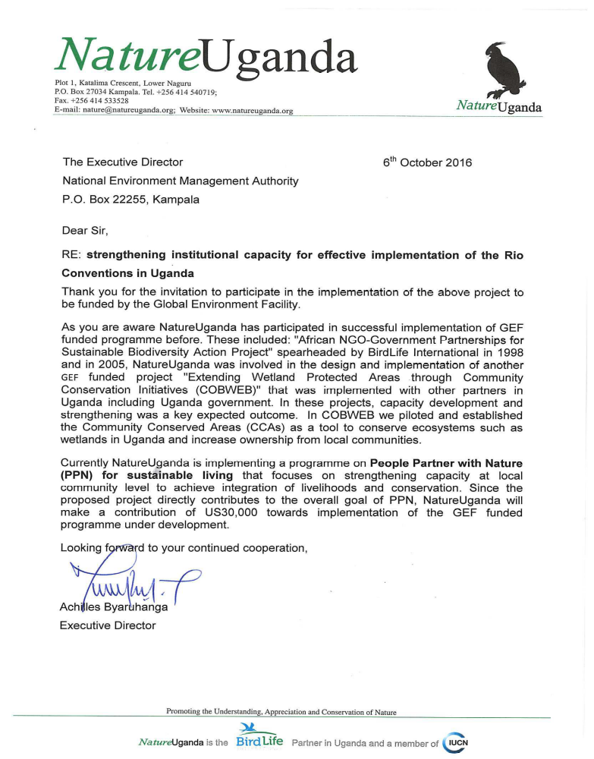

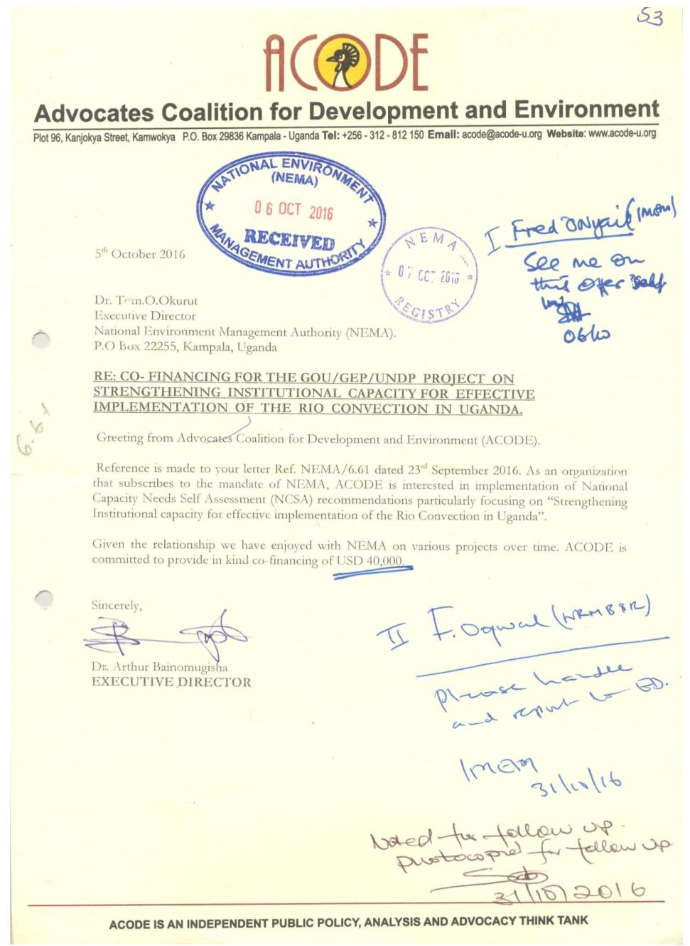
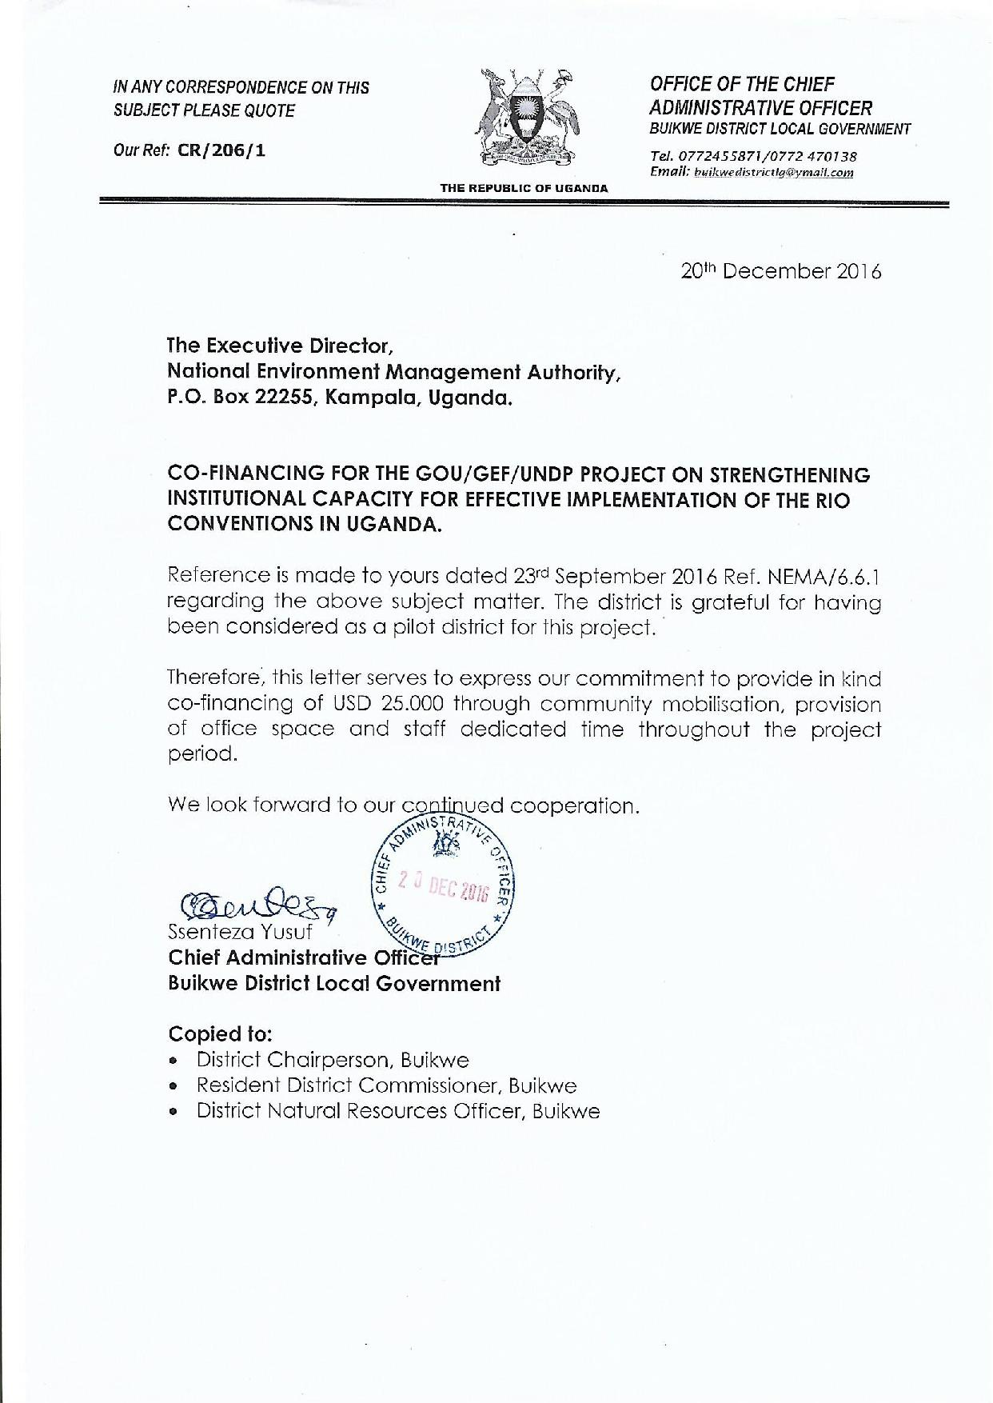

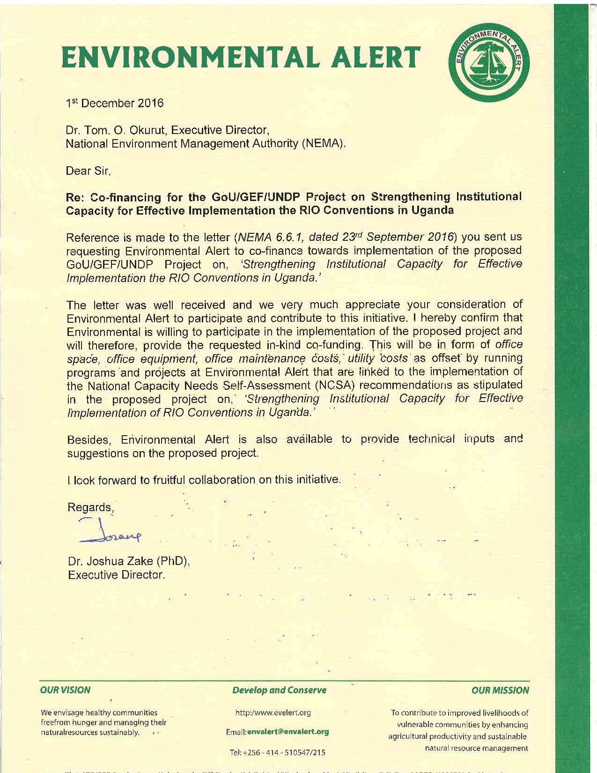

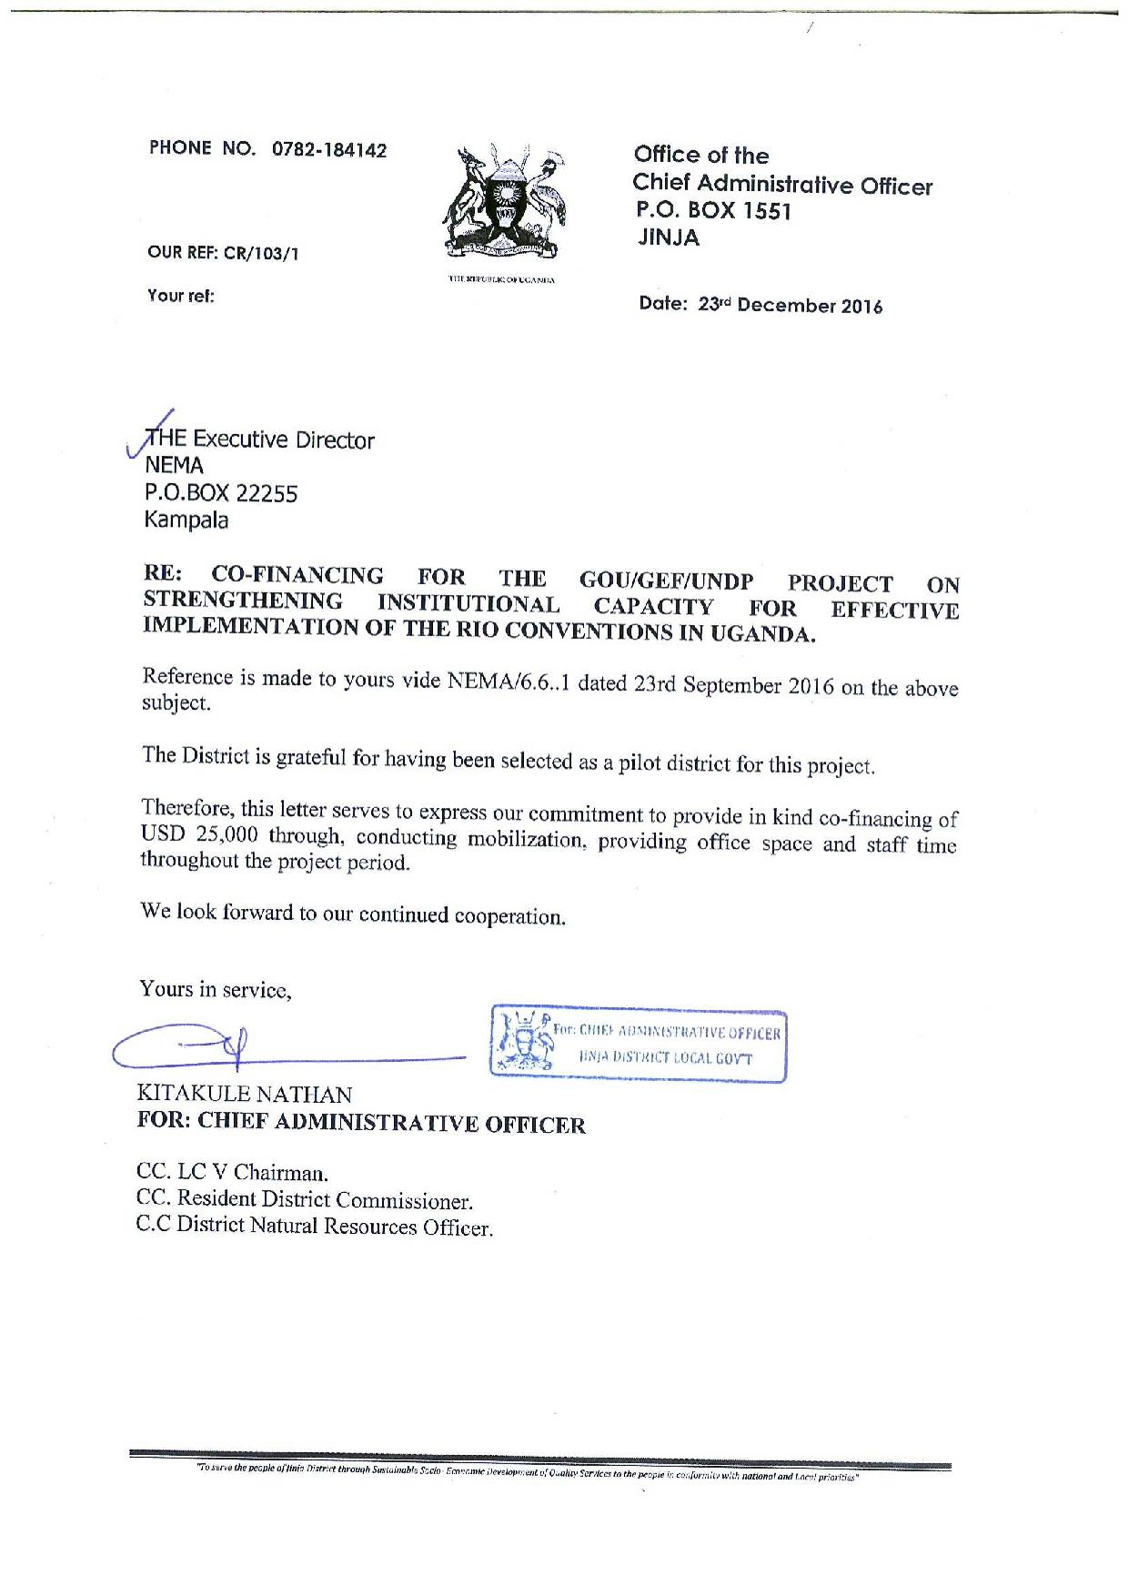

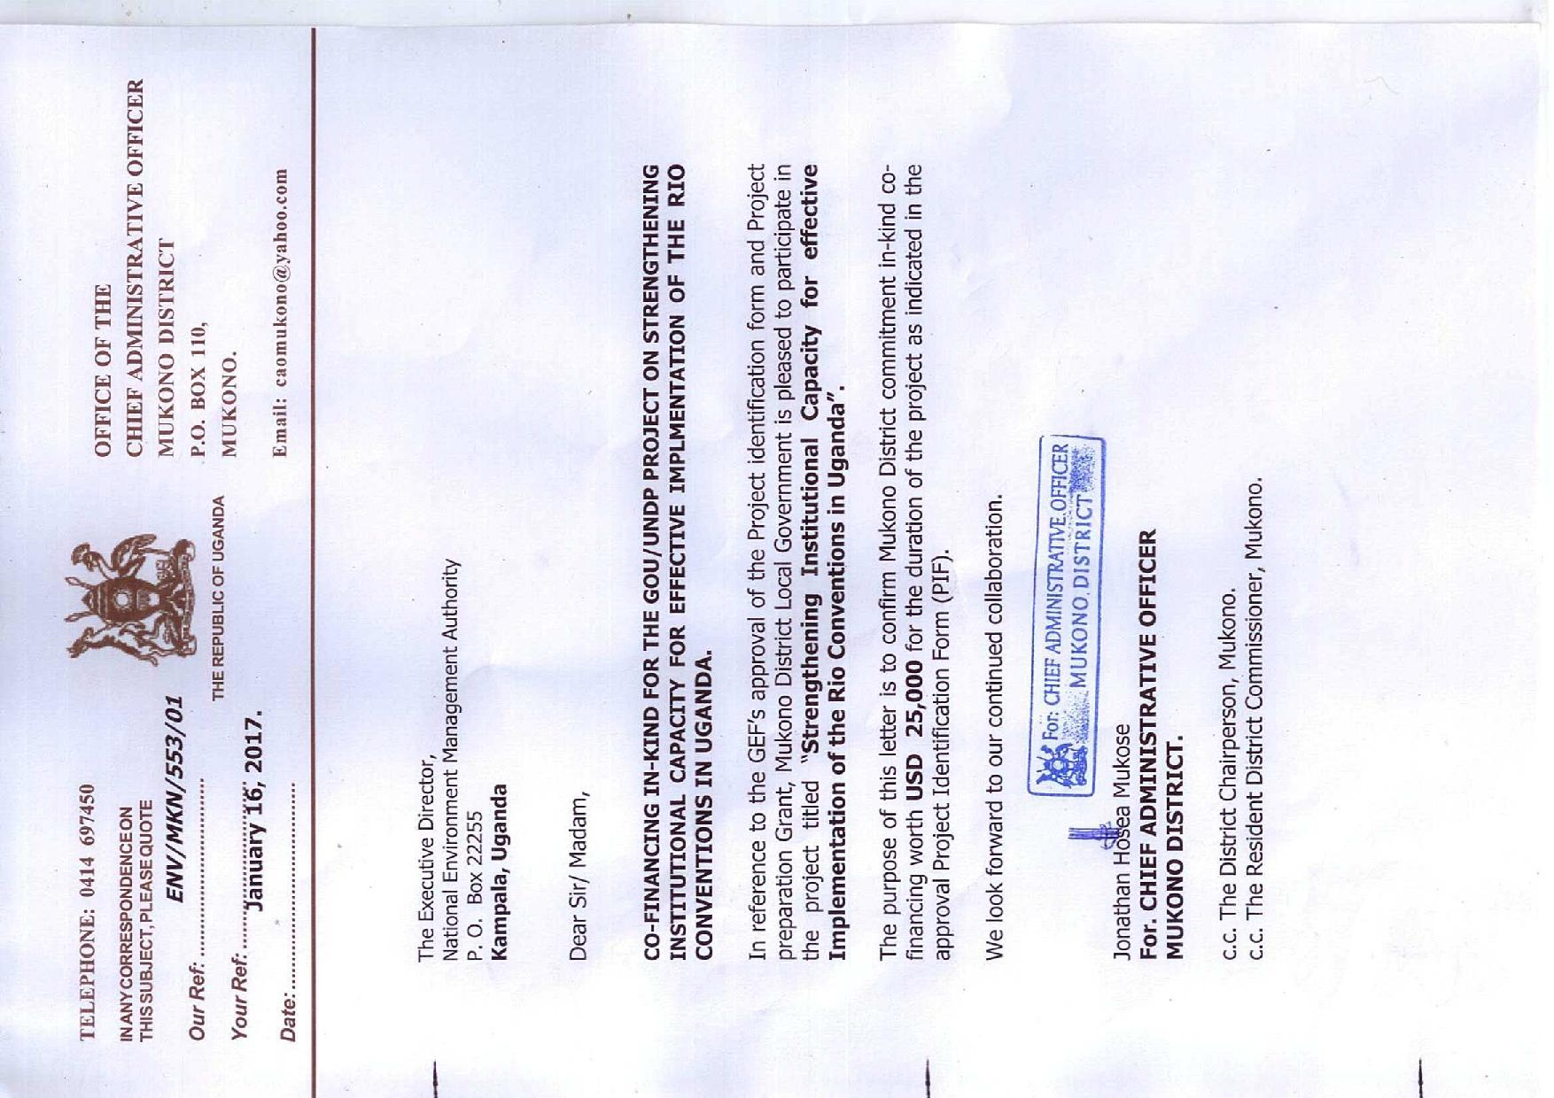

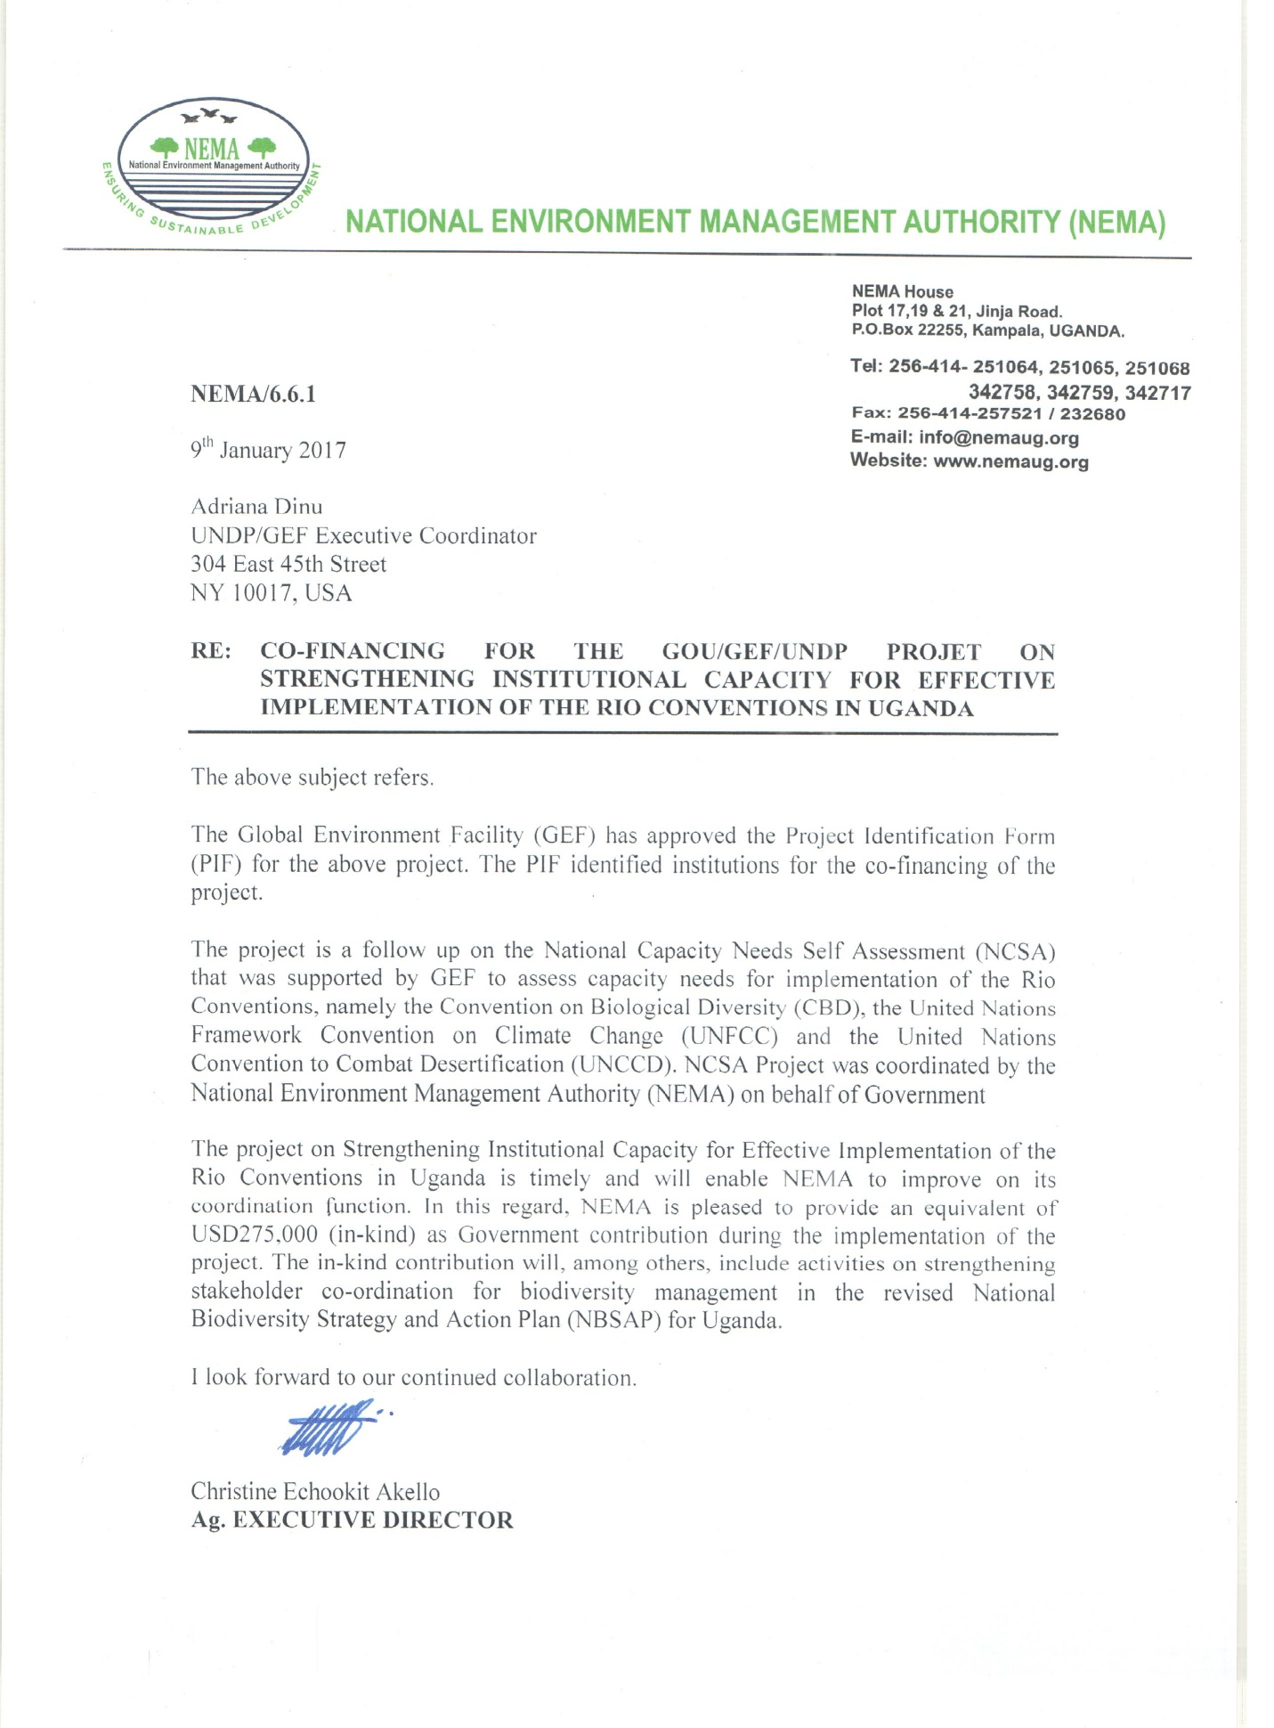

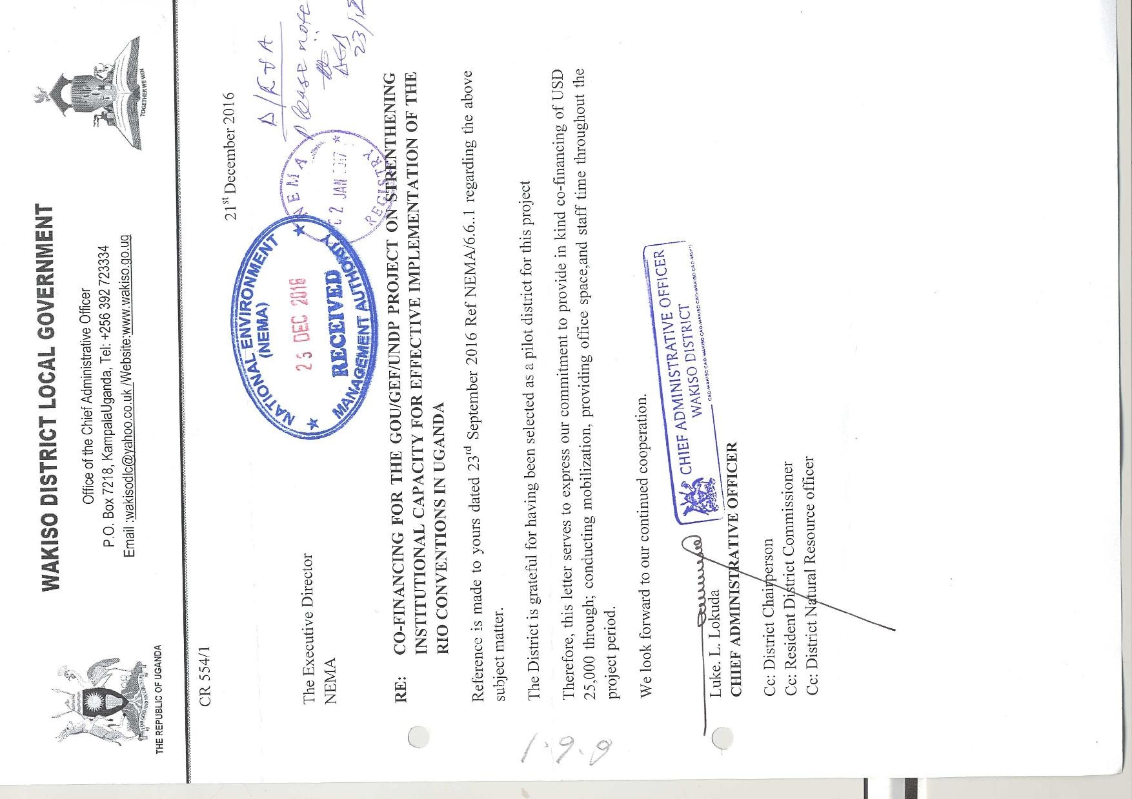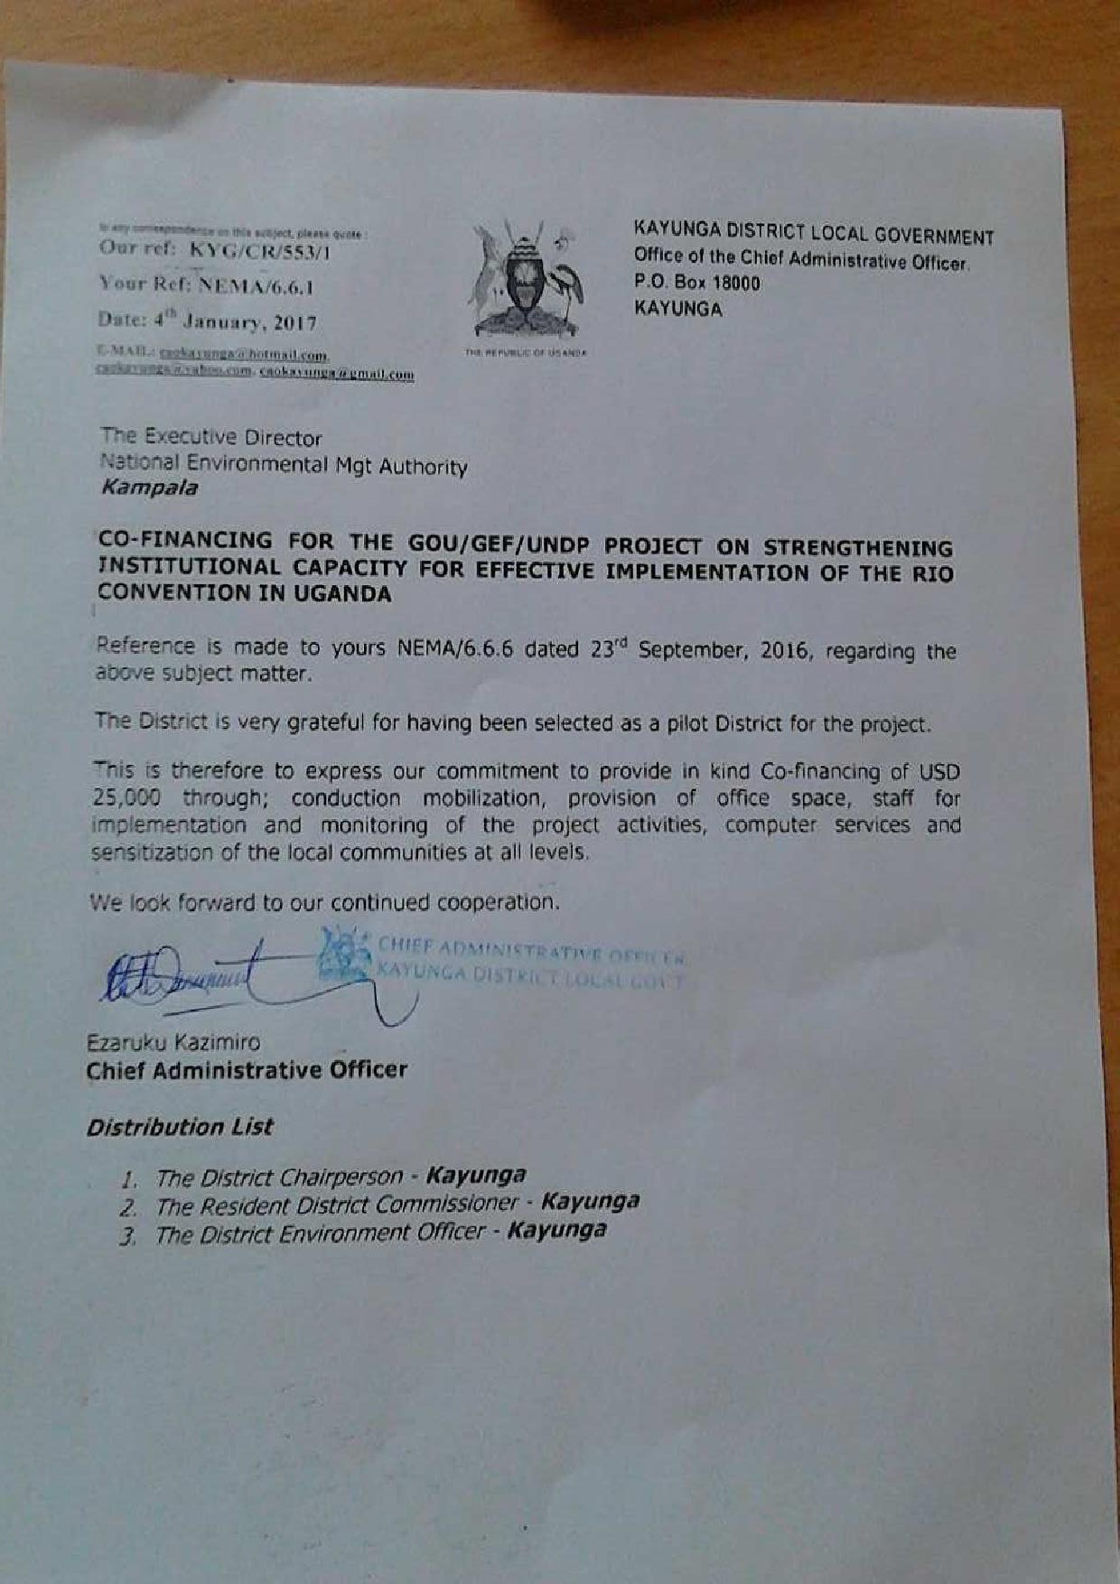
Annex 12. UNDP Project Quality Assurance Report

National Population and Housing Census 2014
Uganda- Industry: http://www.nationsencyclopedia.com/economies/Africa/Uganda-INDUSTRY.html
Climate Data: https://en.climate-data.org/location/5578/
Briggs, Philip, and Andrew Roberts. Uganda. Bradt Travel Guides, 2010. ‏
UGANDA Biodiversity and Tropical Forest Assessment: http://www.vub.ac.be/klimostoolkit/sites/default/files/documents/uganda_biodiversity_assessment_usaid.pdf
UGANDA Biodiversity and Tropical Forest Assessment: http://www.vub.ac.be/klimostoolkit/sites/default/files/documents/uganda_biodiversity_assessment_usaid.pdf
UGANDA Biodiversity and Tropical Forest Assessment: http://docplayer.net/23949549-Uganda-biodiversity-and-tropical-forest-assessment.html
National State of the Environment Report for Uganda 2014: Harnessing our environment as infrastructure for sustainable livelihood and development. NEMA and UNDP http://nema.go.ug/reports/FINAL%20NSOER%202014%20mail.pdf
Environmental Sustainability Issues in Uganda: http://fsdinternational.org/country/uganda/envissues
National Capacity Self-Assessment (NCSA) for Global Environment Management: http://www.thegef.org/project/national-capacity-assessment-ncsa-global-environmental-management-20
Inclusive Green Growth for Poverty Reduction http://www.ug.undp.org/content/uganda/en/home/ourwork/sustainable-inclusive-economic-development/overview.html
Building Resilient Communities and Ecosystems living in proximity to critical wetlands and associated catchments in South Western Uganda Project Document: UNDP Uganda.
https://en.wikipedia.org/wiki/Rebecca_Kadaga, https://en.wikipedia.org/wiki/Rebecca_Kadaga
Joyce Namutebi, Henry Mukasa, and Milton Olupot (19 May 2011). "Kadaga Is First Female Speaker". New Vision (Kampala). Retrieved 6 December 2014.
Wambi, Michael (24 May 2011). "Politics: First Woman Speaker of Parliament Changing Politics". Inter Press Service. Retrieved 6 December 2014
[1] See http://www.undp.org/content/undp/en/home/operations/transparency/information_disclosurepolicy/
[2] See https://www.thegef.org/gef/policies_guidelines
All focal point contributed to the development of the criteria
Roosblad, S. 2015. Pollution Is Silent Killer in Uganda. Available from http://www.voanews.com/a/pollution-is-silent-killer-in-uganda/2648372.html
WHO, 2012. 7 million premature deaths annually linked to air pollution. Available at http://www.who.int/mediacentre/news/releases/2014/air-pollution/en/

